

**Design and implement alarm systems for**

**Home Automation**

|  |
| --- |
| Phạm Văn Cự  Nguyễn Phú Sĩ  Phan Khắc Nguyên Khôi |

|  |  |
| --- | --- |
| Supervised by **Nguyễn Trọng Phúc** | |
| No. SE05.C – 001-ES |  | |

# Acknowledgements

We wish to thank various people for their contribution to this project....

Special thanks should be given to Mr. Nguyễn Trọng Phúc – our mentor for all of his constructive and usefull guidance throughout the course of this project.

# Table of Contents

Acknowledgements 2

Table of Contents 3

List of Figures 8

List of Tables 12

A. Introduction 1

Scenario 1

Existing solutions 1

1. SHENZHEN: GM02 1

2. Green bee group: X-Bee for remote management 2

Proposed solution and Approach 2

Project overview 2

1. Technology overview 2

1.1 Roles in ZigBee network 3

1.2 ZigBee network topology 3

1.3 Addressing basics 4

1.4 Personal Area Network (PAN) Address 4

1.5 Channels 4

2. System overview 5

Scope of project 6

Team introduction 7

B. Project Management Plan 8

Problem Definition 8

1. Capstone Project Name 8

2. Problem Abstract 8

3. Project Overview 8

3.1 The Current Systems 8

3.2 The Proposed System 9

3.3 Development Environment 9

Project Organization 9

1. Software Process Model 9

2. Roles and Responsibilities 10

3. Tools and Techniques 11

Project Management Plan 12

1. Project Iterations 12

2. Risk management 22

Coding Convention 24

C. Requirements Specifications 25

User Requirement Specification 25

1. Monitoring status of the system 25

2. Create a scenario for an expected problems 25

3. Remotely control 25

4. Schedule using time for each device 25

5. Low energy consumption 25

6. High security 25

7. Interoperability 25

Hardware Requirements 26

1. Microcontroller 26

2. X-Bee 27

2.1 Coordinator 27

2.2 Router 27

3. Temperature Sensor 29

4. Gas sensor 30

5. CC3000 module 31

6. MSP430 FR5739 board 32

Functional Requirements 33

1. System boundary 33

2. Normal users 34

2.1 Log-in 34

2.2 Register 36

3. Authorized Users – View system status 38

3.1 View temperature level 38

3.2 View gas/ smoke level 39

3.3 View devices’ status 40

3.4 React to unexpected problems 41

4. Authorized User – Control end devices 43

4.1 Scan system’s devices 43

4.2 Add new device 44

4.3 Delete registered devices 46

4.4 Switch ON/OFF devices 48

4.5 Schedule system’s using time 49

4.6 Create scenario for unexpected problems 51

5. Authorized User 52

5.1 Log-out 53

Main flow 54

Non-functional Requirements 55

1. Reliability 55

2. Availability 55

3. Security 55

4. Maintainability 55

5. Portability 55

6. Performance 55

D. Software Design Description (SDD) 57

Design Overview 57

I. System Architecture Design 57

II. Component Diagram 58

III. Detail Description of Components 59

**1.** **Hardware layer – Master module** 59

a. Overview 59

b. Detail 61

c. Sequence diagram 66

**2.** **Hardware layer – Sensor board** 78

a. Overview 78

b. Detail 83

c. Sequence diagram 87

**3.** **Hardware layer – Plug board** 92

a. Overview 92

b. Detail 96

c. Sequence diagram 97

**4.** **Software layer** 102

**5.** **GUI layer** 105

1. Scan plug 105

2. Connect a plug 107

3. Control plug 109

4. Scan sensor 110

5. Connect sensor 110

6. Create scenario 111

IV. User interface 113

1. Login screen 113

2. Dashboard screen 114

3. Scan device screen 114

4. Add new device screen 115

5. Menu screen 115

6. Create scenario screen 115

E. Software Test Documentation 117

Introduction 117

1. Test overview 117

2. Test approach 117

Test plan 117

1. Testing features 117

2. Features not to be tested 118

3. Test environment 118

4. Test pass/fail criteria 118

Test case 119

1. Functional testing 119

1.Start [I-Home smart config] application 119

1.Start [I-Home smart config] application 119

2. Integration test 130

F. System User’s Manual 137

I. Installation Guide 137

1. Sensor module 137

2. Plug module 137

3. Associate the master module to an access point 137

a. Prerequisites 137

b. Environment set up 137

c. Running the configuration 137

4. Set up PC to work as web server 141

a. Set static IP for server’s PC 141

b. Activate necessary services 141

c. Add remote desktop user 143

d. Install addition features 144

5. Install Web Server ( Wamp Server) 146

a. Install Wamp 146

b. Set up website 147

II. User’s Guide 150

1. Log-in 150

2. Using dashboard page 151

3. Add plug manually 152

4. Manage plug 152

5. Add sensor manually 156

6. Manage sensor page 157

7. Create scenario 158

8. Setting page 161

G. Works Cited 163

# List of Figures

Figure 1: ZigBee network topologies 4

Figure 2: System Overview 6

Figure 3: Project Devices 7

Figure 4: Software Process Model 10

Figure 5: Project overview 12

Figure 6: Planning phase 12

Figure 7: Research and study phase 13

Figure 8: Design phase 14

Figure 9: Implement hardware 15

Figure 10: Coding phase - Sensor Module 16

Figure 11: Coding phase - Plug Module 17

Figure 12: Coding phase - Master Module 18

Figure 13: Coding phase - GUI 19

Figure 14: Testing phase 20

Figure 15: Monitoring and Controlling phase 21

Figure 16: Closing phase 21

Figure 17: Microchip - PIC16F877A 26

Figure 18: Digi - XBee Module 27

Figure 19: Digi - XBee Module Pro S2B 28

Figure 20: Temperature Sensor 29

Figure 21: Gas Sensor 30

Figure 22: TI - CC3000 Module 31

Figure 23: TI - MSP430 FR5739 board 32

Figure 24: System boundary 33

Figure 25: Use case - Normal users’ function 34

Figure 26: Use case - Authorized User control end devices 43

Figure 27: Use case - Authorized user logout 53

Figure 28: Sequence diagram - System main flow 54

Figure 29: System Architecture Design 57

Figure 30: Component Diagram - Hardware layer 58

Figure 31: Component Diagram - Software layer 59

Figure 32: Component Diagram - GUI layer 59

Figure 33: CC3000 module & MSP430 FRAM 60

Figure 34: X-Bee module – coordinator 61

Figure 35: Master board 61

Figure 36: CC3000 Wi-fi Netword Processor 62

Figure 37: CC3000 Host Driver Module 63

Figure 38: SPI Master-Slave Communication Model 64

Figure 39: Xbee UART interface 64

Figure 40: MSP-EXP430FR5739 Overview 65

Figure 41: [Master module] Get temperature and gas level 67

Figure 42: [Master module] Get plug’s status 69

Figure 43: [Master module] Control plug 71

Figure 44: [Master module] Set scenario 73

Figure 45: [Master module] Scan Plug 75

Figure 46: [Master module] Scan sensor 77

Figure 47: PIC 16F877A 79

Figure 48: LM35 temperature sensor 80

Figure 49: MQ2 gas sensor 80

Figure 50: Buzzer 81

Figure 51: X-bee router module 82

Figure 52: Sensor board 83

Figure 53: Schematic of Sensor Module 83

Figure 54: [Sensor board] power supply schematic 84

Figure 55: Power supply module 84

Figure 56: [Sensor board] sensor module schematic 84

Figure 57: [Sensor board] buzzer schematic 85

Figure 58: Buzzer Module 85

Figure 59: [Sensor board] XBee module schematic 86

Figure 60: [Sensor board] PIC16F 877A module schematic 86

Figure 61: [Sensor module] Get current environment’s temperature 87

Figure 62: [Sensor module] Get current environment’s gas level 88

Figure 63: [Sensor module] Send current temperature and gas level 88

Figure 64: [Sensor module] Set gas’s warning value 89

Figure 65: [Sensor module] Set temperature’s warning value 90

Figure 66: [Sensor module] Control Plug module 91

Figure 67: Buttons of Plug Module 93

Figure 68: Relay Schematic 93

Figure 69: Relay picture 93

Figure 70: Plug control board 94

Figure 71: Plug board 95

Figure 72: Plug board schematic 96

Figure 73: [Plug board] Relay schematic 96

Figure 74: [Plug board] Button schematic 97

Figure 75: [Plug module] Switch ON/OFF manually 98

Figure 76: [Plug module] Switch ON/OFF by Master module 99

Figure 77: [Plug module] Switch ON/OFF by Sensor module 100

Figure 78: [Plug module] Get status of single plug 101

Figure 79: [Plug module] Get status of all plugs 102

Figure 80: Transmit data layers 104

Figure 81: Zigbee Network 105

Figure 82: Communication between Coordinator and Device 105

Figure 83: Sequence Diagram - Scan Plug 106

Figure 84: GUI - Scan all Plug in system network 106

Figure 85: Sequence Diagram - Scan failed 106

Figure 86: GUI – Scan plug failed 107

Figure 87: Sequence Diagram - Connect a Plug 107

Figure 88: GUI - Plugs had been connected 107

Figure 89: GUI - Edit description 108

Figure 90: GUI - Set Schedule 108

Figure 91: Sequence Diagram – Connect plug failed 109

Figure 92: GUI – Connect plug failed 109

Figure 93: Sequence diagram - Turn ON/OFF plug 109

Figure 94: Sequence Diagram - Scan sensor 110

Figure 95: Sequence Diagram - Scan sensor failed 110

Figure 96: Sequence Diagram - create scenario 112

Figure 97: GUI - Login page 113

Figure 98: GUI - Dashboard Page (current temperature and gas level) 114

Figure 99: GUI - Dashboard Page (energy) 114

Figure 100: GUI - Manage Plug page (Scan plug function) 114

Figure 101: GUI - Manage Plug page (connect plug function) 115

Figure 102: GUI - Main Menu 115

Figure 103: GUI - Set Scenario page 116

Figure 104: Turn on Configuration mode of Master module 138

Figure 105: config the Smart Config application 139

Figure 106: Master module config success 140

Figure 107: Smart Config application config success 140

Figure 108: Use ipconfig to see local IP (IPv4 Address) 141

Figure 109: Set static IP 141

Figure 110: Run services.msc 142

Figure 111: Active Services (services.msc) 142

Figure 112: Remote Desktop Services Properties 143

Figure 113: Add Remote Desktop Users 144

Figure 114: Install Telnet Client and Telnet Server 144

Figure 115: Run services.msc again 145

Figure 116: Start Telnet service 145

Figure 117: Install WampServer 146

Figure 118: Start All Services 147

Figure 119: Main Screen of WampServer 147

Figure 120: Import Database 148

Figure 121: Define host and Database information 148

Figure 122: Enable PHP Socket 149

Figure 123: Login page 150

Figure 124: Dashboard page 151

Figure 125: Add plug manual page 152

Figure 126: Manage plug page 152

Figure 127: Scan plug function 153

Figure 128: List plugs is scanned 153

Figure 129: Press Connect button to connect plug 154

Figure 130: List plug connected 154

Figure 131: Edit plug function 155

Figure 132: Set schedule function 155

Figure 133: Manage plug board overview 155

Figure 134: Delete plug function 156

Figure 135: Add sensor page 156

Figure 136: Manage sensor page 157

Figure 137: List sensors is scanned 158

Figure 138: Press Connect button to connect the sensor 158

Figure 139: Create scenario page 158

Figure 140: Choose sensor 159

Figure 141: Set temperature option 159

Figure 142: Set gas level option 160

Figure 143: Choose actions 160

Figure 144: Set plugs 160

Figure 145: Finish process 161

Figure 146: Scenario board 161

Figure 147: Setting Page 161

Figure 148: Add more email and phone number 162

# List of Tables

Table 1: List of abbreviations and acronyms 14

Table 2: Team members and role in the project 7

Table 3: Roles and Responsibilities 11

Table 4: Risk management 23

Table 5: Use case - Login SPECIFICATION 36

Table 6: Use case - Register SPECIFICATION 38

Table 7: Use case - Authorized Users view system status 38

Table 8: Use case - View temperature level 39

Table 9: Use case - View gas/smoke level 40

Table 10: Use case - View electric devices’ status 41

Table 11: Use case - React when unexpected problems occurred 42

Table 12: Use case - Scan system devices 44

Table 13: Use case - Add a new device 46

Table 14: Use case - Delete registered devices 48

Table 15: Use case - Switch ON/OFF devices 49

Table 16: Use case - Schedule system’s using time 50

Table 17: Use case - Create scenario for unexpected problems 52

Table 18: Use case - Logout 54

Table 19: CC3000 specifications 63

Table 20: SPI pin description 64

Table 21: UART pin description 65

Table 22: PIN Connections 65

Table 23: Command list 66

Table 24: [Get temperature and gas level] function description 68

Table 25: [Get plug's status] function description 70

Table 26: [Control plug] function description 72

Table 27: [Create scenario] function description 74

Table 28: [Scan plug] function description 76

Table 29: [Scan sensor] function description. 78

Table 30: [Get current environment's temperature] function description 87

Table 31: [Get current environment's temperature] function description 88

Table 32: [Send current temperature and gas level] function description 89

Table 33: [Set gas’s warning value] function description 90

Table 34: [Set temperature’s warning value] function description 91

Table 35: [Control plug module] function description 92

Table 36: Command list 97

Table 37: [Switch ON/OFF manually] function description 98

Table 38: [Switch ON/OFF by Master module] function description 99

Table 39: [Switch ON/OFF by Sensor module] function description 100

Table 40: [Get status of single plug] function description 101

Table 41: [Get status of all plugs] function description 102

Table 42: Testing features 118

Table 43: Functional testing 130

Table 44: Test case 136

Table 45: Description of login page 150

Table 46: Description of dashboard page 151

Table 47: Description of add plug page 152

Table 48: Description of manage plug page 153

Table 49: Description of list scanned plug 153

Table 50: Description of list connected 154

Table 51: Description of set schedule page 155

Table 52: Description of manage plug page 156

Table 53: Description of add sensor page 157

Table 54: Description of manage sensor page 157

Table 55: Description of list scanned sensor 158

Table 56: Description of create scenario page 159

Table 57: Description of scenario page 161

Table 58: Description of setting page 162

|  |  |  |
| --- | --- | --- |
| **No.** | **Abbreviation& Acronym** | **Definition** |
| 1 | HCMC | Ho Chi Minh City |
| 2 | BA | Business Analysis |
| 3 | DEV | Developer |
| 4 | GUI | Graphic User Interface |
| 5 | IDE | Integrated Development Environment |
| 6 | DBMS | Database Management System |
| 7 | Master | A module worked as an controller that control system’s working flow |
| 8 | LED |  |

Table : List of abbreviations and acronyms

This page intentionally left blank.

# Introduction

## Scenario

Nowadays, smart devices are increased rapidly in the world, and smart home (automation home) is the new potential trend. People need to control their home by their smart devices via the internet. And they also need a system that is automatically activated to solve their home’s problems. From careful researches, we realize some basic needs of a customer:

They want a system that can help them to control all devices to the appliances with less effort and reliable

* Device should have a long battery life
* Alarm system is always ON and work correctly
* Provide auto-reaction with dangerous situation
* Control screen is simple and friendly
* All of control command is executed correctly and immediately
* User can create schedule/ scenario for their home to react with unexpected problems

Therefore, we would like to build a system with high rate of reliability and becoming more comfortably controlling their home’s appliances.

## Existing solutions

### SHENZHEN: GM02

**GM02** adopts SMS data transmission and voice platform of GSM network to send control command and receive alarm message remotely. The system can be armed according to user’s requirements, when a signal is detected by sensors, the sensors will send alarm signal to alarm host immediately, then the alarm host will send alarm SMS to pre-set mobile phone numbers, and meanwhile dials its preset telephone/mobile phone numbers automatically. In addition, user can dial the number in the alarm host to remote control the host, such as arm, disarm etc.

Disadvantage:

* Just use to notify users
* Can’t re-act in case of alarms
* Hard to manage all of the devices in home or building(the status of sensor in each room)
* Can’t extend the system by adding other devices.

### Green bee group: X-Bee for remote management

Turning the plug ON/OFF via the internet using Android or web application, their devices are connected to server using “zigbee” technology. The system also includes a temperature sensor for monitoring in-house temperature.

Disadvantage:

* Alarm system can’t react with dangerous situation
* Temperature sensor is used to send temperature only
* Can’t detect gas leakage
* An X-bee module can control only 1 plug.
* Master module (the server which is sent and received data from X-bee module) is too expensive (DIGI’s connectPort X2)
* The plug’s design is not good

## Proposed solution and Approach

Our team proposed a new wireless system has some advantages:

* Using Zigbee technology to have a long-life devices (2 – 3 years)
* We create our own master module to reduce cost
* We create a system that one X-Bee module can control at least 6 plugs
* Ability to re-act based on data from sensor (gas sensor/ temperature sensor)
* Ability to locate the location of each end device in the whole system.
* Interoperability: devices can interact with each other regardless of manufacturing origin.
* Security: the data in network would be authenticated and confidential.
* Ability to control the whole system remotely.

So that, our team also choose ZigBee technology as a main approach combine with some client application like web application or Android application to control all over the system.

## Project overview

### Technology overview

* ZigBee is a protocol specification and industry standard for a type of wireless communications technology generically known as Low-Rate Wireless Personal Area Networks (LR-WPAN).
* “ZigBee” is the name for:
* Short-range
* Low-power
* Low-cost
* Low-data-rate wireless multi-hop networking *technology standard*.
* The features of ZigBee networks include self-organization, support for multi-hop routed networking topologies(mesh network), interoperable application profiles, and security based on the Advanced Encryption Standard (AES).

#### Roles in ZigBee network

There are three roles in a ZigBee network:

* ***Coordinator***: This is the module that establishes the network. Every network must have one (and only one) of these types in it. Think of this device as similar to a wireless internet router. Because this device is constantly administering the network, it consumes more power than other types. It is recommended that this module is not powered by battery.
* ***Router***: This device is similar to the Endpoint, but also specializes in passing data around the network. Data sent from one endpoint to another may pass through several routers on its way to the destination.
* ***Endpoint (End device)***: This is the module that connects in running devices such as temperature sensor, plug…It can be battery powered, and doesn't consume much energy unless it needs to transmit or receive.

#### ZigBee networ***k*** topology

These topologies indicate how the radios are logically connected to each other. There are four major ZigBee topologies:

* **Pair**: The simplest network is one with just two radios, or nodes. One node must be a coordinator so that the network can be formed. The other can be configured as a router or an end device.
* **Star**: This network arrangement is also fairly simple. A coordinator radio sits at the center of the star topology and connects to a circle of end devices. Every message in the system must pass through the coordinator radio, which routes them as needed between devices. The end devices do not communicate with each other directly.
* **Mesh**: The mesh configuration employs router nodes in addition to the coordinator radio. These radios can pass messages along to other routers and end devices as needed. The coordinator (really just a special form of router) acts to manage the network. It can also route messages. Various end devices may be attached to any router or to the coordinator. These can generate and receive information, but will need their parent's help to communicate with the other nodes.
* **Cluster tree**: This is a network layout where routers form a backbone of sorts, with end devices clustered around each router. It is not very different from a mesh configuration.

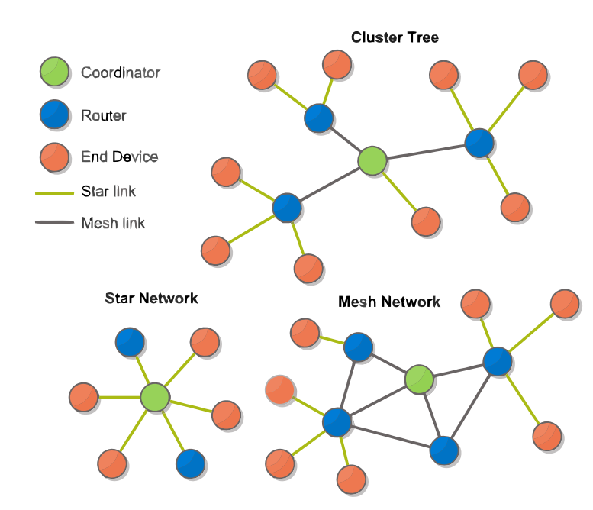

Figure : ZigBee network topologies

#### Addressing basics

If you want to send a ZigBee message, you need to know the address of the destination radio. For starters, each radio has a unique and permanently assigned 64- bit serial number. No other ZigBee radio on earth will have that same serial number. Then there's a shorter 16-bit address that is dynamically assigned to each radio by the coordinator when it sets up a network, similar local host in IP addressing schema. This address is unique only within a given network, but since it’s shorter, many more of them can be manipulated in the very limited memory available on a ZigBee chip.

#### Personal Area Network (PAN) Address

Each coordinator forms a ZigBee network creates a virtual "area", and labels that area with a number; this is the Personal Area Network (PAN) address. This is another 16-bit address. There are 65,536 different PAN addresses available, each having the capability to generate another 65,536 16-bit radio addresses below it. In theory, therefore, this addressing scheme has room for more than 4 billion total radios.

#### Channels

ZigBee network uses 12 different channels. All the radios in that network must use the same channel. In some ZigBee modules origin like XBee from Digi, channel selection handling is done automatically.

### System overview

* There is a module acts as a master controller for the entire network. It’s also a gateway which offers connection to the internet via Wi-Fi
* There are several X-Bee modules act as routers to connect the master module to end devices.
* The end devices are integrated which X-Bee modules can send data and receive command from master module.
* The master module will provide information of the system to a cloud service and also receive commands from it.
* The end users use the Device Manager (web application on PC/Laptop or Android application) connects with the cloud service to control the whole system: monitoring devices’ status, send commands to devices, create scenario for the system …
* Using the system, end users can:
* Manage the status and information of each device in the whole system.
* Remote and control the device in system easily by using web application on PC/Laptop or Android application on smart phone/ tablet.
* Saving energy and money by control the power of device(ON/OFF) actively
* Increases the efficiency, low cost and maintenance
* Prepare a scenario for an expected problems (gas leakage, high temperature …)
* Schedule using time of each device

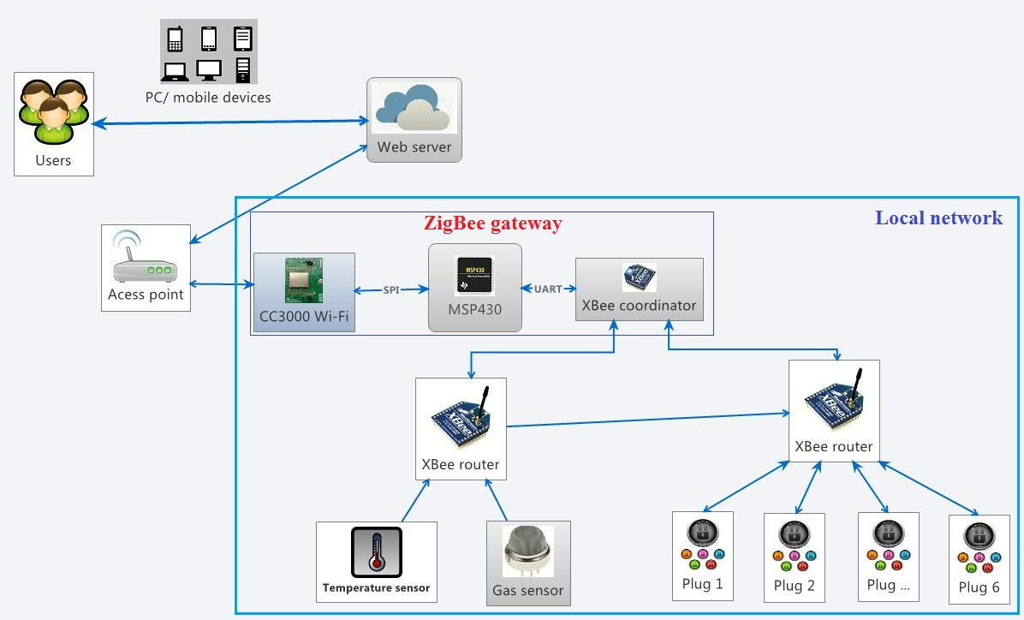

Figure : System Overview

## Scope of project

The scope of this project is prototype the “Wi-Fi for home automation” system, includes both hardware and software.

The final product must satisfy the following specifications:

**Master module**

* Receive the user’s control through web interface
* Send command to control end devices
* Receive data/ signal from end devices
* Send data to user through web interface

**End devices**

* Temperature sensor: Take the temperature of the place where it’s placed
* Gas sensor : Take gas level of place where it’s placed
* Master module : Using CC3000 module and one X-Bee module to collect end device’s data and send command to end devices
* Electric switch: Turn ON/OFF the power of electric device.
* PIC Microcontroller: connect the temperature sensor/ electric switch to X-Bee module. Data (signal) that sent and received is controlled by PIC.
* Re-act under created scenario when expected problems are occurred (high temperature or gas leakage)

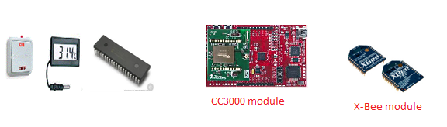

Figure : Project Devices

**Application on Android platform**: For using on mobile phone. Connect to the server, have graphic user interface and basic functions for end user to control and manage the system.

**Web application**: For using on PC/Laptop. Connect to the server, have graphic user interface and basic functions for end user to control and manage the system.

## Team introduction

|  |  |  |  |  |
| --- | --- | --- | --- | --- |
| **Roles and Responsibility:** | | | | |
| **No** | **Full name** | **Role** | **Position** | **Contact** |
| 1 | Nguyễn Trọng Phúc | Project Manager | Instructor | [PhucNT@fpt.edu.vn](mailto:PhucNT@fpt.edu.vn) |
| 2 | Phạm Văn Cự | Developer | Team leader | [CuPV60385@fpt.edu.vn](mailto:CuPV60385@fpt.edu.vn) |
| 3 | Nguyễn Phú Sĩ | Developer | Team member | [SiNPSE60676@fpt.edu.vn](mailto:SiNPSE60676@fpt.edu.vn) |
| 4 | Phan Khắc Nguyên KHôi | Developer | Team member | [KhoiPKN60378@fpt.edu.vn](mailto:KhoiPKN60378@fpt.edu.vn) |

Table : Team members and role in the project

# Project Management Plan

## Problem Definition

### Capstone Project Name

* Project full name: Design and implement alarm systems for Home Automation

### Problem Abstract

Home automation is a new trend in the future when smart devices are increased steadily. People need an intelligence home that they can monitor their home’s status online. They need a reliable and real-time response system which also saves energy and their money. Base on this idea, we use ZigBee technology to make people can remotely manage home’s electric devices easily.

With our system:

* Saving energy and money by control the power of device(ON/OFF) actively
* Increases the efficiency, low cost and maintenance
* Prepare a scenario for an expected problems (gas leakage, high temperature …)
* Schedule using time of each device
* The data in network would be authenticated and confidential.
* Low cost between the connections of all devices in the whole system
* Devices can interact with each other regardless of manufacturing origin.
* End devices can work for a long time (1 – 2 years)

### Project Overview

#### The Current Systems

We all use electricity in our homes every day for almost devices such as lights, fans… More and more electrical devices are used day by day, that’s good for our life but we assume that we get 100 lights at 100 different places and when we want to turn off any of them, we have to go to its place and turn it off. We take a lot of time to do this with all 100 lights. The question is that if we have a good way to turn on or off all 100 lights by just standing in one place. One more thing, we need to monitor 100 kitchens in your building. And you can’t go to a room one by one to make sure everything is ok (temperature, gas, smoke …). Our system will help you to monitor and notify when unexpected problem occurred so all your need is a smart phone or a laptop.

#### The Proposed System

We aimed to develop a wireless system that allows people to control their home’s electric devices. From a light, fan, pump, air conditioner to one room’s devices also, users can monitor all using web application or mobile phone/ tablet with an internet connection. Our provided hardware is also familiar with people and easy to use (plug-and-play). The purpose of it is to make people's lives more convenient. That should be a trend for the future 10 years which we believe that it is coming to real product soon. How to make people’s life safer, more convenient, more comfort ability and less energy consumption will be the series of questions we will care, discuss and design in our project.

#### Development Environment

**Hardware Requirements**

* Internet connected computer (ADSL 4Mbs)
* X-bee module
* Temperature sensor, gas sensor
* TI CC3000 Wi-Fi module
* MSP-EXP430FR5379
* Microprocessor: PIC 16f877a
* Plug
* Relay

**Software Requirements**

* Operating System: Windows 7
* IDE: Visual Studio 2012, Code Composer Studio, C
* DBMS: MySQL
* Subversion Client: Tortoise SVN
* Source Control: Tortoise SVN

## Project Organization

### Software Process Model

Project is developed under incremental model.

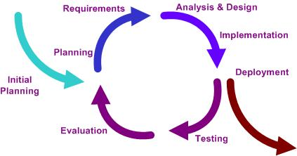

Figure : Software Process Model

The reasons why we choose this model in our project are:

* Generates working hardware and software quickly and early during the software life cycle. We don’t have experience in developing hardware, so we develop our system from simple part
* Easier to manage risk because risky pieces are identified and handled during it’d iteration.
* More flexible – less costly to change scope and requirements.
* Less time is spent on documenting and more time is given for designing.
* Can produce a real product to make sure that software and hardware are worked correctly

### Roles and Responsibilities

|  |  |  |  |
| --- | --- | --- | --- |
| No | Full name | Role in Group | Responsibilities |
| 1 | Nguyễn Trọng Phúc | Project Manager | * Specify user requirement * Control the development process * Provide technique and business analysis support |
| 2 | Phạm Văn Cự | Team Leader, Designer, DEV | * Managing process * Designing hardware * Clarifying requirements * Support technique * Prepare documents * Coding * Create test case * Testing * Creating test plan and test cases |
| 3 | Nguyễn Phú Sĩ | BA,DEV,Tester | * Coding * Clarifying requirements * Support technique * Testing * GUI design |
| 4 | Phan Khắc Nguyên Khôi | BA, DEV, Tester | * Coding * Clarifying requirements * Testing * Design and implement database |

Table : Roles and Responsibilities

### Tools and Techniques

* Microcontroller programming tools: Pic C, Code Composer Studio 5.4
* Circuit supporting tools: Proteus 7.8, Orcard 9.2
* Front-end: html, css, java script, json, jQuery, AJAX
* Back-end: MVC4, log4net
* Web server: PHP server
* DBMS: MySQL

## Project Management Plan

### Project Iterations

* 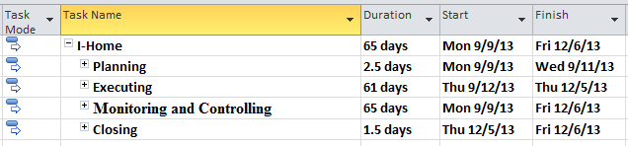Project overview

Figure : Project overview

* Detailed schedule
* 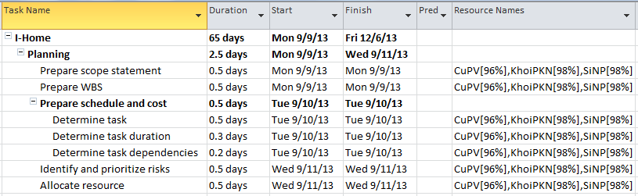Planning phase

Figure : Planning phase

* Executing phase
* 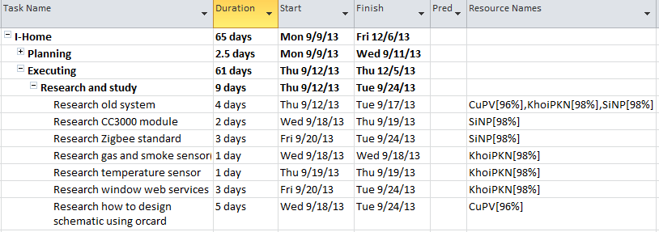Research and study phase

Figure : Research and study phase

* Design phase

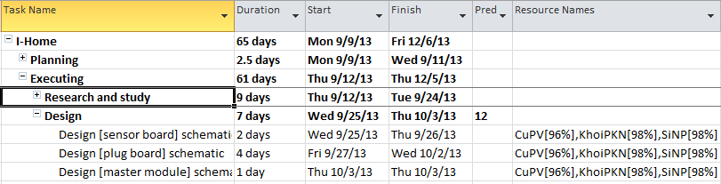

Figure : Design phase

* Implement hardware

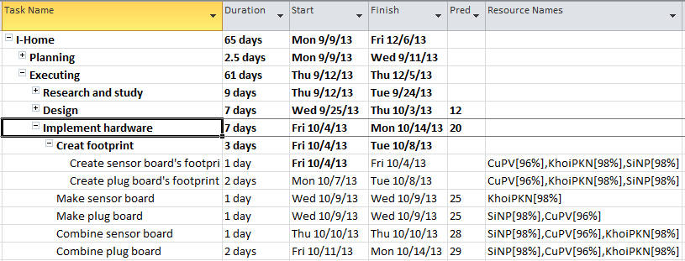

Figure : Implement hardware

* Coding phase

**Implement [sensor] module**

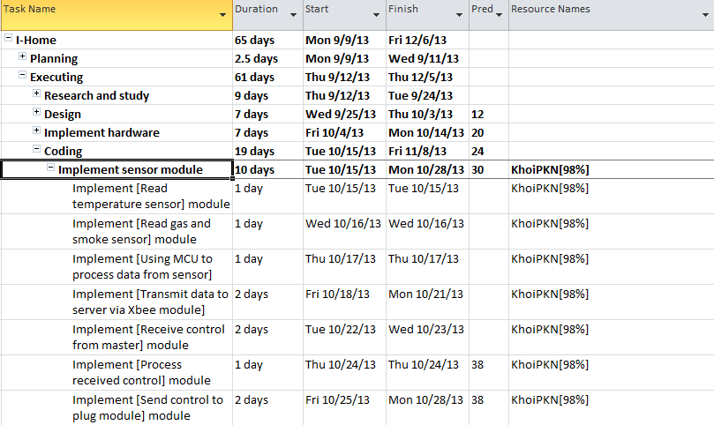

Figure : Coding phase - Sensor Module

**Implement plug module**

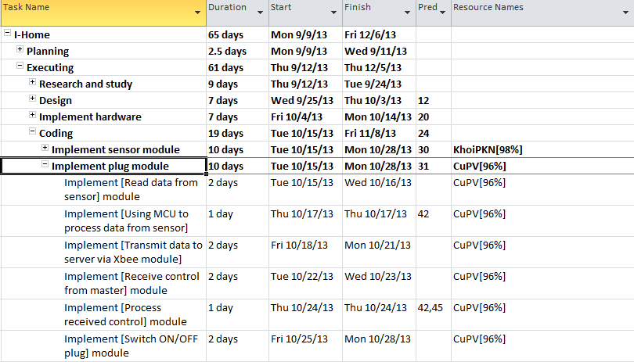

Figure : Coding phase - Plug Module

**Implement master module**

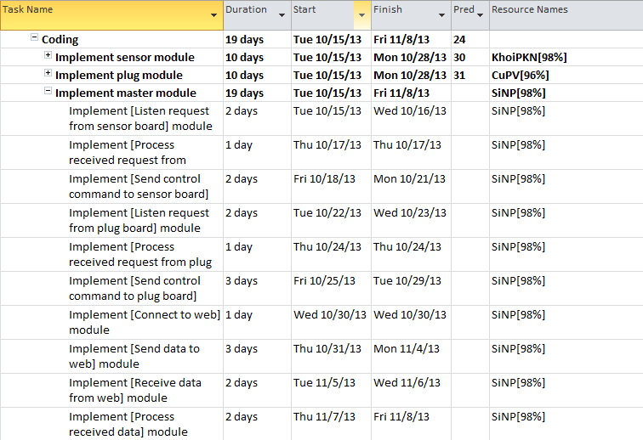

Figure : Coding phase - Master Module

**Implement GUI**

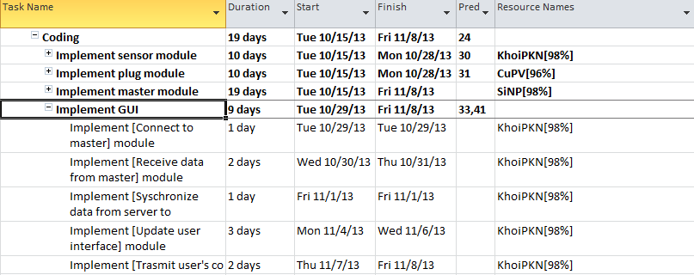

Figure : Coding phase - GUI

* Testing phase

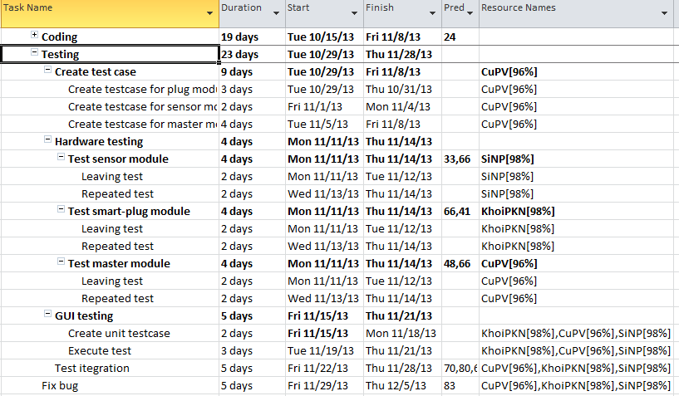

Figure : Testing phase

* Monitoring and Controlling phase

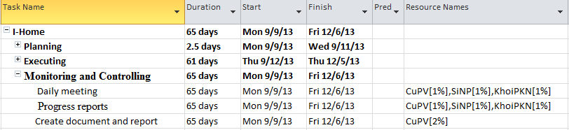

Figure : Monitoring and Controlling phase

* Closing phase

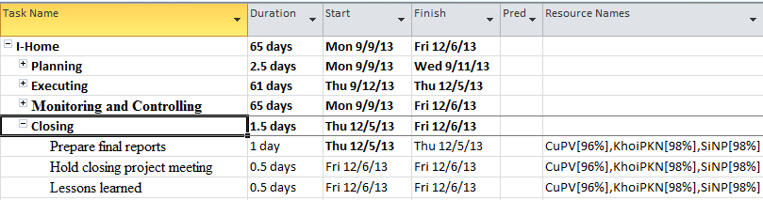

Figure : Closing phase

*For full version please reference to [ProjectManagementPlan.mpp] file.*

### Risk management

|  |  |  |  |  |  |  |
| --- | --- | --- | --- | --- | --- | --- |
| Risk | Description | Category | Root cause | Triggers | Potential Responses | Probability |
| Communication | Team members don’t understand each other | People | Member’s knowledge is difference | Misunderstanding, Delay project time | Daily meeting, face to face communication, | High |
| Hardware | Hardware implementation | Process | Designer don’t have experiment in creating circuit | Delay all of the project phase | Study about circuit.  Ask lecture to support.  Make hardware is the most priority task | Urgent |
| Sickness | Project members out of work because of sickness | People | Sickness | Delay tasks | Arrange backup plan, buffer workload | Medium |
| Material quality | ICs and boards don’t work as expected | Material | Depend on suppliers | Delay coding phase | Buy IC from TI | High |
| Material supplying | The supplier not supply the material on time  In project, material can be broken by wrong action of member in team. So need time to request from supplier and time for supplying | Material | Don’t have experiment on choosing the prestige supplier  Don’t have experiment on manipulation of device | Delay a phase of project | Ask supervisor for advice | Medium |
| Not meet deadline | Not meet the deadline that plan in project management plane | Process | A lot of root causes | Failed of project | Work overtime to meet deadline | Medium |
| Money | Lack of money for buying material | Budget | Shortage of money | Delay a phase of project | Loan from friends, investigator | Low |

Table : Risk management

## Coding Convention

Follow Microsoft Recommendation for C# Coding conventions (<http://msdn.microsoft.com/en-us/library/vstudio/ff926074.aspx>)

# Requirements Specifications

## User Requirement Specification

The system should meet the below needs:

### Monitoring status of the system

* Users can see their current home’s temperature/ gas level
* Users can monitor the status of electric devices in their home

### Create a scenario for an expected problems

* Users can be notified when unexpected problems were occurred (high temperature, gas leakage…).
* System can automatically react when unexpected problems occurred

### Remotely control

* Users can add, remove and manage all their devices everywhere (inside, outside of the place where end devices are set up).
* Users can send commands to their devices to perform some specific tasks.
* Users can update status of each device in the whole system.

### Schedule using time for each device

* Users can schedule using time of each device in the system

### Low energy consumption

* All devices in the system have to have a long battery-life (2 – 3 years).
* The energy for operating the system should be low as much as possible.

### High security

* Users have to be authenticated before using the system.
* A user can only manipulate their own devices (not others’ devices).
* Data and packet commands that exchanged by wireless connection should be protected in case of the stranger or hacker attack the system.

### Interoperability

* New end devices can be added to the system and interact with other ones regardless of manufacturing origin.

## Hardware Requirements

### Microcontroller

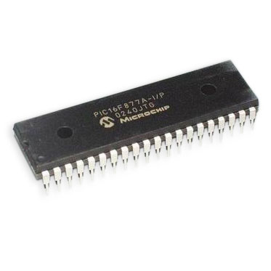

Figure : Microchip - PIC16F877A

* Power input: 3V to 5V DC
* Operating speed: DC – 4MHz to 20 MHz clock input
* Memory: 8K x 14 words of Flash Program Memory, 368 x 8 bytes of Data Memory (RAM), 256 x 8 bytes of EEPROM Data Memory
* Timer0: 8-bit timer/counter with 8-bit prescaler
* Timer1: 16-bit timer/counter with prescaler, can be incremented during Sleep via external crystal/clock
* Universal Synchronous Asynchronous Receiver Transmitter USART with 9-bit address detection
* 10-bit, 2-channel Analog-to-Digital Converter (A/D)
* In-Circuit Serial Programming™ (ICSP™)
* Single-supply 5V In-Circuit Serial Programming

### X-Bee

#### Coordinator

Figure : Digi - XBee Module

* Power input: 5V to 12V DC
* Management: HTTP/HTTPS web interface, Password access control, IP service port control, Optional secure enterprise management via Device Cloud
* Protocols: UDP/TCP, DHCP, SNMPv1
* Memory (User-available memory varies by firmware and OS version): 8 MB RAM, 4 MB Flash
* Ports: 1 RJ-45 port
* Physical Layer: 10/100Base-T
* Data Rate: 10/100 Mbps (auto-sensing)
* Mode Full or half duplex (auto-sensing)
* Ethernet Isolation: 1500VAC min per IEEE802.3/ANSI X3.263

#### Router

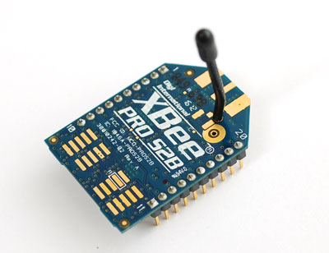

Figure : Digi - XBee Module Pro S2B

* Power input: 3V to 5V DC
* Indoor/Urban Range: up to 133 ft. (40 m)
* Outdoor RF line-of-sight Range: up to 400 ft. (120 m)
* RF Data Rate: 250,000 bps
* Data Throughput: up to 35000 bps
* Serial Interface Data Rate: 1200 bps - 1 Mbps
* Operating Current: 35 mA – 40 mA
* Idle Current: < 15mA
* Power-down Current: < 1uA
* Operating Frequency Band: ISM 2.4 GHz
* I/O Interface: 3.3V CMOS UART
* Supported Network Topologies: Point-to-point, Point-to-multipoint, Peer-to-peer, and Mesh
* Channels: 11 to 26
* Addressing Options: PAN ID and Addresses, Cluster IDs and Endpoints

### Temperature Sensor

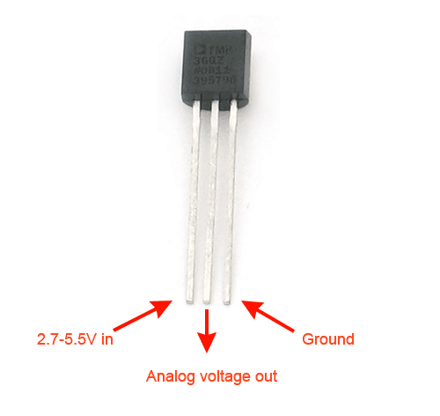

Figure : Temperature Sensor

* + Power input: 3V to 5V DC
* Calibrated directly in ˚ Celsius (Centigrade)
* Temperature range: −55 to +150˚C
* 0.5˚C accuracy guaranteed
* Suitable for remote applications

### Gas sensor

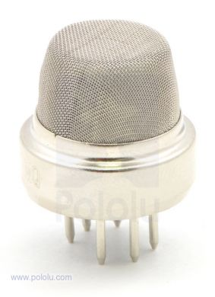

Figure : Gas Sensor

* Circuit voltage: 5V±0.1 DC
* Heating voltage: 5V±0.1 DC
* Heater resistance: 33Kohm±5%
* Operating Temp.: -20°C-50°C
* Oxygen concentration 21%(standard condition)Oxygen

### CC3000 module

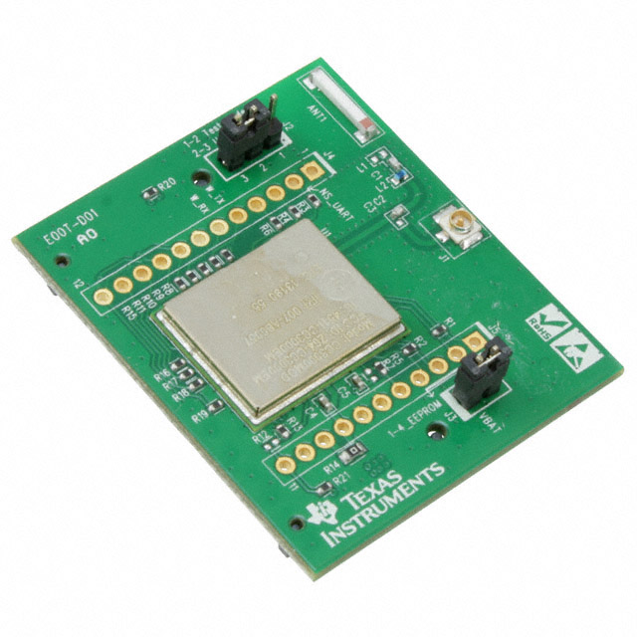

Figure : TI - CC3000 Module

* Wireless network processor: IEEE 802.11 b/g
* Embedded IPv4 TCP/IP stack
* TX power: +18.0 dBm at 11 Mbps, CCK
* RX sensitivity: –88 dBm, 8% PER, 11 Mbps
* Operating temperature: –20°C to 70°C

### MSP430 FR5739 board

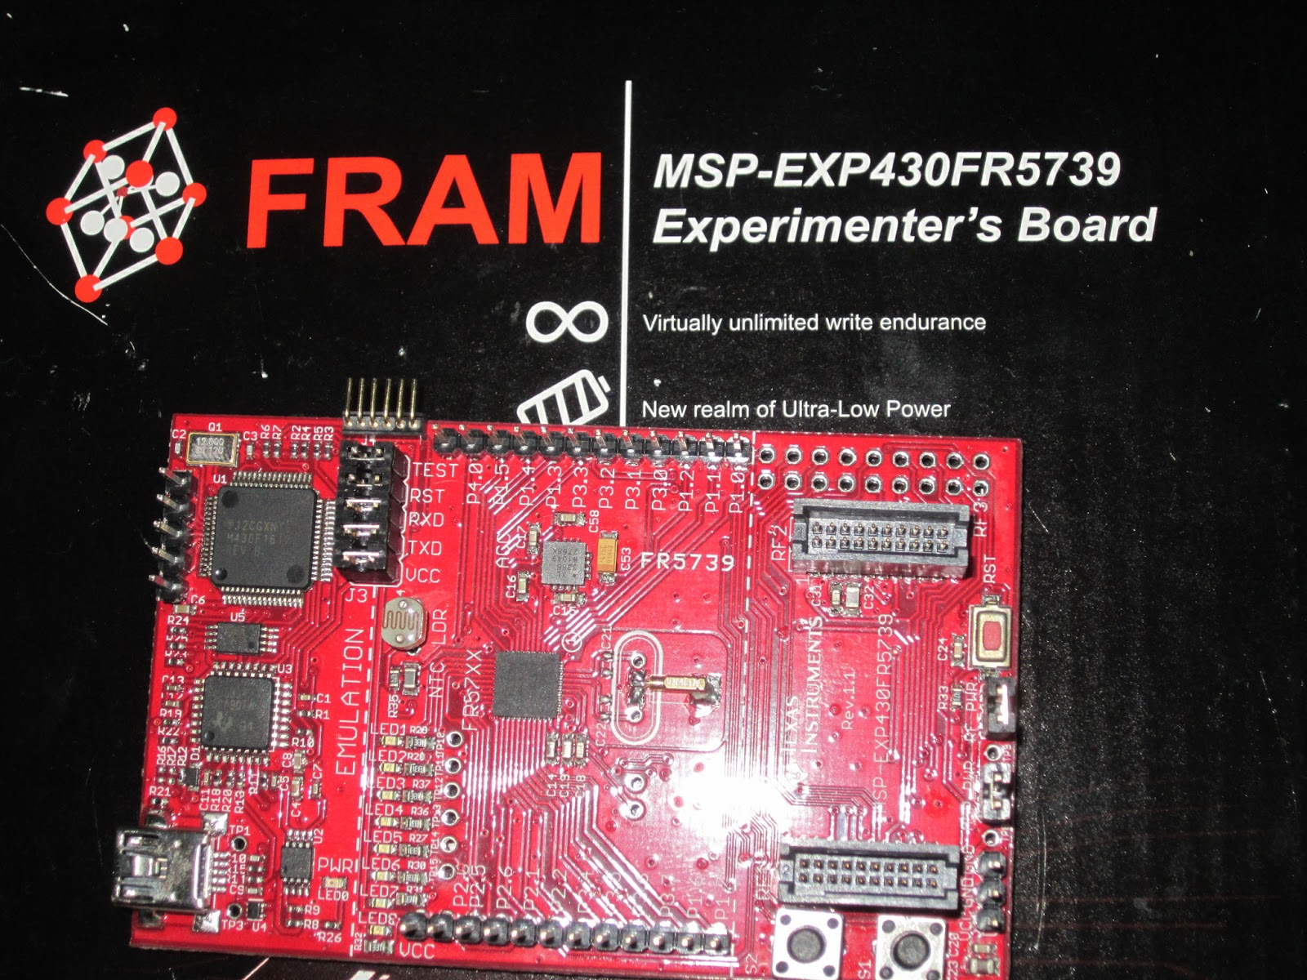

Figure : TI - MSP430 FR5739 board

* Circuit voltage : 2V – 3.6V
* Operating temperature: -40°C to 85°C
* Active Mode 81.4 µA/MHz
* Real-Time Clock (LPM3.5 With Crystal) 1.5 µA

## Functional Requirements

### System boundary

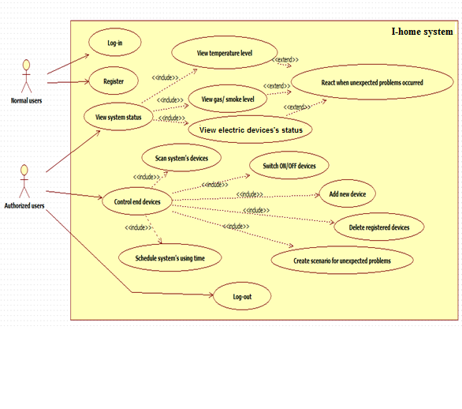

Figure : System boundary

### Normal users

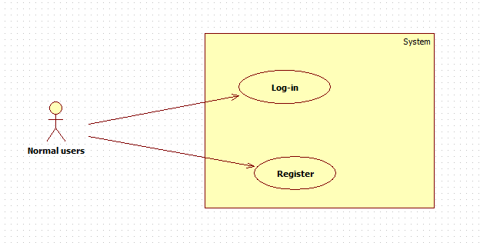

Figure : Use case - Normal users’ function

#### Log-in

|  |  |  |  |  |
| --- | --- | --- | --- | --- |
| USE CASE - Login SPECIFICATION | | | | |
| Use-case No. | UC001 | Use-case Version | | 1.0 |
| Use-case Name | Login | | | |
| Author | Nguyễn Phú Sĩ | | | |
| Date | Oct-4-2013 | Priority | Normal | |
| **Actor**:  Normal Users  **Summary:**  Users want to manage and control the system must login into the system  **Goal**:  Users can use the function in system after they log in.  **Triggers**:  End user accesses the main page then clicks the “Login” button.  **Preconditions**:  User must have a registered account in the system.  **Post Conditions**:  After logging in, user moves to main page with the information that he/she has logged in successfully (his/her username is showed on the website).  **Main Success Scenario**:   |  |  |  | | --- | --- | --- | | Step | Actor Action | System Response | | 1 | Access Home page | Display home page | | 2 | Fill “Username” and “Password” fields | Check the username and password validation. | | 3 | Clicks “Login” | Check conflict in database.  Log user into the system.  Navigate to main page with username is showed |   **Alternative Scenario:**   |  |  |  | | --- | --- | --- | | Step | Actor Action | System Response | | 1 | Access Home page | Display home page | | 2 | Clicks “Register” link | Shows the Register page |   **Exceptions**:   |  |  |  | | --- | --- | --- | | Step | Actor Action | System Response | | 1 | Access Home page | Display home page | | 2 | Not fill Username or Password fields | Display “Invalid username or password” message. |  |  |  |  | | --- | --- | --- | | Step | Actor Action | System Response | | 1 | Access Home page | Display home page | | 2 | Enter invalid (not registered username, wrong password) data. |  | | 3 | Click “Login” | Display “Invalid username or password” message. | | | | | |

Table : Use case - Login SPECIFICATION

#### Register

|  |  |  |  |  |
| --- | --- | --- | --- | --- |
| USE CASE - Register SPECIFICATION | | | | |
| Use-case No. | UC002 | Use-case Version | | 1.0 |
| Use-case Name | Register | | | |
| Author | Nguyễn Phú Sĩ | | | |
| Date | Oct-4-2013 | Priority | Normal | |
| **Actor**:  Normal Users  **Summary:**  A visitor wants to be “User” of the system. He/she must register with some information: email, password, etc…  **Goal**:  End user becomes “Authorized User” of the system  **Triggers**:  End user clicks the tab “Register”.  **Preconditions**:  Home page is displayed correctly.  **Post Conditions**:  End user becomes “Authorized User” of system. He/she can use all functions of “Authorized User” role.  **Main Success Scenario**:   |  |  |  | | --- | --- | --- | | Step | Actor Action | System Response | | 1 | User accesses Register page | Show all fields in form: email, password, retype password | | 2 | Fill mandatory fields and | Check validation. | | 3 | Click “Register” button | Check conflict then save data into database.  Display Register successfully message.  Navigate backs to login page. |   **Alternative Scenario:**   |  |  |  | | --- | --- | --- | | Step | Actor Action | System Response | | 1 | User accesses Register page | Show all fields in form: email, password, retype password | | 2 | Click other button or link | Navigate to specific page |   **Exceptions**:   |  |  |  | | --- | --- | --- | | Step | Actor Action | System Response | | 1 | User accesses Register page | Show all fields in form: email, password, retype password | | 2 | Not fill all required field or enters invalid data | Display warning message of invalid fields. | | | | | |
| **Description**:  User has to provide some information when register an account:   |  |  |  | | --- | --- | --- | | Field Name | Data Type and Constraints | Required | | Email | String (no Unicode)  Valid email format (for example: abc@gmail.com) | Yes | | Password | String (no Unicode)  (valid 4-35 character) | Yes | | Retype Password | String (no Unicode)  (valid 4-35 character)  Retype password must be same as password. | Yes | | | | | |

Table : Use case - Register SPECIFICATION

### Authorized Users – View system status

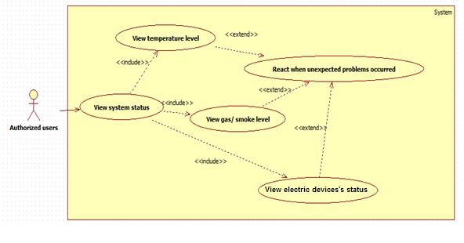

Table : Use case - Authorized Users view system status

#### View temperature level

|  |  |  |  |  |
| --- | --- | --- | --- | --- |
| USE CASE - View temperature level | | | | |
| Use-case No. | UC003 | Use-case Version | | 1.0 |
| Use-case Name | View temperature level | | | |
| Author | Nguyễn Phú Sĩ | | | |
| Date | Oct-4-2013 | Priority | Normal | |
| **Actor**:  Authorized Users  **Summary:**  Users can monitor temperature of the temperature sensor device via web server or mobile application.  **Goal**:  Users can see the temperature level every time they access the system.  **Triggers**:  After user logged to the system and click “Temperature Monitor” tab.  **Preconditions**:  User must have an account and login to system.  Temperature sensors must be connected to the system.  **Post Conditions**:  Information must be displayed in real time.    **Main Success Scenario**:   |  |  |  | | --- | --- | --- | | Step | Actor Action | System Response | | 1 | Access Temperature page | Navigate to Temperature page.  Display information about current temperature. | | 2 | Click “Refresh” button | Refresh the information. | | | | | |

Table : Use case - View temperature level

#### View gas/ smoke level

|  |  |  |  |  |
| --- | --- | --- | --- | --- |
| USE CASE - View gas/smoke level | | | | |
| Use-case No. | UC004 | Use-case Version | | 1.0 |
| Use-case Name | View gas/smoke level | | | |
| Author | Nguyễn Phú Sĩ | | | |
| Date | Oct-04-2013 | Priority | Normal | |
| **Actor**:  Authorized Users  **Summary:**  Users can monitor gas/smoke level of the gas/smoke sensor device via web server or mobile application.  **Goal**:  Users can see the gas/smoke level every time they access the system.  **Triggers**:  After user logged to the system and click “Gas/Smoke Monitor” tab.  **Preconditions**:  User must have an account and login to system.  Temperature sensors must be connected to the system.  **Post Conditions**:  Information must be displayed in real time.  **Main Success Scenario**:   |  |  |  | | --- | --- | --- | | Step | Actor Action | System Response | | 1 | Access Gas/Smoke page | Navigate to Gas/Smoke page.  Display information about current gas/smoke information. | | 2 | Click “Refresh” button | Refresh the information. | | | | | |

Table : Use case - View gas/smoke level

#### View devices’ status

|  |  |  |  |  |
| --- | --- | --- | --- | --- |
| USE CASE - View electric devices’ status | | | | |
| Use-case No. | UC005 | Use-case Version | | 1.0 |
| Use-case Name | View device’s status | | | |
| Author | Nguyễn Phú Sĩ | | | |
| Date | Oct-04-2013 | Priority | Normal | |
| **Actor**:  Authorized Users  **Summary:**  Users can monitor all electric devices’ status via web server or mobile application.  **Goal**:  Users can see a device is ON or OFF every time they access the system.  **Triggers**:  After user logged to the system and navigated to “Dashboard” tab  **Preconditions**:  User must have an account and login to system.  Electric devices must be connected to the system.  **Post Conditions**:  Information must be displayed in real time.  **Main Success Scenario**:   |  |  |  | | --- | --- | --- | | Step | Actor Action | System Response | | 1 | Access to web server | Navigate to Dashboard page.  Display all devices’ status. | | 2 | Click “Refresh” button | Refresh the information. | | | | | |

Table : Use case - View electric devices’ status

#### React to unexpected problems

|  |  |  |  |  |
| --- | --- | --- | --- | --- |
| USE CASE - React when unexpected problems occurred | | | | |
| Use-case No. | UC006 | Use-case Version | | 1.0 |
| Use-case Name | React when unexpected problems occurred | | | |
| Author | Nguyễn Phú Sĩ | | | |
| Date | Oct-4-2013 | Priority | Normal | |
| **Actor**:  N/A  **Summary:**  System will automatically process scenarios when problems occurred.  **Goal**:  System can process the scenarios correctly when problems occurred.  **Triggers**:  Temperature level raises higher then accepted level.  Gas/smoke level raises higher then accepted level.  **Preconditions**:  Temperature, gas/smoke sensor must be connected to the system.  **Post Conditions**:  These scenarios can be manually start/stop by users.  **Main Success Scenario**:   |  |  |  | | --- | --- | --- | | No | Trigger | System Response | | 1 | Temperature level raises higher then accepted level. | Start the scenario.(Ring alarm, turn on other devices) | | 2 | Gas/smoke level raises higher then accepted level. | Start the scenario.(Ring alarm, turn on other devices) | | | | | |

Table : Use case - React when unexpected problems occurred

### Authorized User – Control end devices

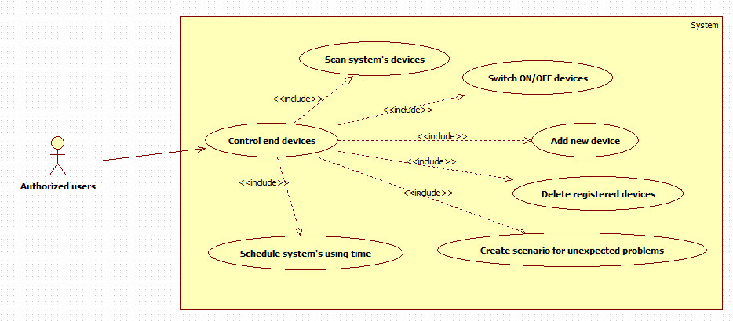

Figure : Use case - Authorized User control end devices

#### Scan system’s devices

|  |  |  |  |  |
| --- | --- | --- | --- | --- |
| USE CASE - Scan system devices | | | | |
| Use-case No. | UC007 | Use-case Version | | 1.0 |
| Use-case Name | Scan system’s devices | | | |
| Author | Phạm Văn Cự | | | |
| Date | Oct-4-2013 | Priority | High | |
| **Actor**:  Authorized users  **Summary:**  User can scan all devices of system which are discoverable  **Goal**:  All active devices are discoverable  **Triggers**:  Click “Scan device” button  **Preconditions**:  End devices must be activated  **Post Conditions**:  After discovered, end devices can be monitored  **Main Success Scenario**:   |  |  |  | | --- | --- | --- | | Step | Actor Action | System Response | | 1 | Click “Scan device” button at the Home page | Shows the processing dialogue “Scanning for device”  Disable “Scan device” button | | 2 | Waiting for results | Display all active devices of the system. Device’s information as below:   * MAC address * IP Address * Device Name * Device ID |   **Alternative Scenario:**   |  |  |  | | --- | --- | --- | | Step | Actor Action | System Response | | 1 | N/A | When cannot find any device, Display “There is no device, Please try again”  Enable “Scan device” button |   **Exceptions**:   |  |  |  | | --- | --- | --- | | Step | Actor Action | System Response | | 1 | N/A | Display “Time-out” message |   **Relationships**: N/A | | | | |

Table : Use case - Scan system devices

#### Add new device

|  |  |  |  |  |
| --- | --- | --- | --- | --- |
| USE CASE - Add a new device | | | | |
| Use-case No. | UC008 | Use-case Version | | 1.0 |
| Use-case Name | Add a new device | | | |
| Author | Phạm Văn Cự | | | |
| Date | Ocr-4-2013 | Priority | Normal | |
| **Actor**:  Authorized users  **Summary:**  User can add new device that was discovered  **Goal**:  Users can add a new device to the current system without any errors.  **Triggers**:  User click on “Add” button of a device  **Preconditions**:  End devices must be activated.  End devices was discovered by “Scan device” function  **Post Conditions**:  After add new device, the information of new device will display on user screen. And users can control this device.  **Main Success Scenario**:   |  |  |  | | --- | --- | --- | | Step | Actor Action | System Response | | 1 | User click on “Add” button of a device | Shows confirm dialog | | 2 | User confirmed “Add” a device | Display processing message “New device is adding to system” | | 3 | N/A | Display success message “New device has been added successfully”. Device’s information includes:   * MAC address * IP Address * Device name * Device ID |   **Alternative Scenario:**   |  |  |  | | --- | --- | --- | | Step | Actor Action | System Response | | 1 | When the device is not recognized automatically, click “Add Manually” button | Display 4 fields for user to add manually:   * MAC address * IP Address * Device name * Device ID | | 2 | User fill in the fields with valid information | Add the new device with provided information | | 3 | N/A | Display success message “New device has been added successfully”. Device’s information includes:   * MAC address * IP Address * Device name * Device ID |   **Exceptions**:   |  |  |  | | --- | --- | --- | | Step | Actor Action | System Response | | 1 | Same as Main Success Scenario. | | | 2 | If inputted device’s information was incorrect | Display message “Device not found. Please try again” | | 3 | N/A | Display “Time-out” message |   **Relationships**: N/A | | | | |

Table : Use case - Add a new device

#### Delete registered devices

|  |  |  |  |  |
| --- | --- | --- | --- | --- |
| USE CASE - Delete registered devices | | | | |
| Use-case No. | UC009 | Use-case Version | | 1.0 |
| Use-case Name | Delete registered devices | | | |
| Author | Phan Khắc Nguyên Khôi | | | |
| Date | Oct-4-2013 | Priority | Normal | |
| **Actor**:  Authorized users  **Summary:**  User can remove any registered device of the system  **Goal**:  Users can eliminate any unnecessary device from current system  **Triggers**:  Click on “Delete” button of any device  **Preconditions**:  There has at least one end device added to system and have X-BEE module connected.  **Post Conditions**:  After removing device, device is removed from system.  The device name and information of removed device will be removed on user screen.  **Main Success Scenario**:   |  |  |  | | --- | --- | --- | | Step | Actor Action | System Response | | 1 | Select a device | The device is selected. | | 2 | Click Delete button | A confirm dialogue is displayed and inform to the user continue delete or not with Yes and No button | | 3 | Click Yes button on confirm dialogue | The device is removed from system  Display successful message “A selected device is remove from system” |   **Alternative Scenario:**   |  |  |  | | --- | --- | --- | | Step | Actor Action | System Response | | 2 | Click No button | Return to the main screen. The status and information of device is the same as before. |   **Exceptions**:   |  |  |  | | --- | --- | --- | | Step | Actor Action | System Response | | 3 | N/A | Display message inform to user “Can’t delete device. Please check connection or device” |   **Relationships**: N/A | | | | |

Table : Use case - Delete registered devices

#### Switch ON/OFF devices

|  |  |  |  |  |
| --- | --- | --- | --- | --- |
| USE CASE - Switch ON/OFF devices | | | | |
| Use-case No. | UC010 | Use-case Version | | 1.0 |
| Use-case Name | Switch ON/OFF devices | | | |
| Author | Phan Khắc Nguyên Khôi | | | |
| Date | Oct-4-2013 | Priority | Normal | |
| **Actor**:  Authorized Users  **Summary:**  User can turn on/off devices that connected to the system via web server or mobile application.  **Goal**:  User can turn on/off devices correctly via web server or mobile application.  **Triggers**:  Click On/Off buttons of specific devices.  **Preconditions**:  User must have an account and logged to the system.  Device must be connected to the system.  **Post Conditions**:  N/A  **Main Success Scenario**:   |  |  |  | | --- | --- | --- | | Step | Actor Action | System Response | | 1 | Click On/Off button of specific device in Smart Plug page | -Turn on/off the device.  - Update on/off status to server | | | | | |

Table : Use case - Switch ON/OFF devices

#### Schedule system’s using time

|  |  |  |  |  |
| --- | --- | --- | --- | --- |
| USE CASE - Schedule system’s using time | | | | |
| Use-case No. | UC011 | Use-case Version | | 1.0 |
| Use-case Name | Schedule system’s using time | | | |
| Author | Phan Khắc Nguyên Khôi | | | |
| Date | Oct-4-2013 | Priority | Normal | |
| **Actor**:  Authorized users  **Summary:**  User can schedule using time of any device of systems  **Goal**:  Scheduled device is worked correctly  **Triggers**:  Click on “Schedule” button of any device  **Preconditions**:  There has at least one end device added to system and have X-BEE module connected.  **Post Conditions**:  Schedule can be modified by users  Device is worked correctly  **Main Success Scenario**:   |  |  |  | | --- | --- | --- | | Step | Actor Action | System Response | | 1 | Select a device | The device is selected. | | 2 | Click “Schedule” button | Display “Schedule detail” includes:  Start using time:  End using time: | | 3 | Input valid data | Confirm dialog is displayed to make sure user’s schedule is correct | | 4 | Users confirm the dialog | Display success message “Your schedule is created” |   **Alternative Scenario:**   |  |  |  | | --- | --- | --- | | Step | Actor Action | System Response | | 2 | Don’t input End using time | Schedule is created without ending time |   **Exceptions**:   |  |  |  | | --- | --- | --- | | Step | Actor Action | System Response | | 4 | N/A | Display message inform to user “Can’t create the schedule. Please check connection and your schedule” |   **Relationships**: N/A | | | | |

Table : Use case - Schedule system’s using time

#### Create scenario for unexpected problems

|  |  |  |  |  |
| --- | --- | --- | --- | --- |
| USE CASE - Create scenario for unexpected problems | | | | |
| Use-case No. | UC012 | Use-case Version | | 1.0 |
| Use-case Name | Create scenario for unexpected problems | | | |
| Author | Phan Khắc Nguyên Khôi | | | |
| Date | Oct-4-2013 | Priority | Normal | |
| **Actor**:  Authorized users  **Summary:**  Users can create scenarios of actions to proceed when a problems occur.  Such as turn on some devices in an order.  **Goal**:  Users can create a scenarios of action that work correctly.  **Triggers**:  User Click “Create Scenario” button.  **Preconditions**:  Necessary devices must be connected to the system.  **Post Conditions**:  Created scenario must work correctly.  **Main Success Scenario**:   |  |  |  | | --- | --- | --- | | Step | Actor Action | System Response | | 1 | Click “Add Scenario” button | Display “critical” dialog includes  Limit temperature  Limit gas/ smoke level  Limit consumed energy | | 2 | Input valid data | Display confirm screen to make sure user’s scenario is corrected | | 3 | Confirm the dialog | Display success message “Scenario is created”. |   **Alternative Scenario:**   |  |  |  | | --- | --- | --- | | Step | Actor Action | System Response | | 2 | Don’t input anything | Prompt user to input data | | 3 | Don’t confirm the dialog | Back to main screen |   **Exceptions**:   |  |  |  | | --- | --- | --- | | Step | Actor Action | System Response | | 3 | N/A | Display error message “Scenario can’t be created. Please check your connection and scenario” |   **Relationships**: N/A | | | | |

Table : Use case - Create scenario for unexpected problems

### Authorized User

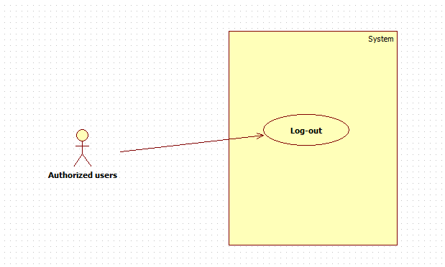

Figure : Use case - Authorized user logout

#### Log-out

|  |  |  |  |  |
| --- | --- | --- | --- | --- |
| USE CASE - Log out | | | | |
| Use-case No. | UC13 | Use-case Version | | 1.0 |
| Use-case Name | Log out | | | |
| Author | Phạm Văn Cự | | | |
| Date | Oct-4-2013 | Priority | Normal | |
| **Actor**:  Authorized Users  **Summary:**  Authorized Users can log out after using system  **Goal**:  Authorized Users can log out  **Triggers**:  Authorized Users clicks “Log out” link.  **Preconditions**:  None  **Post Conditions**:  Display a friendly message to user  **Main Success Scenario**:   |  |  |  | | --- | --- | --- | | Step | Actor Action | System Response | | 1 | Click “Log out ” link | Display a confirm message to make sure that users want to log out | | 2 | Confirm log out | Save user’s session information to log file  End user’s session  Display a message to user | | | | | |

Table : Use case - Logout

## Main flow

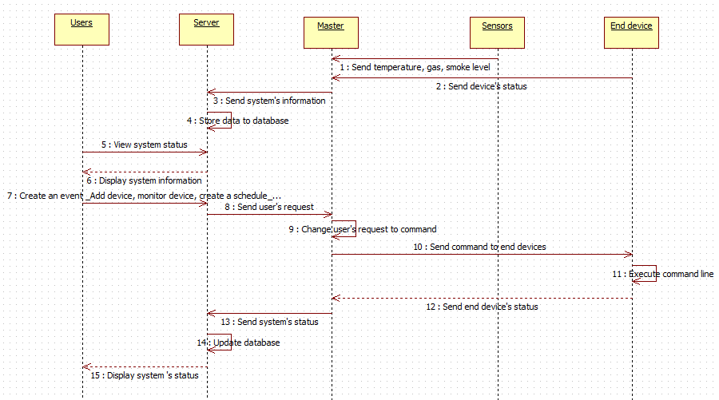

Figure : Sequence diagram - System main flow

## Non-functional Requirements

### Reliability

* System is expected to run continuously for years without errors (or in some cases recover by themselves if an error occurs).
* Ensure that when system starts a “mission”, it has a high probability of completing that mission without experiencing a failure.
* System can safely be shut down for repair, or another way to repair without stopping system.
* The system shall never crash or hang, other than as the result of a network error.
* Mean Time Between Failures (MTBF): The acceptable failure is once a year.
* Mean Time To Repair (MTTR): When the failure occurs, it should take at least time as possible to repair. The acceptable mean time for a particular failure must be least than 1 minute.

### Availability

* The server shall be working 24/7. When the system goes in under-maintenance, the page or application will display message “System is maintaining at the moment. Please check again later”

### Security

* Guarantee the data and application protection from being stolen and modified by encoding and decoding data.

### Maintainability

* All code shall be fully documented. All program files shall include comments concerning authorship and date of last change.
* The code shall be modular to permit future modifications.

### Portability

* The system shall be designed to control and run on Web platform, Android platform. Make sure that control device must be portable device as smartphone, tablet…
* X-Bee slave device can be easy to disconnect and reconnect to another end device
* Provided hardware can be plug-and-play

### Performance

This is the system’s performance characteristics:

* Capacity: 1 end user a time.
* Response time for a transaction:
* Average: 2 second
* Maximum: 7 seconds

# Software Design Description (SDD)

## Design Overview

This part provides for project’s stakeholders a general view of system which includes:

1. System architecture design which describes system’s model, system’s layers, layer’s component and the function of each layer.
2. The detailed description of components and the relationship between each component.
3. The detailed algorithms and pseudo code to implement of each component
4. User interface design which describes system’s screens and how users interact to systems. Each screen includes functions, types of input/ output and event handling.

## System Architecture Design

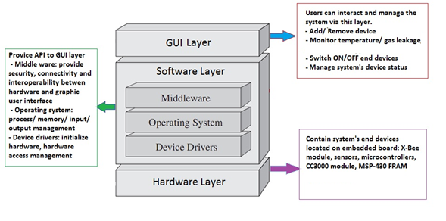

Figure : System Architecture Design

## Component Diagram

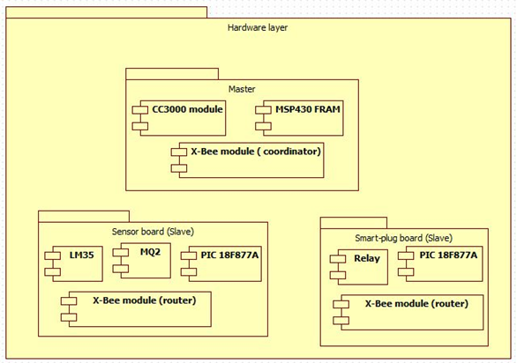

Figure : Component Diagram - Hardware layer

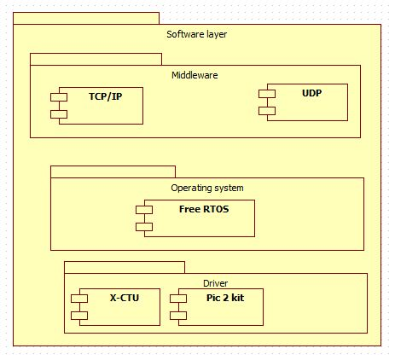

Figure : Component Diagram - Software layer

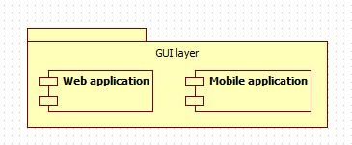

Figure : Component Diagram - GUI layer

## Detail Description of Components

1. **Hardware layer – Master module**

#### a. Overview

The Master module is implemented as a ZigBee to Wi-Fi Gateway.

A ZigBee to Wi-Fi Gateway is a physical device that manages communication, data processing, controls end-devices not only limitedly in a local ZigBee network but also widely through the internet.

*Master module is the combination of [CC3000 Wi-Fi module], [MSP-EXP430FR5739 Experiment Board] and [X-Bee coordinator].*

CC3000 module & MSP-EXP430FR5739 Experiment Board

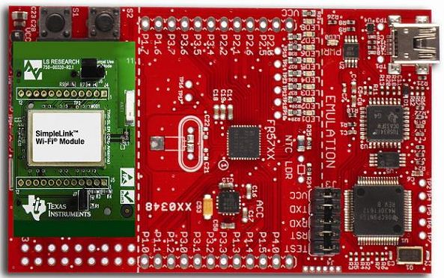

Figure : CC3000 module & MSP430 FRAM

**Description**

The CC3000 FRAM Evaluation Module Kit is a full turn-key TI Wi-Fi evaluation and demonstration tool for the MSP430 FRAM MCUs and TI's Simplelink Wi-Fi that includes all of the necessary hardware and software to get started quickly. SimpleLink™ CC3000 Wi-Fi is a self-contained wireless solution that simplifies the process of implementing Internet connectivity. SimpleLink Wi-Fi minimizes host microcontroller (MCU) software requirements making it the ideal solution for embedded applications using any low-cost/low-power MCU. The kit also allows users to take advantage of the new generation of MSP430 microcontroller devices with integrated Ferroelectric Random Access Memory (FRAM).

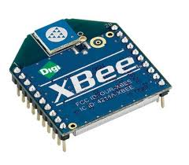X-Bee module – coordinator

Figure : X-Bee module – coordinator

**Description**

The technology defined by the [ZigBee specification](http://en.wikipedia.org/wiki/ZigBee_specification) is intended to be simpler and less expensive than other [WPANs](http://en.wikipedia.org/wiki/Wireless_personal_area_network), such as [Bluetooth](http://en.wikipedia.org/wiki/Bluetooth). X-Bee is targeted at [radio-frequency](http://en.wikipedia.org/wiki/Radio_frequency) (RF) applications that require a low data rate, long battery life, and secure networking.

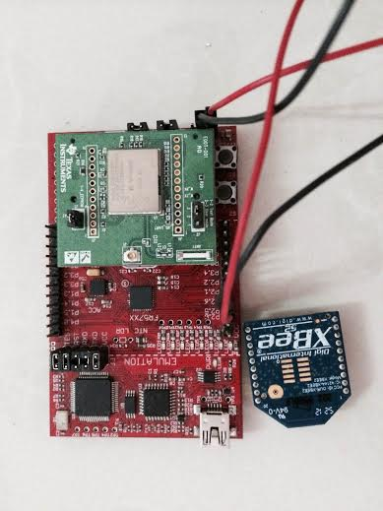

Figure : Master board

#### b. Detail

* CC3000 Wi-Fi module

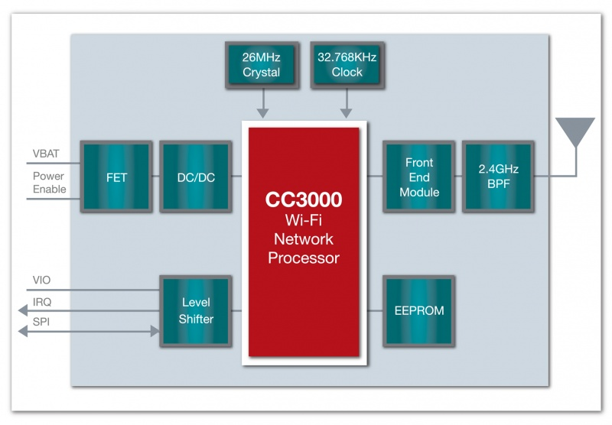

Figure : CC3000 Wi-fi Netword Processor

**CC3000 Specifications**

|  |  |
| --- | --- |
|  | **CC3000’s Characteristic** |
| Standards | 802.11 b/g, BSS Station |
| Wi-Fi Security Modes | WEP, WPA/WPA2 (AES and TKIP – Personal) |
| Embedded Wi-Fi | TCP/IP stack (IPv4 – DHCP client, DNS, mDNS, ARP),  Wi-Fi driver, security supplicant, Auto-calibrated radio |
| Required Code size | As low as 5KB Flash & 360B RAM |
| Host Interface | SPI at 16MHz |
| Power Modes | Active Mode (92mA typ RX current),  Shutdown Mode (<5uA) |
| Power Supply | 2.9V – 4.8V |
| I/O Voltage | 1.8V – 3.6V |
| Connections | 4 Sockets (UDP or TCP) |
| Throughput (TCP) | ~4 Mbps*  **Note** This was measured for CC3000, when combined with MSP430FR573 |

Table : CC3000 specifications

CC3000 Module provides user’s API which is organized into 4 different entities:

* WLAN APIs, which interact with the underlying entity that is responsible for 802.11 protocol implementation
* Network stacks APIs (Socket API), which interact with the embedded network stack. These APIs comply with the well-known Berkeley socket APIs and are easy to use.
* Embedded network application APIs (NetApp API), which interact with the embedded networking application delivered as a complementary part of the on-chip content. These include basic networking applications that the user can leverage (for example, ping utility and DNS).
* Nonvolatile memory APIs (NVMEM API), which configure the external CC3000 device EEPROM, where most of the configuration is store.

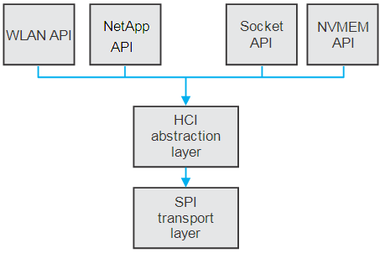

Figure : CC3000 Host Driver Module

CC3000 Module use SPI Protocol to Associate to Host processor MCU (MSP430FR5739) that is implemented in HCI layer and SPI layer.

*Brief describe about SPI Protocol (Serial Port Interface):*

The SPI is based on the five-line, master/slave communication model as shown in the following figure:

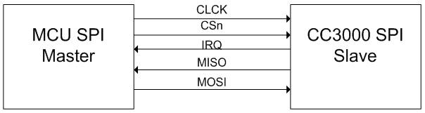

Figure : SPI Master-Slave Communication Model

|  |  |
| --- | --- |
| **I/O** | **Description** |
| CLCK | Provides a clock from master to slave |
| CSn | Active low signal from master to slave, indicate that the master wants to communicate to a slave |
| IRQ | Interrupt from slave to master |
| MISO | Data from slave to master (Master in Slave out) |
| MOSI | Data from master to slave (Master out Slave in) |

Table : SPI pin description

The MSP430FR5739 MCU is acting as the SPI master while the CC3000 Wi-Fi module is the SPI slave.

Data will be transmitted from master to slave and vice versa on every falling edge of the clock cycle. In addition, all data sent or received via SPI interface must be 16-bit aligned and defined in a specific frame.

* X-Bee module – coordinator

Xbee use ZigBee protocol which is an open standard built on the IEEE 802.15.4 MAC/PHY. As described before, there are three type of Xbee module: coordinator, router and end device. In this master module, Xbee module is used as a Xbee coordinator module.

The coordinator is responsible for creating a network – select the channel, PAN ID, security policy, and stack profile. After a network is created by the coordinator, new devices are allowed to join the network. Therefore, Each ZigBee network must have one coordinator.

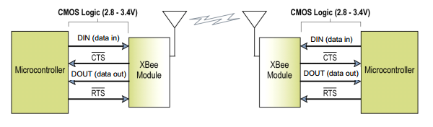

Figure : Xbee UART interface

Xbee communicates with a MCU through UART interface.

|  |  |
| --- | --- |
| **I/O** | **Description** |
| DIN (pin 3) | UART Data In |
| $\overline{CTS}$ (pin 12) | Clear-to-Send Flow Control |
| DOUT (pin 2) | UART Data Out |
| $\overline{RTS}$ (pin 16) | Request-to-Send Flow Control |

Table 21: UART pin description

* MSP-EXP430FR5739 Experiment Board

MSP-EXP430FR5739 Experiment Board is based on MSP430FR5739 microprocessor which supports UART interface and SPI interface. MSP430FR5739 is designed to work perfectly with CC3000 Wi-Fi module

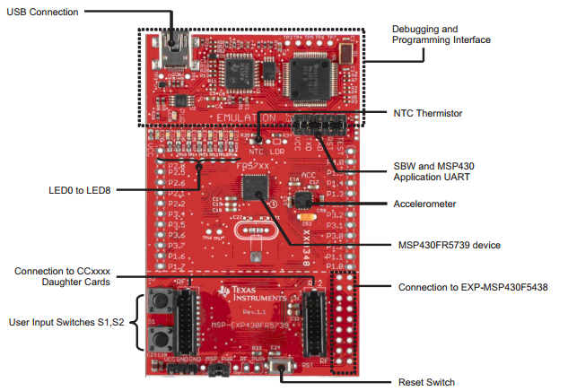

Figure : MSP-EXP430FR5739 Overview

MSP430FR5739 communicate with X-bee module through UART interface.

PIN connection is shown in a table below:

|  |  |
| --- | --- |
| **MSP430FR5739** | **X-bee module** |
| VCC | VCC |
| GND | GND |
| PIN 2.6 (RX) | PIN 2 (DOUT) |
| PIN 2.5 (TX) | PIN 3 (DIN) |

Table : PIN Connections

MSP430FR5739 communicate with CC3000 module through SPI interface.

This board is designed with 2 jumpers RF1 and RF2 to connect to CC3000 module easily.

#### c. Sequence diagram

* Received command from web server

|  |  |  |  |
| --- | --- | --- | --- |
| No | Command | Command frame | Description |
| 1 | Scan plug | **[‘1’]** | Discover all plugs module in network |
| 2 | Scan sensor | **[‘2’]** | Discover all sensors module in network |
| 3 | Set a scenario | **[‘3’][a][t][v][s]** | Create a scenario  .[a]: address of sensor module  .[t]: type of sensor,  [t]=‘1’: gas sensor  [t]=’0’: temperature sensor  .[v]: value of the limit  .[s]: status of 6 plugs to be set  ‘1’: on  ‘2’: off  ‘3’: ignore (do nothing) |
| 4 | Set plug status | **[‘4’][a][i][s]** | Turn on/off a plug  .[a]: address of plug module  .[i]: id of relay  .[s]: status |
| 5 | Get plug status | **[‘7’][a][i]** | Get current status of selected plugs  .[a]: address of plug module  .[i]: id of relay |
| 6 | Get temperature & gas | **[‘6’][a]** | Request current temperature and gas  .[a]: address of sensor module |

Table : Command list

* Get temperature and gas level

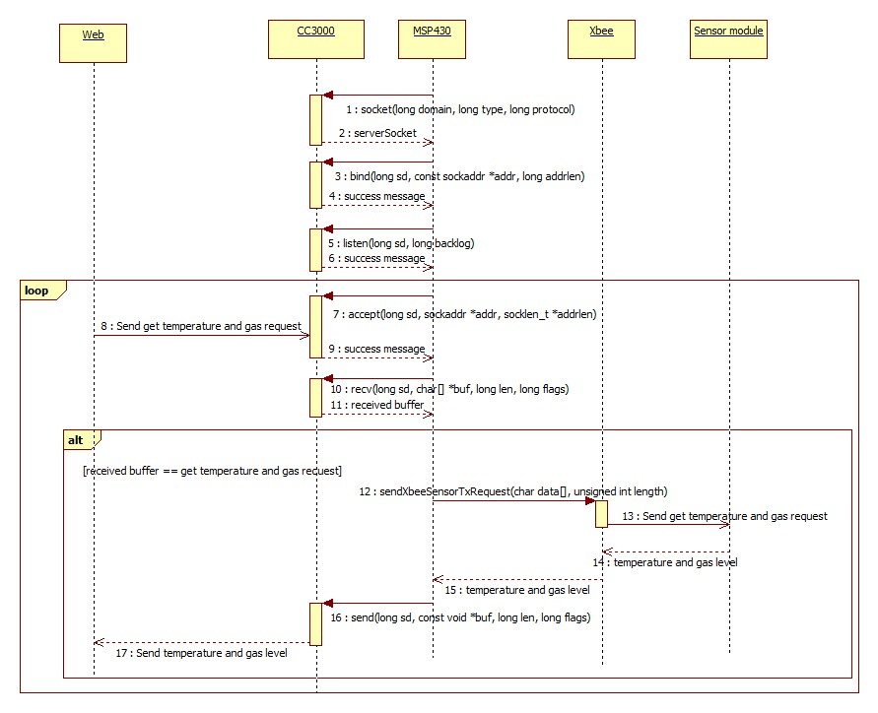

Figure : [Master module] Get temperature and gas level

Description

|  |  |  |  |
| --- | --- | --- | --- |
| **Step** | **Action** | **Description** | **Return** |
| 1 | socket() | Create a socket for communication | Socket handler |
| 2 | bind() | Bind a socket to a ip address and port, in order to listen to new connection | 0 on success,  -1 on failure |
| 3 | listen() | Enable listen for connections on a socket.  Wait for connections. | 0 on success,  -1 on failure |
| 4 | Send get temperature and gas request (from web) | Web’s socket connects to the listening socket, then sends a request to get current temperature and gas level.  Command code: ‘6’ | Current temperature and gas level |
| 5 | accept() | Accept the connection from web.  Output the address of the connected socket from web. | Socket handler |
| 6 | recv() | Read the received data from the socket.  Output an array of received data. | Number of received bytes |
| 7 | received buff == get temperature and gas request | Check if the Command code equal to ‘6’.  If true, continues processing.  Else, close connection, then listen to new connections | N/A |
| 8 | sendXbeeSensorTXRequest() | Send a [get temperature/gas request] to Xbee coordinator.  The request follows Xbee API frame standard. | Current temperature and gas level |
| 9 | Send get temperature and gas request (from Xbee coordinator) | Xbee coordinator send the request to the Sensor module | Current temperature and gas level |
| 10 | send() | Write data to socket.  Return current temperature and gas level to Web | Number of byte transmitted. |
| 11 | Close connection | Close current socket connection.  Start listening to new connections. | N/A |

Table : [Get temperature and gas level] function description

* Get plug’s status

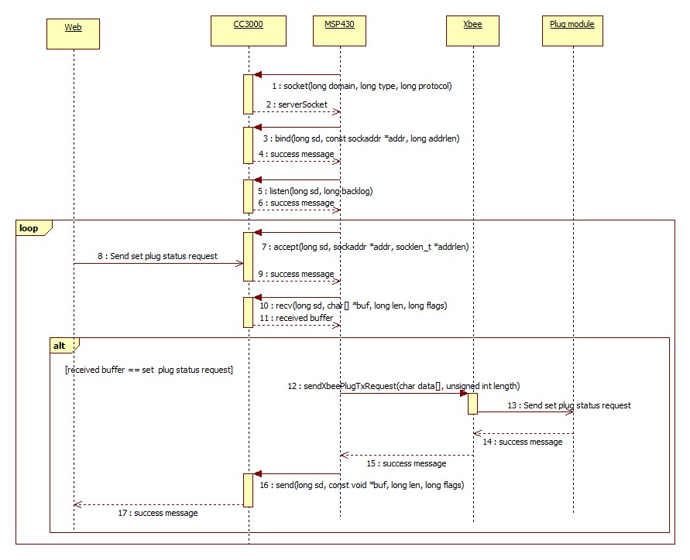

Figure : [Master module] Get plug’s status

Description

|  |  |  |  |
| --- | --- | --- | --- |
| **Step** | **Action** | **Description** | **Return** |
| 1 | socket() | Create a socket for communication | Socket handler |
| 2 | bind() | Bind a socket to a ip address and port, in order to listen to new connection | 0 on success,  -1 on failure |
| 3 | listen() | Enable listen for connections on a socket.  Wait for connections. | 0 on success,  -1 on failure |
| 4 | Send get plug status request (from web) | Web’s socket connects to the listening socket, then sends a request to get current temperature and gas level.  Command code: ‘7’ | Selected plug(s) status |
| 5 | accept() | Accept the connection from web.  Output the address of the connected socket from web. | Socket handler |
| 6 | recv() | Read the received data from the socket.  Output an array of received data. | Number of received bytes |
| 7 | received buff == get plug status request | Check if the Command code equal to ‘7’.  If true, continues processing.  Else, close connection, then listen to new connections | N/A |
| 8 | sendXbeePlugTXRequest() | Send a [get plug status request] to Xbee coordinator.  The request follows Xbee API frame standard. | Selected plug(s) status |
| 9 | Send get plug status request (from Xbee coordinator) | Xbee coordinator send the request to the Plug module | Selected plug(s) status |
| 10 | send() | Write data to socket.  Return selected plug(s) status to Web | Number of byte transmitted. |
| 11 | Close connection | Close current socket connection.  Start listening to new connections. | N/A |

Table : [Get plug's status] function description

* Control plug



Figure : [Master module] Control plug

Description

|  |  |  |  |
| --- | --- | --- | --- |
| **Step** | **Action** | **Description** | **Return** |
| 1 | socket() | Create a socket for communication | Socket handler |
| 2 | bind() | Bind a socket to a ip address and port, in order to listen to new connection | 0 on success,  -1 on failure |
| 3 | listen() | Enable listen for connections on a socket.  Wait for connections. | 0 on success,  -1 on failure |
| 4 | Send set plug status request (from web) | Web’s socket connects to the listening socket, then sends a request to get current temperature and gas level.  Command code: ‘4’ | 1 on success,  0 on failure |
| 5 | accept() | Accept the connection from web.  Output the address of the connected socket from web. | Socket handler |
| 6 | recv() | Read the received data from the socket.  Output an array of received data. | Number of received bytes |
| 7 | received buff == set plug status request | Check if the Command code equal to ‘4’.  If true, continues processing.  Else, close connection, then listen to new connections | N/A |
| 8 | sendXbeePlugTXRequest() | Send a [set plug status request] to Xbee coordinator.  The request follows Xbee API frame standard. | 1 on success,  0 on failure |
| 9 | Send set plug status request (from Xbee coordinator) | Xbee coordinator send the request to the Plug module | 1 on success,  0 on failure |
| 10 | send() | Write data to socket.  Return 1 on success,  0 on failure | Number of byte transmitted. |
| 11 | Close connection | Close current socket connection.  Start listening to new connections. | N/A |

Table : [Control plug] function description

* Set scenario

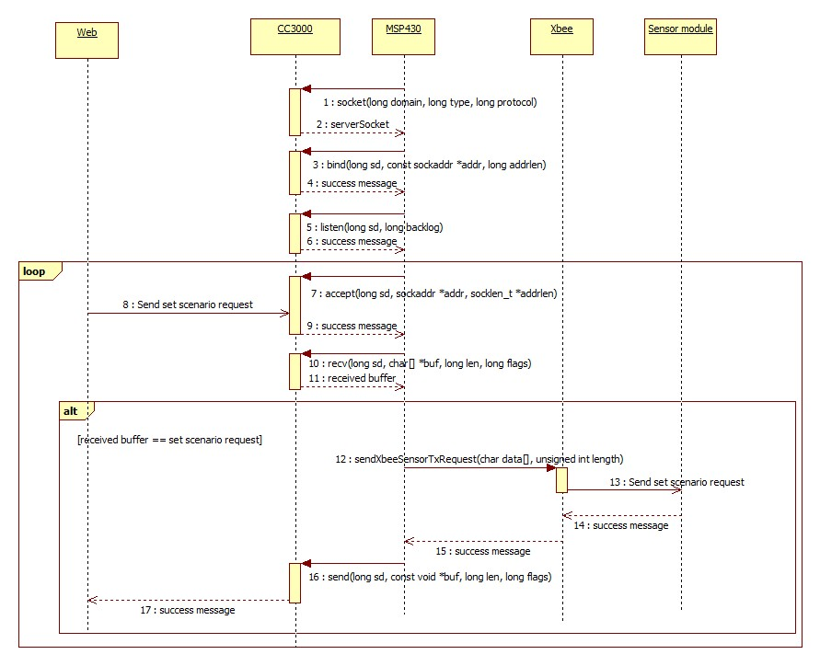

Figure : [Master module] Set scenario

Description

|  |  |  |  |
| --- | --- | --- | --- |
| **Step** | **Action** | **Description** | **Return** |
| 1 | socket() | Create a socket for communication | Socket handler |
| 2 | bind() | Bind a socket to a ip address and port, in order to listen to new connection | 0 on success,  -1 on failure |
| 3 | listen() | Enable listen for connections on a socket.  Wait for connections. | 0 on success,  -1 on failure |
| 4 | Send set scenario request (from web) | Web’s socket connects to the listening socket, then sends a request to get current temperature and gas level.  Command code: ‘3’ | 1 on success,  0 on failure |
| 5 | accept() | Accept the connection from web.  Output the address of the connected socket from web. | Socket handler |
| 6 | recv() | Read the received data from the socket.  Output an array of received data. | Number of received bytes |
| 7 | received buff == set scenario request | Check if the Command code equal to ‘3’.  If true, continues processing.  Else, close connection, then listen to new connections | N/A |
| 8 | sendXbeeSensorTXRequest() | Send a [set scenario request] to Xbee coordinator.  The request follows Xbee API frame standard. | 1 on success,  0 on failure |
| 9 | Send set scenario request (from Xbee coordinator) | Xbee coordinator send the request to the Sensor module | 1 on success,  0 on failure |
| 10 | send() | Write data to socket.  Return 1 on success,  0 on failure to Web | Number of byte transmitted. |
| 11 | Close connection | Close current socket connection.  Start listening to new connections. | N/A |

Table : [Create scenario] function description

* Scan plug

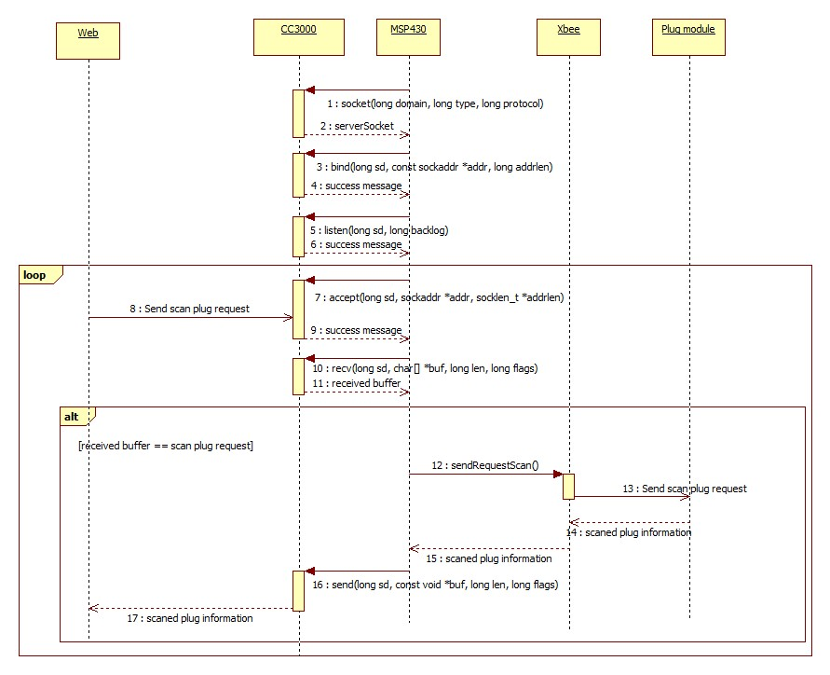

Figure : [Master module] Scan Plug

Description

|  |  |  |  |
| --- | --- | --- | --- |
| **Step** | **Action** | **Description** | **Return** |
| 1 | socket() | Create a socket for communication | Socket handler |
| 2 | bind() | Bind a socket to a ip address and port, in order to listen to new connection | 0 on success,  -1 on failure |
| 3 | listen() | Enable listen for connections on a socket.  Wait for connections. | 0 on success,  -1 on failure |
| 4 | Send scan plug request (from web) | Web’s socket connects to the listening socket, then sends a request to get current temperature and gas level.  Command code: ‘1’ | Scanned plugs information(Mac address) |
| 5 | accept() | Accept the connection from web.  Output the address of the connected socket from web. | Socket handler |
| 6 | recv() | Read the received data from the socket.  Output an array of received data. | Number of received bytes |
| 7 | received buff == scan plug request | Check if the Command code equal to ‘1’.  If true, continues processing.  Else, close connection, then listen to new connections | N/A |
| 8 | sendRequestScan() | Send a [scan plug request] to Xbee coordinator.  The request follows Xbee API frame standard. | Scanned plugs information(Mac address) |
| 9 | Send scan plug request (from Xbee coordinator) | Xbee coordinator send the request to the Plug module | Scanned plugs information(Mac address) |
| 10 | send() | Write data to socket.  Return scanned plugs information(Mac address) to Web | Number of byte transmitted. |
| 11 | Close connection | Close current socket connection.  Start listening to new connections. | N/A |

Table : [Scan plug] function description

* Scan sensor

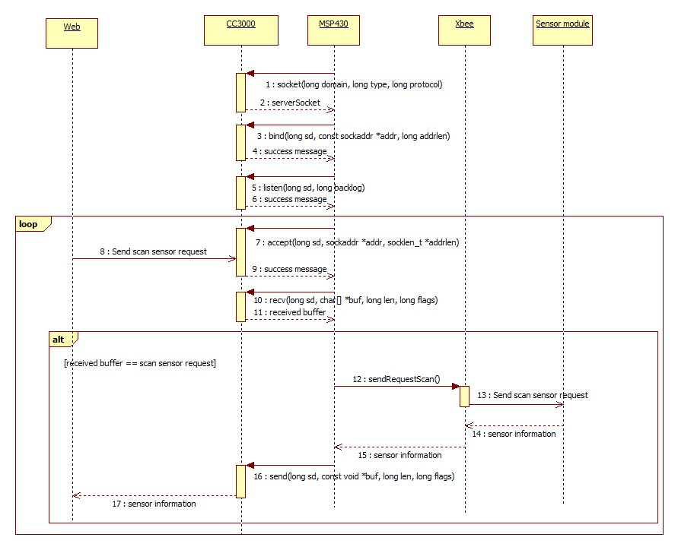

Figure : [Master module] Scan sensor

Description

|  |  |  |  |
| --- | --- | --- | --- |
| **Step** | **Action** | **Description** | **Return** |
| 1 | socket() | Create a socket for communication | Socket handler |
| 2 | bind() | Bind a socket to a ip address and port, in order to listen to new connection | 0 on success,  -1 on failure |
| 3 | listen() | Enable listen for connections on a socket.  Wait for connections. | 0 on success,  -1 on failure |
| 4 | Send scan sensor request (from web) | Web’s socket connects to the listening socket, then sends a request to get current temperature and gas level.  Command code: ‘2’ | Scanned sensor information(Mac address) |
| 5 | accept() | Accept the connection from web.  Output the address of the connected socket from web. | Socket handler |
| 6 | recv() | Read the received data from the socket.  Output an array of received data. | Number of received bytes |
| 7 | received buff == scan sensor request | Check if the Command code equal to ‘2’.  If true, continues processing.  Else, close connection, then listen to new connections | N/A |
| 8 | sendRequestScan() | Send a [scan sensor request] to Xbee coordinator.  The request follows Xbee API frame standard. | Scanned sensors information(Mac address) |
| 9 | Send scan sensor request (from Xbee coordinator) | Xbee coordinator send the request to the Sensor module | Scanned sensors information(Mac address) |
| 10 | send() | Write data to socket.  Return scanned sensors information(Mac address) to Web | Number of byte transmitted. |
| 11 | Close connection | Close current socket connection.  Start listening to new connections. | N/A |

Table : [Scan sensor] function description.

1. **Hardware layer – Sensor board**

#### a. Overview

*Sensor module is the combination of [PIC 16F877A], [LM35] temperature sensor, [MQ2] gas sensor, [Buzzer] and [X-Bee router] module.*

**PIC micro controller (16F877A)**



Figure : PIC 16F877A

Description

PIC is a family of [modified Harvard architecture](http://en.wikipedia.org/wiki/Modified_Harvard_architecture) [microcontrollers](http://en.wikipedia.org/wiki/Microcontroller) made by [Microchip Technology](http://en.wikipedia.org/wiki/Microchip_Technology), originally developed by [General Instrument](http://en.wikipedia.org/wiki/General_Instrument)'s Microelectronics Division. The name PIC initially referred to "Peripheral Interface Controller”.

PICs are popular with both industrial developers and hobbyists alike due to their low cost, wide availability, large user base, extensive collection of application notes, availability of low cost or free development tools, and serial programming (and re-programming with flash memory) capability. They are also commonly used in educational programming as they often come with the easy to use 'pic logicator' software.

**LM35 (Temperature sensor)**



Figure : LM35 temperature sensor

Description

The LM35 series are precision integrated-circuit temperature sensors, with an output voltage linearly proportional to the Centigrade temperature. Thus theLM35 has an advantage over linear temperature sensors calibrated in ° Kelvin, as the user is not required to subtract a large constant voltage from the output to obtain convenient Centigrade scaling.

**MQ2 (Gas/ Smoke sensor)**



Figure : MQ2 gas sensor

Description

The MQ series of gas sensors use a small heater inside with an electro-chemical sensor. They are sensitive for a range of gasses and are used indoors at room temperature. They can be calibrated more or less (see the section about "Load-resistor" and "Burn-in") but a known concentration of the measured gas or gasses is needed for that.

**Buzzer**

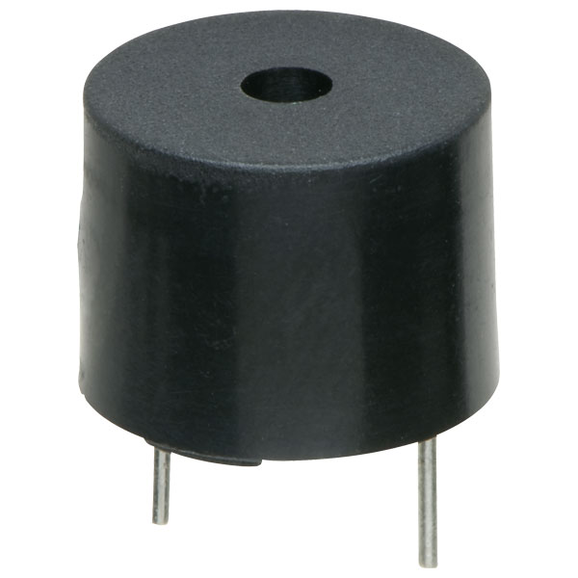

Figure : Buzzer

Description

Buzzer is used for making beeps, tones and alerts. This one is petite but loud! Drive it with 3-30V peak-to-peak square wave. For using, connect one pin to ground (either one) and the other pin to a square wave out from a timer or microcontroller. For the loudest tones, stay around 4 KHz, but works quite well from 2KHz to 10KHz. For extra loudness, you can connect both pins to a microcontroller and swap which pin is high or low ('differential drive') for double the volume.

**X-Bee module – router**

**

Figure : X-bee router module

Description

The same specification to X-Bee – coordinator module but this module is configured differently to provide the specific function.

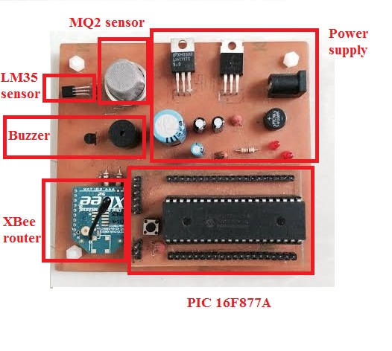

Figure : Sensor board

#### b. Detail

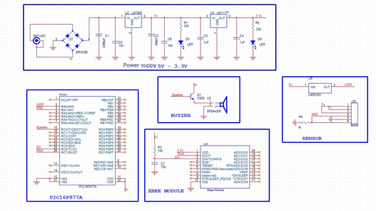

Figure : Schematic of Sensor Module

* [Power supply] module

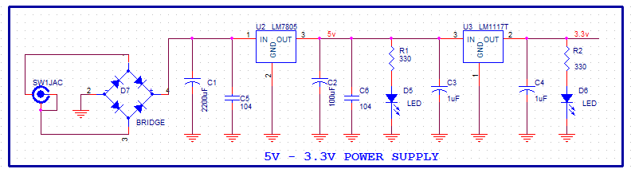

Figure : [Sensor board] power supply schematic

This module provides power to [XBEE MODULE], PIC 16F877A, LM35 sensor, MQ2 sensor and Buzzer. [XBEE MODULE] consumes 3.3v power while PIC 16F877A and sensors consume 5v power, so [Power supply] module must output 3.3v and 5v power. If D6 LED is ON, there is a 3.3v outputted power. And it’s 5V when LED D6 is ON. Module’s inputted power is 12v.

Power supply module provides power to [sensor board]

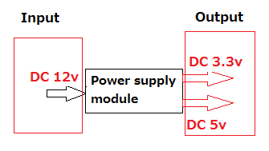

Figure : Power supply module

* [Sensor] module

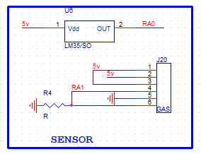

Figure : [Sensor board] sensor module schematic

[Sensor] module connect to PIC 16F877A by ADC mode. Sensor’s data (environment’s temperature/ gas level) is analog signal.

Sensor module measures current environment’s temperature/ gas level.

* [Buzzer] module

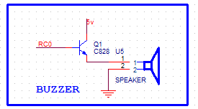

Figure : [Sensor board] buzzer schematic

[Buzzer] module connect to RC0 (pin 15) of [PIC 16F877A] module to receive control signal. If control signal is “1”, buzzer will play a sound. If control signal is “0”, buzzle will play no sound.

Figure : Buzzer Module

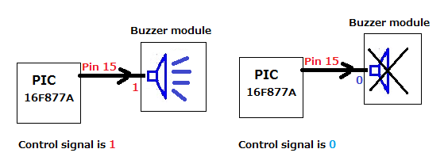Buzzer module plays a sound base on [PIC 16F877A]’s instruction

* [XBEE] module

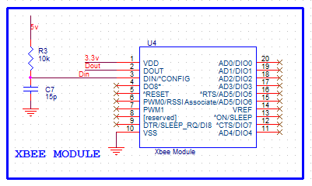

Figure : [Sensor board] XBee module schematic

[XBEE] module uses power from [power supply] module via pin 1 and pin 10. XBEE’s pin 2(Dout) is connected to pin 26 (RX) of PIC 16F877A. XBEE’s pin 3(Din) is connected to pin 25 (TX) of PIC 16F877A.

XBEE module is used to transfer data between [PIC 16F877A] module and XBee network via UART standard.

* PIC16F877A

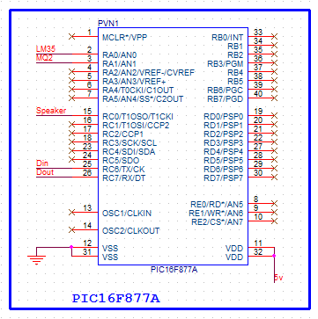

Figure : [Sensor board] PIC16F 877A module schematic

[PIC16F877A] works as an controller, which reads data from censor, receives data from XBEE module and put processed data to XBEE, generate command to control the [Plug module] and control buzzer to make sound or not.

#### c. Sequence diagram

* Get current environment’s temperature

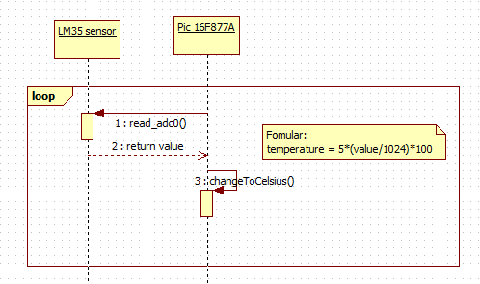

Figure : [Sensor module] Get current environment’s temperature

|  |  |  |  |
| --- | --- | --- | --- |
| **Step** | **Action** | **Description** | **Return** |
| 1 | read_adc0() | Read current analog values of RA0 port | A values from 0 to 1023 |
| 2 | changeToCelsius () | Convert measured analog values to Celsius degree | Current temperature in Celsius degree (from 0 to 500) |

Table : [Get current environment's temperature] function description

* Get current environment’s gas level

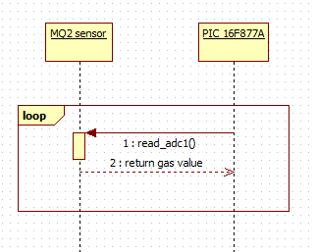

Figure : [Sensor module] Get current environment’s gas level

|  |  |  |  |
| --- | --- | --- | --- |
| **Step** | **Action** | **Description** | **Return** |
| 1 | read_adc1() | Read current analog values of RA1 port | Current environment gas level |

Table : [Get current environment's temperature] function description

* Send current temperature and gas level

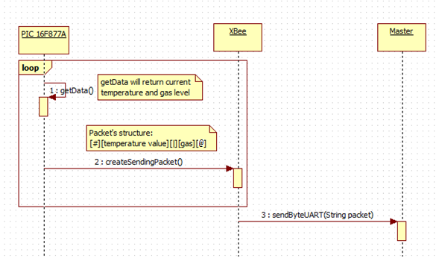

Figure : [Sensor module] Send current temperature and gas level

|  |  |  |  |
| --- | --- | --- | --- |
| **Step** | **Action** | **Description** | **Return** |
| 1 | getData() | MCU get current environment temperature and gas level | Temperature in Celsius degree and gas level |
| 2 | createSendingPacket () | Create a data string that contains necessary information to send to master. | Data string with below structure:  [**#**][**temperature**][**|**][**gas level**][**@**] |
| 3 | sendByteUART(String packet) | Send prepared data string to master | None |

Table : [Send current temperature and gas level] function description

* Set gas’s warning value

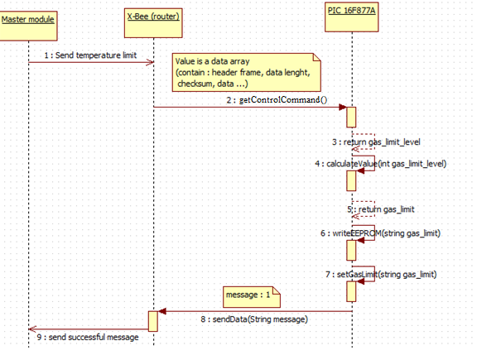

Figure : [Sensor module] Set gas’s warning value

|  |  |  |  |
| --- | --- | --- | --- |
| **Step** | **Action** | **Description** | **Return** |
| 1 | getControlCommand() | MCU get command and data which were sent from master | Gas’s limit level (1 or 2 or 3) |
| 2 | calculateValue(int gas_limit_level) | Calculate limit values based on received level | Gas’s limit value |
| 3 | writeEEPROM(String gas_limit) | Save gas’s limit value to EEPROM to prevent losing data in case of losing power | None |
| 4 | setGasLimit(String gas_limit) | Update limit values by the new values | None |
| 5 | sendData(String message) | Send a message with below structure to send to master module :  “1” | None |

Table : [Set gas’s warning value] function description

* Set temperature’s warning value

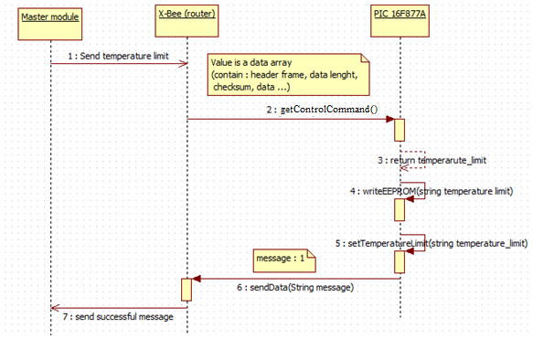

Figure : [Sensor module] Set temperature’s warning value

|  |  |  |  |
| --- | --- | --- | --- |
| **Step** | **Action** | **Description** | **Return** |
| 1 | getControlCommand() | MCU get command and data which were sent from master | Temperature limit in Celsius degree |
| 2 | writeEEPROM(String temperature_limit) | Save temperature ‘s limit value to EEPROM to prevent losing data in case of losing power | None |
| 3 | setTemperatureLimit(String temperature_limit) | Update limit values by the new values | None |
| 4 | sendData(String message) | Send a message with below structure to send to master module :  “1” | None |

Table : [Set temperature’s warning value] function description

* Control to Plug module

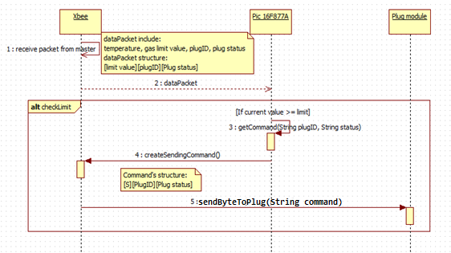

Figure : [Sensor module] Control Plug module

|  |  |  |  |
| --- | --- | --- | --- |
| **Step** | **Action** | **Description** | **Return** |
| 1 | Receive packet from master | The control packet includes the scenario that user was created before. | Data packet includes: limit values (gas or temperature), Plug ID, Plug status |
| 2 | checkLimit() | Check whether current values are more than the limit that received from master | True or False |
| 3 | getCommand(String plugID, String status ) | Get the content of scenario which user set before | None |
| 4 | createSendingPacket () | Create a data string that contains necessary information to send to plug module. | Data string with below structure:  [**S**][**Plug ID**[**Plug status**] |
| 5 | sendByteToPlug(String command) | Send prepared command string to plug module | None |

Table : [Control plug module] function description

1. **Hardware layer – Plug board**

#### a. Overview

*Plug module is the combination of [Relay], [Button], [PIC 16F877A] and [X-Bee router] module.*

*[PIC 16F877A] and [X-Bee router] is the same as Sensor module*

**Button**

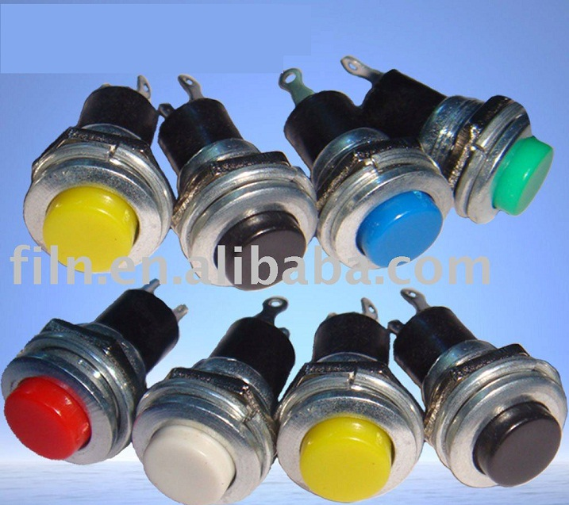

Figure : Buttons of Plug Module

Description

A push-button (also spelled pushbutton) or simply button is a simple [switch](http://en.wikipedia.org/wiki/Switch) mechanism for controlling some aspect of a [machine](http://en.wikipedia.org/wiki/Machine) or a [process](http://en.wikipedia.org/wiki/Process_(engineering)). Buttons are typically made out of hard material, usually [plastic](http://en.wikipedia.org/wiki/Plastic) or [metal](http://en.wikipedia.org/wiki/Metal). The surface is usually flat or shaped to accommodate the human finger or hand, so as to be easily depressed or pushed. Buttons are most often [biased switches](http://en.wikipedia.org/wiki/Switch#Biased_switches), though even many un-biased buttons (due to their physical nature) require a [spring](http://en.wikipedia.org/wiki/Spring_(device)) to return to their un-pushed state. Different people use different terms for the "pushing" of the button, such as press, depress, mash, and punch.

**Relay**

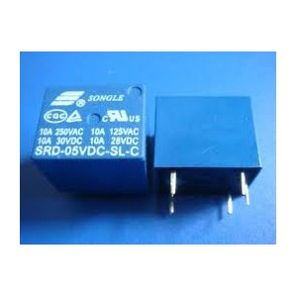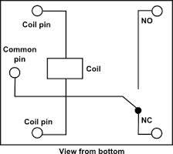

Figure : Relay Schematic

Figure : Relay picture

Description

Relays are switches that open and close circuits electromechanically or electronically. Relays control one electrical circuit by opening and closing contacts in another circuit. As relay diagrams show, when a relay contact is normally open (NO), there is an open contact when the relay is not energized. When a relay contact is Normally Closed (NC), there is a closed contact when the relay is not energized. In either case, applying electrical current to the contacts will change their state. Relays are generally used to switch smaller currents in a control circuit and do not usually control power consuming devices except for small motors and Solenoids that draw low amps. Nonetheless, relays can "control" larger voltages and amperes by having an amplifying effect because a small voltage applied to a relays coil can result in a large voltage being switched by the contacts.

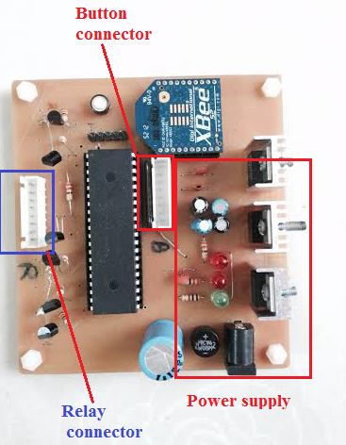

Figure : Plug control board

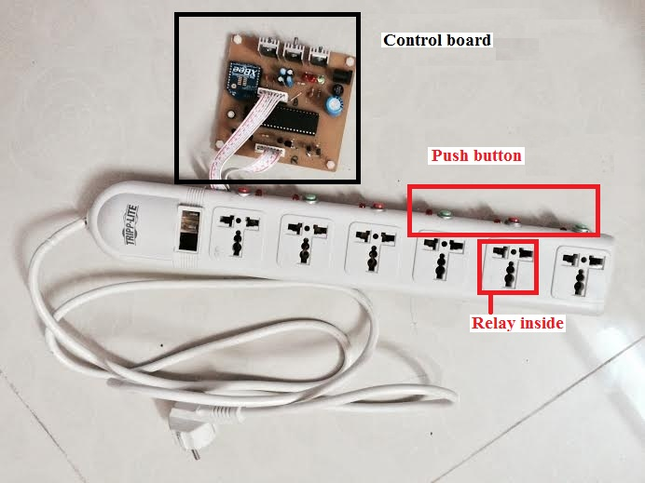

Figure : Plug board

#### b. Detail

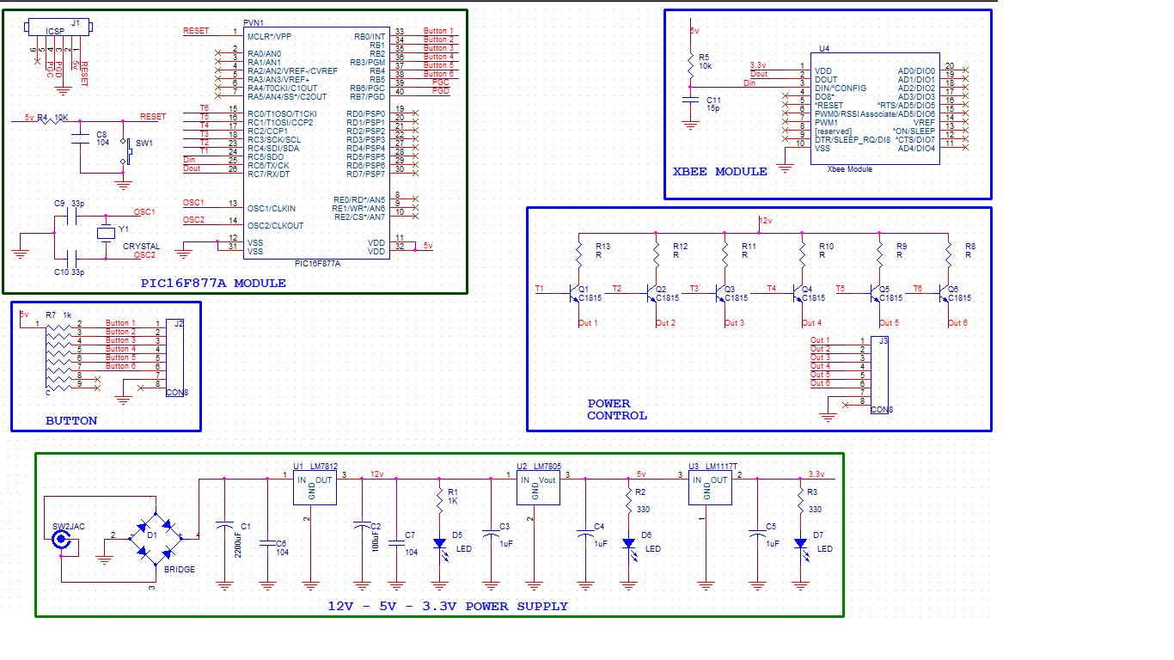

Figure : Plug board schematic

* Relay

This plug module contains 6 relays, which are used to switch on/off 6 plugs of the module.

These relays use 12V power supply. They are controlled by Pin RC0 – RC5 of the PIC16F877A MCU. (Set to turn on and clear to turn off).

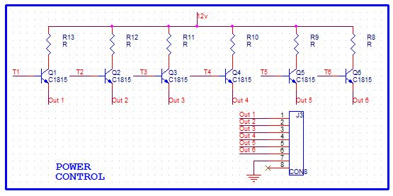

Figure : [Plug board] Relay schematic

* Button

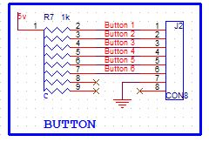

Figure : [Plug board] Button schematic

The plug module also contains 6 physical buttons to control the relays manually.

Whenever a button is pushed, a correlated relay will be toggled.

The buttons are connected to 6 input pin of PIC16F877A MCU (RB0 – RB5).

#### c. Sequence diagram

* Received command from other modules

|  |  |  |  |
| --- | --- | --- | --- |
| No | Command | Command frame | Description |
| 1 | Get plug status | **[‘G’][id]** | . [id]: from 1 to 6, get status of plug [id].  . [id]: 0, get statuses of all plugs |
| 2 | Set plug stats | **[‘S’][id][status]** | [id]: from 1 to 6, select plug [id]  [status]: 0 to turn off, 1 to turn on |

Table : Command list

* Switch ON/OFF manually

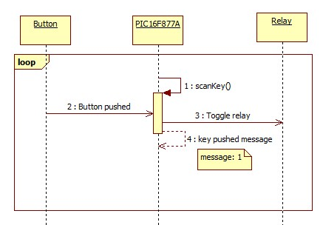

Figure : [Plug module] Switch ON/OFF manually

|  |  |  |  |
| --- | --- | --- | --- |
| **Step** | **Action** | **Description** | **Return** |
| 1 | scanKey() | Repeatedly scan if there is any pushed button. | If any key is pushed, return 1  Else, return 0 |
| 2 | Button pushed | User pushes a button. | N/A |
| 3 | Toggle relay | Toggle the selected relay. | N/A |

Table : [Switch ON/OFF manually] function description

* Switch ON/OFF by Master module

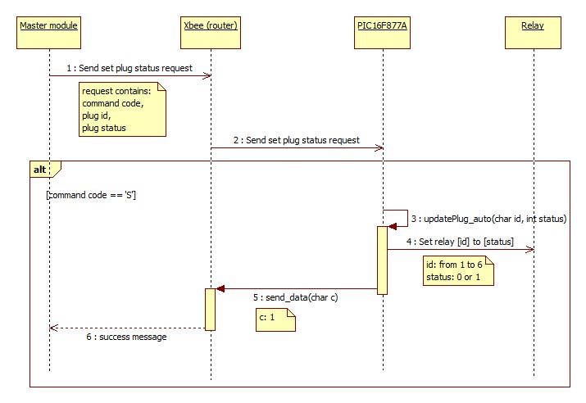

Figure : [Plug module] Switch ON/OFF by Master module

|  |  |  |  |
| --- | --- | --- | --- |
| **Step** | **Action** | **Description** | **Return** |
| 1 | Send set plug status request  (From Master module to XBee module) | Master module sends a set plug status request.  Command code: ‘S’ | Return 1 if  success,  0 if fail to set |
| 2 | Send set plug status request  (From XBee module to PIC16F877A) | Pass the set plug status request to MCU – PIC16F877A | N/A |
| 3 | updatePlug_auto() | Set the plug [id] to [status]. | Return 1 if  success,  0 if fail to set |
| 4 | Set relay [id] to [status] | Set the Pin of relay [id] to 0 if [status]=0, 1 if [status]=1 | N/A |
| 5 | send_data() | Send success message (‘1’) to XBee module.  Xbee module will pass the message to Master module. | N/A |

Table : [Switch ON/OFF by Master module] function description

* Switch ON/OFF by Sensor module

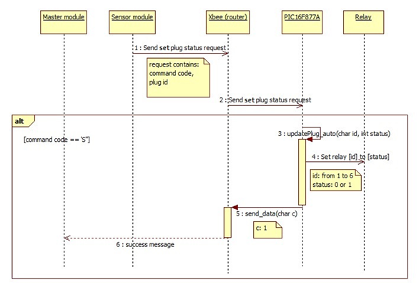

Figure : [Plug module] Switch ON/OFF by Sensor module

|  |  |  |  |
| --- | --- | --- | --- |
| **Step** | **Action** | **Description** | **Return** |
| 1 | Send set plug status request  (From Sensor module to XBee module) | Master module sends a set plug status request.  Command code: ‘S’ | Return 1 if  success,  0 if fail to set |
| 2 | Send set plug status request  (From XBee module to PIC16F877A) | Pass the set plug status request to MCU – PIC16F877A | N/A |
| 3 | updatePlug_auto() | Set the plug [id] to [status]. | Return 1 if  success,  0 if fail to set |
| 4 | Set relay [id] to [status] | Set the Pin of relay [id] to 0 if [status]=0, 1 if [status]=1 | N/A |
| 5 | send_data() | Send success message (‘1’) to XBee module.  Xbee module will pass the message to Master module. | N/A |

Table : [Switch ON/OFF by Sensor module] function description

* Get status of single plug

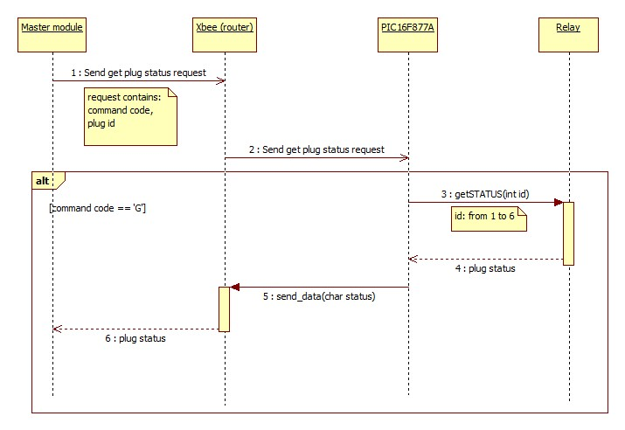

Figure : [Plug module] Get status of single plug

|  |  |  |  |
| --- | --- | --- | --- |
| **Step** | **Action** | **Description** | **Return** |
| 1 | Send get plug status request  (From Master module to XBee module) | Master module sends a get plug status request.  Command code: ‘G’ | Selected plug status |
| 2 | Send get plug status request  (From XBee module to PIC16F877A) | Pass the get plug status request to MCU – PIC16F877A | N/A |
| 3 | getSTATUS() | Get status of pin of relay [id] | Relay [id] status |
| 4 | Set relay [id] to [status] | Set the Pin of relay [id] to 0 if [status]=0, 1 if [status]=1 | N/A |
| 5 | send_data() | Send the status of selected relay [id] to XBee module.  Xbee module will pass the status to Master module. | N/A |

Table : [Get status of single plug] function description

* Get status of all plugs

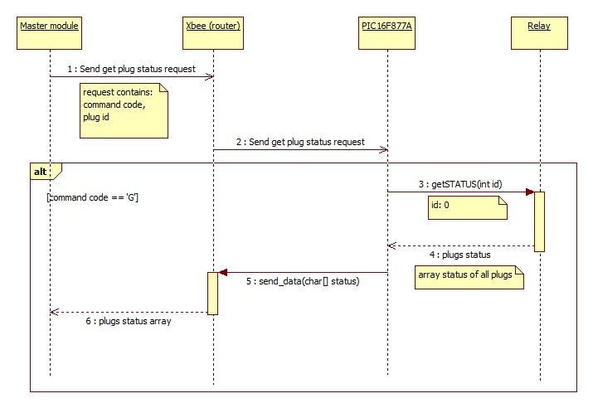

Figure : [Plug module] Get status of all plugs

|  |  |  |  |
| --- | --- | --- | --- |
| **Step** | **Action** | **Description** | **Return** |
| 1 | Send get plug status request  (From Master module to XBee module) | Master module sends a get all plug status request.  Command code: ‘G’ | An array of statuses of all plugs |
| 2 | Send get plug status request  (From XBee module to PIC16F877A) | Pass the get plug status request to MCU – PIC16F877A | N/A |
| 3 | getSTATUS() | Get status of all relay | An array of statuses of all plugs |
| 4 | send_data() | Send the statuses of all relays to XBee module. XBee module will pass the statuses to Master module. | N/A |

Table : [Get status of all plugs] function description

1. **Software layer**

***Operating system***

Free RTOS (Real Time Operating System) for MSP FR5739:

Free RTOS is a cooperator, event driven, priority based, multi-tasking RTOS with highly efficient memory utilization. Written in C, it is very easy to use, employing standardized RTOS methods and terminology. This RTOS makes MCU microprogramming a breeze, and includes:

• Over 40 callable user services in its API

• Up to 16 separate dynamic task priority levels

• Support for multiple event types

• Timer-based services

• Minimal call … return stack usage

• Low interrupt latency and fast context switching

Every application must adhere to two “golden rules”:

1. Each task must have at least one context switch.

2. Context switches may only occur in tasks.

For this application, Salvo was user-configured to provide the basic multi-tasking kernel, along with binary semaphore and message event services, as well as timer based delays. It automatically manages complex issues, like task scheduling, access to shared resources, inter-tasks communication, real-time delays, PIC micro RAM banking and interrupt control. With this multi-tasking RTOS foundation in place, the application programmer can concentrate on quickly and efficiently implementing the desired system functionality

***Middleware***

TCP/UDP, DHCP are the protocol to transmit data from CC3000 module to host server.

**TCP:** Transmission Control Protocol

TCP is used for transmission of data from an application to the network.

TCP is responsible for breaking data down into IP packets before they are sent, and for assembling the packets when they arrive.

**DHCP**: Dynamic Host Configuration Protocol

DHCP is used for allocation of dynamic IP addresses to computers in a network.

**UDP**: User Datagram Protocol.

With UDP, computer applications can send messages, in this case referred to as [datagrams](https://en.wikipedia.org/wiki/Datagram), to other hosts on an IP network without prior communications to set up special transmission channels or data paths

**IEEE 802.15.4 is the protocol to transmit data from X-BEE module router to Coordinator.**

**IEEE 802.15.4**: is a standard which specifies the [physical layer](https://en.wikipedia.org/wiki/Physical_layer) and [media access control](https://en.wikipedia.org/wiki/Media_Access_Control) for low-rate wireless [personal area networks](https://en.wikipedia.org/wiki/Personal_area_network). It is possible to build short-range wireless networking based solely on IEEE 802.15.4. **It is the protocol to transmit data from X-BEE module router to Coordinator.**

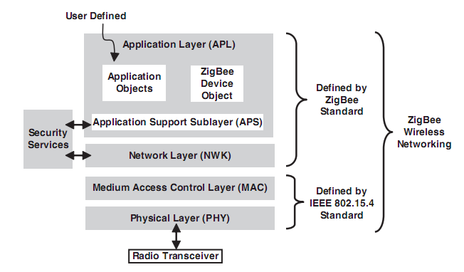

Figure : Transmit data layers

An IEEE 802.15.4 network, regardless of its topology, is always created by a PAN coordinator. The PAN coordinator controls the network and performs the following minimum duties:

* Allocate a unique address (16-bit or 64-bit) to each device in the network.
* Initiate, terminate, and route the messages throughout the network.
* Select a unique PAN identifier for the network. This PAN identifier allows the devices within a network to use the 16-bit short-addressing method and still be able to communicate with other devices across independent networks.

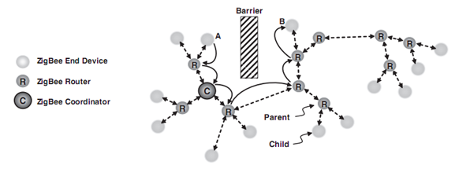

Figure : Zigbee Network

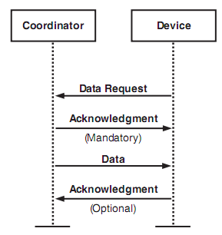

Figure : Communication between Coordinator and Device

1. **GUI layer**

#### 1. Scan plug

* When user click button “Scan”, website send a command request to Master Module and then receive a package include plugs was scanned through TCP Protocol.

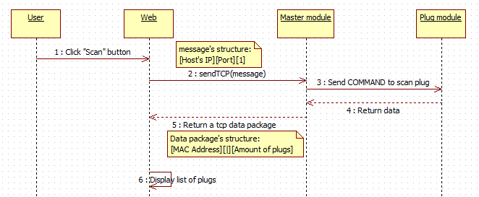

Figure : Sequence Diagram - Scan Plug

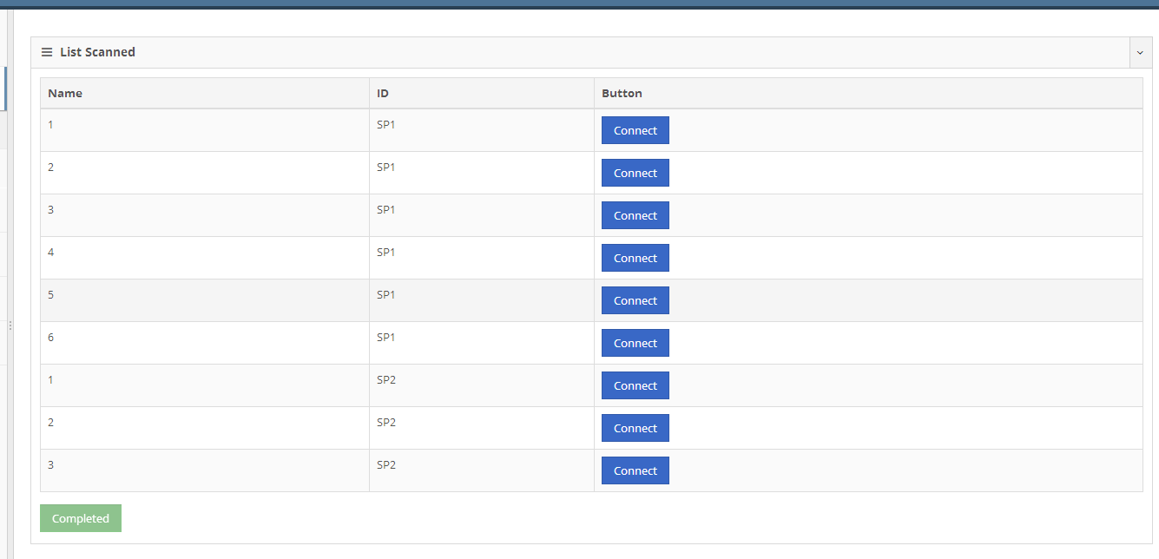

Figure : GUI - Scan all Plug in system network

* 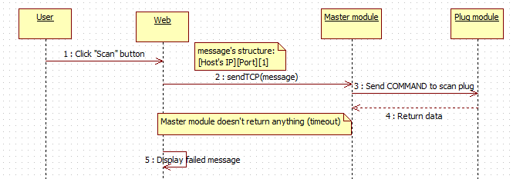If timeout was reached. Button “Scan” will be changed to “Scan Again” button.

Figure : Sequence Diagram - Scan failed

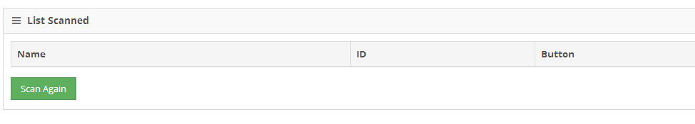

Figure : GUI – Scan plug failed

#### 2. Connect a plug

* For each plug was scanned has a “Connect” button. Website send a command request status of that plug which is clicked “Connect” and then insert into database, show in list plugs connected below.

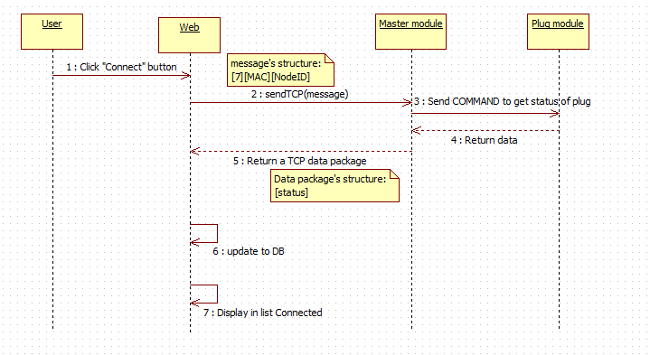

Figure : Sequence Diagram - Connect a Plug

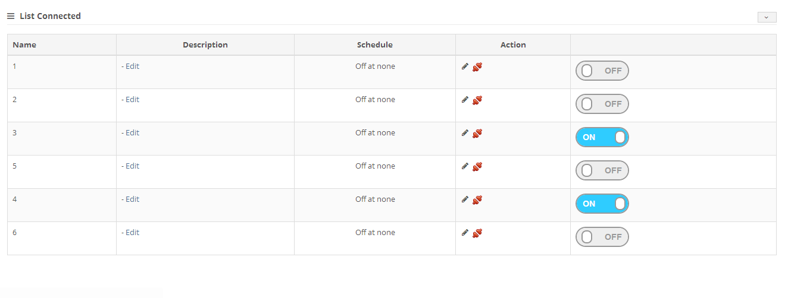

Figure : GUI - Plugs had been connected

* + “Name” column: The name of plugs which are defined in Master Module.
  + “Description” column: User can click “Edit” to enter description for that plug.

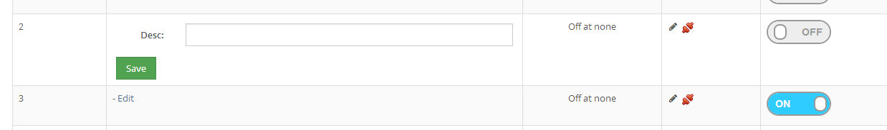

Figure : GUI - Edit description

* + “Schedule” column: The time is set by user to switch on/off the plug automatically.

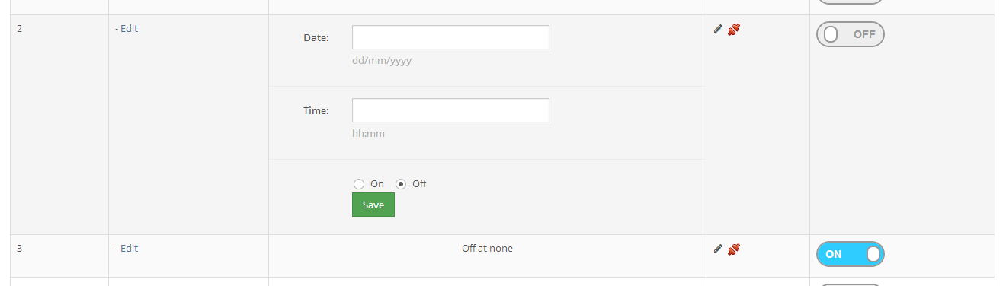

Figure : GUI - Set Schedule

* + “Action” column: have 2 actions to manage plugs.
    - “Set Schedule”: Set time to on/off for plug.
    - “Delete”: Delete plug from table and database.
* If timeout was reached. Button “Connect” will be changed to “Connect Again” button.

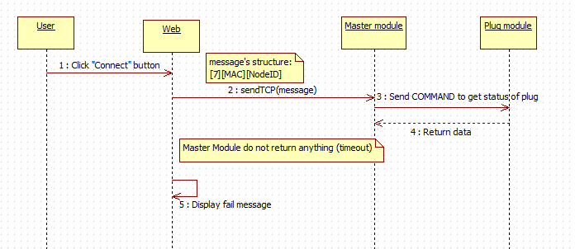

Figure : Sequence Diagram – Connect plug failed

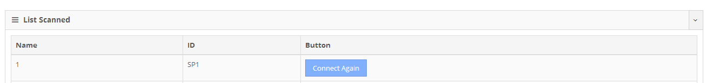

Figure : GUI – Connect plug failed

#### 3. Control plug

* When user clicked switcher, website will send command to Master Module to turn on/off plug. If success, switcher’s display will change, and update to database the status. If fail, do nothing.

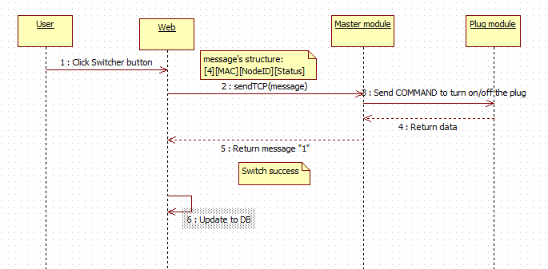

Figure : Sequence diagram - Turn ON/OFF plug

#### 4. Scan sensor

* When user click button “Scan”, website send a command request to Master Module and then receive a package include sensors was scanned through TCP Protocol.

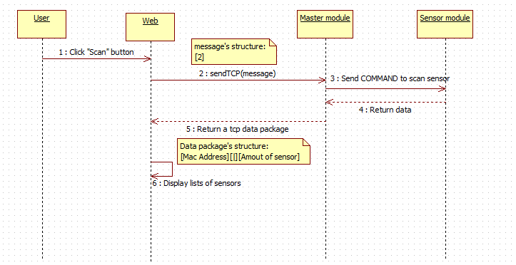

Figure : Sequence Diagram - Scan sensor

* If timeout is reached. “Scan” button will be changed to “Scan Again” button.

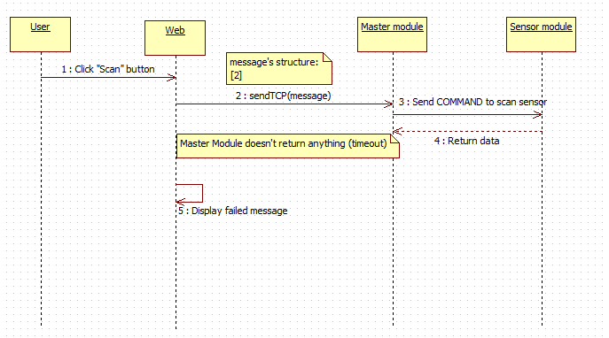

Figure : Sequence Diagram - Scan sensor failed

#### 5. Connect sensor

* For each sensor was scanned has a “Connect” button. When press the “Connect” button Web Server will insert plug’s ID into database, show in list sensors connected below.

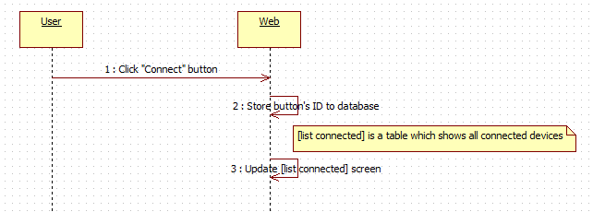

#### 6. Create scenario

* This page help user can create a scenario when unintended case, i-Home will react automatically.
* In this version, i-Home can detect gas and temperature anomaly. If system detected gas or temperature anomaly, some actions can be perform (Ex: send mail, send SMS, activated the alarm, auto turn on/off some plugs).
* Scenario need below information
  + What sensor (gas sensor, temperature sensor)
  + Warning values (temperature limit, gas level limit )
  + Action to react (send Email, send SMS, activated alarm, activated plugs)
  + Plug ID and plug status in case of activating plugs

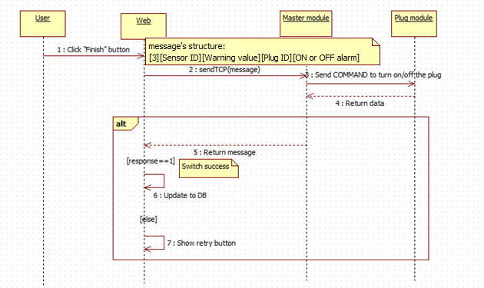

Figure : Sequence Diagram - create scenario

## User interface

### Login screen

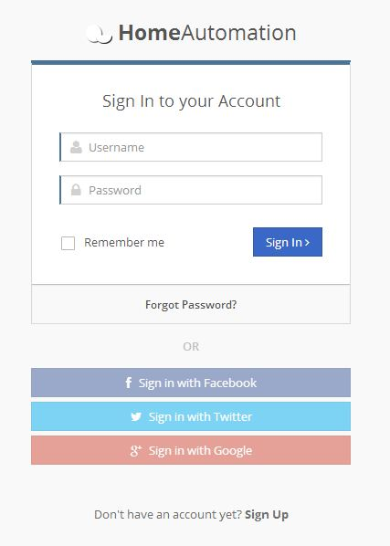

Figure : GUI - Login page

### Dashboard screen

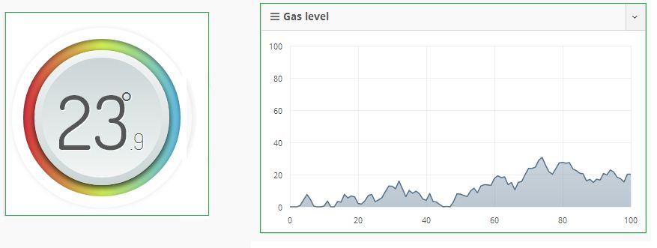

Figure : GUI - Dashboard Page (current temperature and gas level)

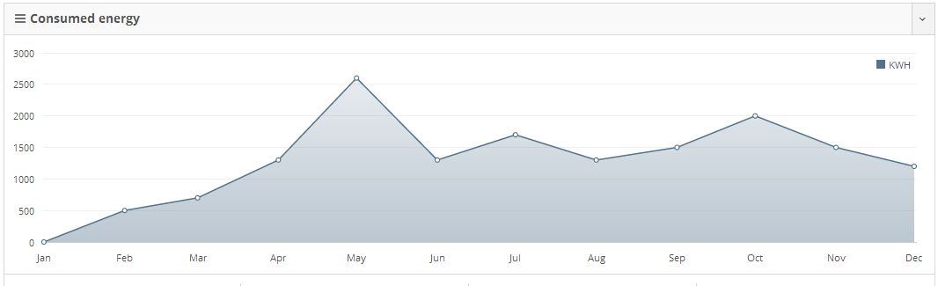

Figure : GUI - Dashboard Page (energy)

### Scan device screen

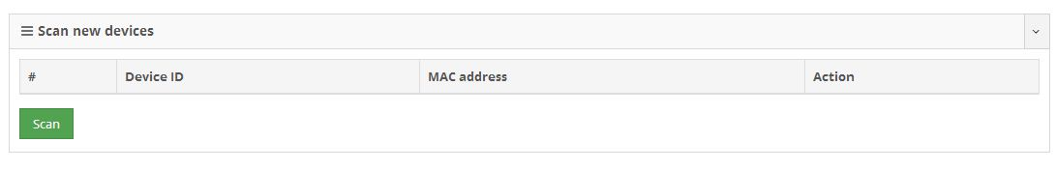

Figure : GUI - Manage Plug page (Scan plug function)

### Add new device screen

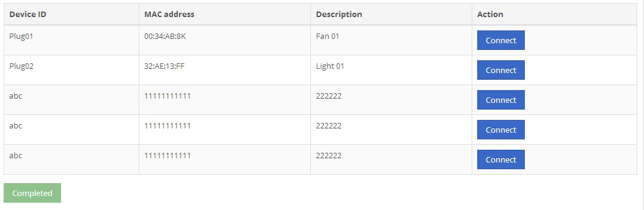

Figure : GUI - Manage Plug page (connect plug function)

### Menu screen

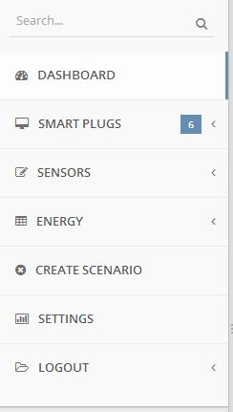

Figure : GUI - Main Menu

### Create scenario screen

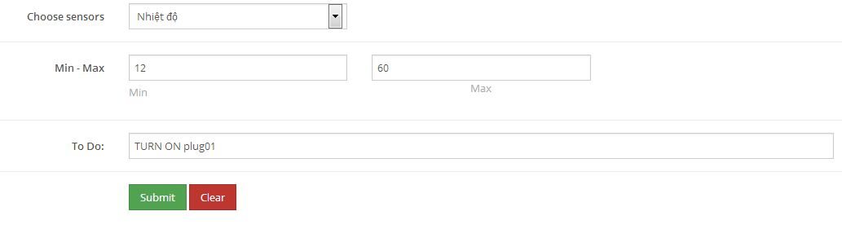

Figure : GUI - Set Scenario page

# Software Test Documentation

## Introduction

### Test overview

In this part, we’ll provide all necessary information about the test approach, test plan, test process, testing environment, test pass/fail criteria and test results of our system.

### Test approach

**White box test**: Developers self-test on code in which function they developed (code inspector, unit test).

**Black box test**: Test on each function of each module in system to ensure them execute correctly. After that, we execute integration testing to test the function in system when integrated. Finally, system test to test the whole system.

## Test plan

The next content will describe which function will be tested and which will not and plan for them.

### Testing features

|  |  |  |  |
| --- | --- | --- | --- |
| Test object | Test content | Execute date | Tester |
| **Master module** | Test configuration cc3000 to a specified network |  | SiNP |
| Test sending command to slave module |  | SiNP |
| Test receiving data from slave module |  | SiNP |
| Test receiving control from web client(web or mobile interface) |  | SiNP |
| Test sending result to web client(web or mobile interface) |  | SiNP |
| **Sensor module** | Test reading current temperature/ gas level |  | CuPV |
| Test activation alarm |  | CuPV |
| Test setting alert values |  | CuPV |
| Test sending data to master module |  | CuPV |
| Test receiving command from master module |  | CuPV |
| **Plug module** | Test switching ON/OFF plug manually |  | CuPV |
| Test sending data to master module |  | CuPV |
| Test receiving command from master module |  | CuPV |
| **Energy meter module** | Test reading current consumed energy |  | CuPV |
| Test sending data to master module |  | CuPV |
| **Web application** | Test scanning device |  | KhoiPKN |
| Test displaying consumed energy/ temperature/ gas level |  | KhoiPKN |
| Test turning ON/OFF plug |  | KhoiPKN |
| Test removing a device from system |  | KhoiPKN |
| Test creating scenario for unexpected situation |  | KhoiPKN |
| Test connecting device to system |  | KhoiPKN |
| **Mobile interface** | Test scanning device |  | KhoiPKN |
| Test displaying consumed energy/ temperature/ gas level |  | KhoiPKN |
| Test turning ON/OFF plug |  | KhoiPKN |
| Test removing a device from system |  | KhoiPKN |
| Test creating scenario for unexpected situation |  | KhoiPKN |
| Test connecting device to system |  | KhoiPKN |

Table : Testing features

### Features not to be tested

* Log in/Log out function

### Test environment

* Web application: Internet Explorer (version 8.0), Firefox (newest version), Chrome (newest version)
* OS: Win 7 professional (32-bit), Win 8 professional (64-bit)
* Android platform: Android 4.1 (Jerry Bean)

### Test pass/fail criteria

For system testing, the criteria are:

* 90% of the test cases must pass
* 100% of test cases about hardware module must pass
* All test cases dealing with critical functionality must pass
* All medium and high severity defects must be fixed
* Test coverage must be at least 90%

## Test case

### Functional testing

|  |  |  |  |  |  |  |  |  |  |
| --- | --- | --- | --- | --- | --- | --- | --- | --- | --- |
| **ID** | **Function** | | | **Pre-condition** | **Procedure** | **Expected result** | **Created by** | **Executed by** | **Result** |
| **Large function** | **Medium function** | **Small function** |
| 1 | **Master module** | Configure cc3000 to a specified network | Without internet access | -Prepare an access point which was not connected to the internet  -Prepare an android phone which was connected to prepared access point | 1.Start [I-Home smart config] application 2.Fill all fields with valid information  Press [Connect] button | CC3000 is connected to the specified network | CuPV | SiNP | Pass |
| 2 | **Master module** | Configure cc3000 to a specified network | With internet access | -Prepare an android phone which can start a wi-fi hotspot  -Prepare another android phone which was connected to prepared net work | 1.Start [I-Home smart config] application 2.Fill all fields with valid information  Press [Connect] button | CC3000 is connected to the specified network | CuPV | SiNP | Pass |
| 3 | **Master module** | Sending command to slave module | To Sensor module | Prepare a command with below structure  [0x7E][length of frame][**content**][check sum]  (0x7E is the start message signal)  Sensor module is connected to master module | Send the prepared command to sensor module | Message is sent to sensor module successfully with specified structure | CuPV | SiNP | Pass |
|  |  |  |  |  |  |  |  |  |  |
| 4 | **Master module** | Sending command to slave module | To Plug module | Prepare a command with below structure  [0x7E][length of frame][**content**][check sum]  (0x7E is the start message signal)  Plug module is connected to master module | Send the prepared command to plug module | Message is sent to plug module successfully with specified structure | CuPV | SiNP | Pass |
| 5 | **Master module** | Sending command to slave module | To Energy module | Prepare a command with below structure  [0x7E][length of frame][**content**][check sum]  (0x7E is the start message signal)  Energy module is connected to master module | Send the prepared command to energy module | Message is sent to energy module successfully with specified structure | CuPV | SiNP | Pass |
| 6 | **Master module** | Receiving data from slave module | From sensor module | Prepare a data packet with below structure  [@] [**content**][#] (@ is the start message signal and # is end message signal)  Sensor module is sent the specified packet to master module | Receive the specified packet from sensor module | Message is received successfully with specified structure | SiNP | KhoiPKN | Pass |
|  |  |  |  |  |  |  |  |  |  |
| 7 | **Master module** | Receiving data from slave module | From energy module | Prepare a data packet with below structure  [@] [content][#] (@ is the start message signal and # is end message signal)  Energy module is sent the specified packet to master module | Receive the specified packet from energy module | Message is received successfully with specified structure | CuPV | SiNP | Pass |
| 8 | **Master module** | Receiving data from slave module | From plug module | Prepare a data packet with below structure  [@] [content][#] (@ is the start message signal and # is end message signal)  Plug module is sent the specified packet to master module | Receive the specified packet from plug module | Message is received successfully with specified structure | CuPV | SiNP | Pass |
|  |  |  |  |  |  |  |  |  |  |
| 9 | **Master module** | Receiving control from web client(web or mobile interface) | From web | Master module is activated  User is connected to [Auto-Home.biz] website | Receive the specified control from web | Message is received correctly | CuPV | SiNP | Pass |
| 10 | **Master module** | Sending result to web client(web or mobile interface) | From mobile interface | Master module is activated  User is connected to [Auto-Home.biz] website from mobile device | Send the specified control to web | Message is sent successfully and correctly | CuPV | SiNP | Pass |
| 11 | **Sensor module** | Reading current temperature/ gas level | Temperature | Temperature sensor is worked normally | Measure current temperature | Environment’s temperature is measured correctly | KhoiPKN | CuPV | Pass |
| 12 | **Sensor module** | Reading current temperature/ gas level | Gas level | Gas sensor is worked normally | Measure current gas level | Environment’s gas level is measured correctly | KhoiPKN | CuPV | Pass |
| 13 | **Sensor module** | Activating alarm | - | Alarm is worked normally | Control alarm to make sound | Alarm’s sound is played normally | KhoiPKN | CuPV | Pass |
| 14 | **Sensor module** | Setting alert values | Temperature | Temperature sensor is worked normally | Set the maximum value of temperature in normal situation | When temperature is higher than specified value, system alerts user | KhoiPKN | CuPV | Pass |
| 15 | **Sensor module** | Setting alert values | Gas level | Gas sensor is worked normally | Set the maximum value of gas level in normal situation | When gas level is higher than specified value, system alerts user | KhoiPKN | CuPV | Pass |
| 16 | **Sensor module** | Receiving command from master module |  | Master was sent [B] command to sensor module | Receive message from master | [B] is received | KhoiPKN | CuPV | Pass |
| 17 | **Sensor module** | Sending data to master module | Temperature and as level | Prepare a data packet with below structure  **[@] [temperature][|][gas level][#]** (@ is the start message signal and # is end message signal) | Send the prepared command to master module | Message is sent to master module successfully with specified structure | KhoiPKN | CuPV | Pass |
| 18 | **Plug module** | Switching ON/OFF plug manually | Plug No.3 | - | Push the button which is controlled plug 3 continuously | Plug no 3 is switched ON/OFF normally | KhoiPKN | CuPV | Pass |
| 19 | **Plug module** | Receiving command from master module | ON | Master was sent [S][plug ID][1] command to sensor module | Receive message from master | Command is sent successfully with specified structure | KhoiPKN | CuPV | Pass |
| 20 | **Plug module** | Sending data to master module | Plug No.5 | Prepare a data packet with below structure  [@] [current status] [#] (@ is the start message signal and # is end message signal) | Send the prepared command to master module | Message is sent to master module successfully with specified structure | KhoiPKN | CuPV | Pass |
| 21 | **Energy meter module** | Sending data to master module | Consumed energy | Prepare a data packet with below structure  [@] [consumed energy] [#] (@ is the start message signal and # is end message signal) | Send the prepared command to master module | Message is sent to master module successfully with specified structure | KhoiPKN | CuPV | Pass |
| 22 | **Energy meter module** | Reading current consumed energy | - | ADE7758 chip is worked normally | Measure current energy | Consumed energy is measured correctly | KhoiPKN | CuPV | Pass |
| 23 | **Web application** | Scanning device | Plug module | User has logged in to [Auto-Home.biz] site by chrome (latest version) | 1.Navigate to [Manage plugs] tab  2.Click on [Scan] button | Send [1][Mac address of plug board] command to master module successfully  Scan screen is displayed normally | SiNP | KhoiPKN | Pass |
| 24 | **Web application** | Displaying consumed energy/ temperature/ gas level | Temperature | User has logged in to [Auto-Home.biz] site by IE (latest version  Sensor module is connected | 1.Navigate to [Manage sensors] tab | Send [6][Mac address of sensor board] command to master module successfully  Current environment temperature is displayed normally | SiNP | KhoiPKN | Pass |
| 25 | **Web application** | Switching ON/OFF plug | ON | User has logged in to [Auto-Home.biz] site by IE (latest version  Plug module is connected  Plug no.2 is ON | 1.Navigate to [Manage plugs] tab  2.Switch OFF plug no.2 | Send [4][MAC address of plug][2][0] command to master module successfully  Plug no.2’s status is displayed by OFF status | SiNP | KhoiPKN | Pass |
| 26 | **Web application** | Removing a device from system | Sensor module | User has logged in to [Auto-Home.biz] site by IE (latest version  Sensor module is connected | Navigate to [Manage sensors] tab  Click [Disconnect] button of connecting sensor board | Selected device is displayed correctly  Selected device’s function is disable | SiNP | KhoiPKN | Pass |
| 27 | **Web application** | Creating scenario for unexpected situation | - | User has logged in to [Auto-Home.biz] site by IE (latest version  Sensor module is connected | Navigate to [Create scenario] tab  Create a scenario then click [Finish] button | Send specified command to master module (base on scenario)  Scenario screen is displayed normally | SiNP | KhoiPKN | Pass |
| 28 | **Web application** | Connecting device to system | Plug module | User has logged in to [Auto-Home.biz] site by IE (latest version  Plug module is not connected | 1.Navigate to [Manage plugs] tab  2.Tap on [Connect] button of Plug module | Send [4][MAC address of plug][plug ID] command to master module successfully  Screen is displayed normally and plug module is connected | SiNP | KhoiPKN | Pass |
| 29 | **Mobile interface** | Scanning device | Sensor module | User has logged in to [Auto-Home.biz] site by mobile device (Android ) | 1.Navigate to [Manage sensors] tab  2.Click on [Scan] button | Send [2][Mac address of plug board] command to master module successfully  Scan screen is displayed normally | SiNP | KhoiPKN | Pass |
| 30 | **Mobile interface** | Displaying consumed energy/ temperature/ gas level | Gas level | User has logged in to [Auto-Home.biz] site by mobile (iOS)  Sensor module is connected | 1.Navigate to [Manage sensors] tab | Send [6][Mac address of sensor board] command to master module successfully  Current environment gas level is displayed normally | SiNP | KhoiPKN | Pass |
| 31 | **Mobile interface** | Switching ON/OFF plug | ON | User has logged in to [Auto-Home.biz] site by mobile  Plug module is connected  Plug no.6 is OFF | 1.Navigate to [Manage plugs] tab  2.Switch ON plug no.6 | Send [4][MAC address of plug][6][1] command to master module successfully  Plug no.6’s status is displayed by ON status | SiNP | KhoiPKN | Pass |
| 32 | **Mobile interface** | Removing a device from system | Plug module | User has logged in to [Auto-Home.biz] site by mobile  Sensor module is connected | Navigate to [Manage plugs] tab  Click [Disconnect] button of connecting plug board | Selected device is displayed correctly  Selected device’s function is disable | SiNP | KhoiPKN | Pass |
| 33 | **Mobile interface** | Creating scenario for unexpected situation | - | User has logged in to [Auto-Home.biz] site by mobile ( iOS)  Sensor module is connected | Navigate to [Create scenario] tab  Create a scenario then click [Finish] button | Send specified command to master module (base on scenario)  Scenario screen is displayed normally | SiNP | KhoiPKN | Pass |
| 34 | **Mobile interface** | Connecting device to system | Plug module | User has logged in to [Auto-Home.biz] site by IE (latest version  Plug module is not connected | 1.Navigate to [Manage plugs] tab  2.Tap on [Connect] button of Plug module | Send [4][MAC address of plug][plug ID] command to master module successfully  Screen is displayed normally and plug module is connected | SiNP | KhoiPKN |  |

Table : Functional testing

### Integration test

|  |  |  |  |  |  |  |  |  |  |
| --- | --- | --- | --- | --- | --- | --- | --- | --- | --- |
| **Function** | **Description** | | **Pre-condition** | **Procedure** | | **Expected result** | | **Tester** | |
| Display current temperature/ gas level | Getting current environment temperature/ gas level then displaying to user | | Sensor module is worked normally  Master module is worked normally  Sensor module is connected to system | User access to [Auto-home.biz] website | | Temperature/ gas level is measured by sensor module  Measured result is sent to master module successfully  Data from master module is sent to web normally  Web interface is displayed received result normally by graph | | KhoiPKN | |
| Scan sensors | Scanning sensor module then adding scanned module to the system | | User was accessed to [Auto-home.biz] website  Sensor module is worked normally  Master module is worked normally | Navigate to [Manage sensor] tab  Click on [Scan] button | | Send [2] command to master module  Master module send broadcast message to find all sensor modules of the network  Exist modules are responded to master module  Master module get notification from entire modules  Send exist module’s MAC address to web  Web displayed received data normally | | SINP | |
| Scan plugs | Scanning plug module then adding scanned module to the system | | User was accessed to [Auto-home.biz] website  Plug module is worked normally  Master module is worked normally | Navigate to [Manage plug] tab  Click on [Scan] button | | Send [2] command to master module  Master module send broadcast message to find all plug modules of the network  Exist modules are responded to master module  Master module get notification from entire modules  Send exist module’s MAC address to web  Web displayed received data normally | | CuPV | |
| Turn ON the plug | Turn ON the selected plug | User accessed to [Auto-home.biz/manageplug.php] site.  Switcher button of testing plug at the website is “OFF”.  Testing [Plug ID ]in Plug module is OFF  Plug module worked normally.  Master module worked normally. | | | On the “List Connected” table at the website, Click on switcher button to turn ON a plug. | | Send [4][Plug Address][Plug ID][1] command to master module.  (Example: [4][SP1][1][1])  Master module send message to [Plug Address] (SP1) to turn ON the plug [Plug ID] (1).  Plug module respond to Master module message “1”.  Master module respond to Website message “1” via TCP protocol.  The switcher button change to “ON”.  The Website show alert with content “OK”.  Testing [Plug ID] (1) of plug module is ON normally. | | KhoiPKN |
| Turn OFF the plug | Turn OFF the selected plug | User accessed to [Auto-home.biz/manageplug.php] site.  Switcher button of testing plug at the website is “ON”.  Testing [Plug ID]in Plug module is ON.  Plug module worked normally.  Master module worked normally. | | | On the “List Connected” table at the website, Click on switcher button to turn OFF a plug. | | Send [4][Plug Address][Plug ID][0] command to master module.  (Example: [4][SP1][2][0])  Master module send message to [Plug Address] (SP1) to turn OFF the plug [Plug ID] (2).  Plug module respond to Master module message “1”.  Master module respond to Website message “1” via TCP protocol.  The switcher button changes to “OFF”.  The Website show alert with content “OK”.  Testing [Plug ID] (2) of plug module is OFF normally. | | KhoiPKN |
| Turn ON plug | Turn ON plug 1 | |  |  | |  | |  | |
| Set schedule for Plug | Turn ON the plug “2” at 11:00 AM 29/11/2013. | User accessed to [Auto-home.biz/manageplug.php] site.  Plug module worked normally.  Master module worked normally.  Plug “2” on the website is OFF.  Plug “2” at plug module is OFF.  Current time to do this test is earlier than 11:00 AM 29/11/2013. | | | In row of Plug “2”. Click on Pencil icon (Set Schedule) on the website.  At “Date” textbox, type: [29/11/2013].  At “Time” textbox, type: [11:00].  Then choose “On” radio button.  Finally, click Save to finish. | | When the schedule (11:00 29/11/2013) is reached. Website send [4SP120] message through TCP protocol Master Module.  Master Module send message to plug module [SP1] to turn plug ID #2 OFF.  Plug Module [SP1] reply to Master Module message “1”.  Master Module respond to Web message “1”  Refresh Manage Plug Page, the switcher button of plug “2” is OFF.  Plug #2 in plug module “SP1” if OFF. | | KhoiPKN |
| Turn ON 2 plugs concurrently | Turn ON plug 3 and 4 concurrently | User accessed to [Auto-home.biz/manageplug.php] site.  Switcher button of plug 3 and plug 4 in the website are “OFF”.  Plug 3 and 4 of plug module is OFF  Plug module worked normally.  Master module worked normally. | | | On the “List Connected” table at the website, Click on switcher button to turn ON plug 3 and plug 4. | | Plug 3 and plug 4 of plug module is ON normally  Switcher button of plug 3 and plug 4 is at ON status | | CuPV |
| Turn OFF 3 plugs concurrently | Turn ON plug 1, 2 and 6 concurrently | User accessed to [Auto-home.biz/manageplug.php] site.  Switcher button of plug 1, 2 and plug 6 in the website are “ON”.  Plug 1, 2 and 6 of plug module is OFF  Plug module worked normally.  Master module worked normally. | | | On the “List Connected” table at the website, Click on switcher button to turn OFF plug 1, 2 and plug 6. | | Plug 1,2 and plug 6 of plug module is OFF normally  Switcher button of plug 1, 2 and plug 6 is at OFF status | | CuPV |
| Notify user | Test alarm when temperature is high | Master module worked normally.  Sensor module is worked normally | | | Environment temperature exceeded the limit | | Alarm of sensor module is activated | | CuPV |
| Notify user | Test controlling the plug module when gas level is high | Master module worked normally.  Sensor module is worked normally  Plug module is worked normally  Scenario is set (When gas is high, turn ON plug 1 and turn OFF plug 5)  Plug 1 is OFF and plug 5 is ON | | | Environment gas level exceeded the limit | | Plug 1 is changed to ON  Plug 5 is changed to OFF | | CuPV |
| Display at website | Test switcher button’s display when OFF plug manually | Master module worked normally.  Plug module is worked normally  Switcher button of plug 2 and plug 5 in the website are “ON”.  Plug 2 and 5 of plug module is ON | | | Turn OFF plug 2 and plug 5 manually | | Switcher button of plug 2 and 5 are changed to OFF normally (maximum delaying time is 4s) | | CuPV |
| Display at website | Test switcher button’s display when ON plug manually | Master module worked normally.  Plug module is worked normally  Switcher button of plug 1 and plug 4 in the website are “OFF”.  Plug 1 and 4 of plug module is OFF | | | Turn ON plug 1 and plug 4 manually | | Switcher button of plug 2 and 5 are changed to ON normally (maximum delaying time is 4s) | | CuPV |
| Leaving test | Turn ON plug | Master module worked normally.  Plug module is worked normally  Plug 3 and 6 of plug module is OFF | | | Turn ON plug 3 and plug 6 manually  After 30 minutes, check plug 3 and plug 6 | | Plug 3 and plug 6 are still ON and worked normally | | CuPV |

Table : Test case

# System User’s Manual

## Installation Guide

### Sensor module

* + The sensor board uses 12V DC power, please make sure that you use 12V power supplier.
  + Plug in 12V DC power to sensor board. If two LEDs are ON, your sensor board works normally

### Plug module

* + The plug control board uses 12V DC power, please make sure that you use 12V power supplier.
  + Connect control board to plug by 2 cables.
  + Plug in 220V AC to plug
  + Plug in 12V DC power to control board. If two LEDs are ON, your control board works normally
  + When control board is supplied power. Six plug’s LEDs are ON and the plug can supply 220v AC power.

### Associate the master module to an access point

#### Prerequisites

The following items are needed to run the Configuration:

* *Hardware*
  + 1 x Master module
  + 1 x Wi-Fi Access Point (AP)
  + 1 x Smart phone (Android)
* *Software*
  + I-HomeConfig.apk

#### Environment set up

* Power on Access Point
* Power on Master module
* Associate your smart phone to the Access Point

#### Running the configuration

* Turn on Configuration mode of Master module

Press the S1 button on the Master module. If the Master module was already associated to another Access Point, it will disconnect and LEDs 1-4 will turn off. In all cases, LED6 will turn on and then start blinking, indicating that the Smart Configuration process has started:

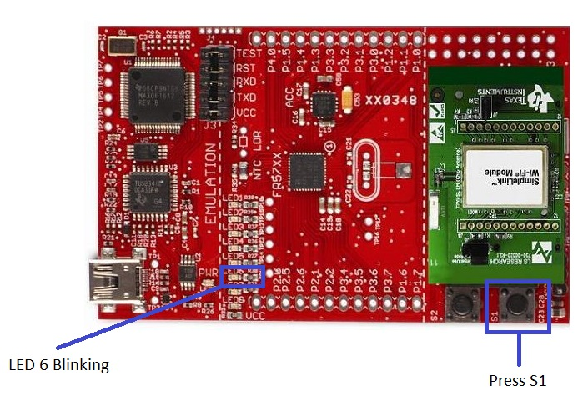

Figure 104: Turn on Configuration mode of Master module

* **Start configuration:**

Associate your smart phone to the Access Point. Open your I-Home Config application. Enter required fields.

* SSID: AP’s SSID is automatically detected.
* Password: AP’s password in the case where WEP, WPA, WPA2 security is used. When security is OPEN, leave this field empty.
* Gateway IP Address: AP’s IP is automatically detected.
* Key (Optional): Fill in this field only case when AES is enabled. Make sure the key is identical to the key on the embedded side. Key length: 16 characters.
* Device Name (Default: CC3000): In order to stop the configuration process (once Master Module is associated to the AP) an mDNS packet is sent with the device name. Make sure the device name is identical to the device name on the embedded side.
* Start: Press this key to start the configuration process. At this point this button will turn to STOP and will be colored red. Once Master Module is connected and the configuring device receives the mDNS packet with the device name, this button will turn blue again.

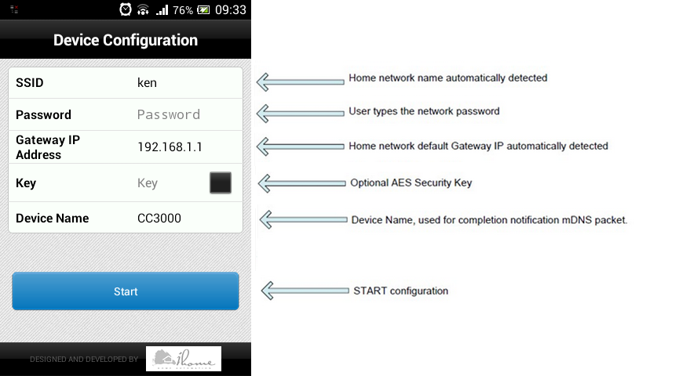

Figure : config the Smart Config application

* **Finish the configuration**

When the Master Module has received the Smart Configuration information, LED6 will remain solid on and the Master Module will attempt to associate using the Smart Configuration information. If it is successful, LEDs 2, 3 and 4 will turn on indicating successful association, IP address, and server running.

If LED2 does not turn on (indicating that it is unable to associate to the AP), please check the Smart Configuration parameters you entered in the Smart Phone application SSID and security information is correct to the AP to which you're attempting to connect.

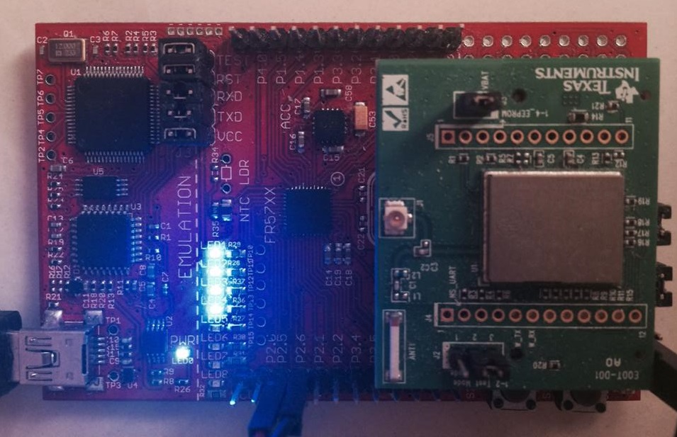

Figure : Master module config success

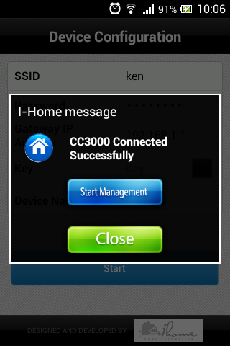

Figure : Smart Config application config success

**Congratulations, you successfully associated your [master module] to a Wi-Fi access point!**

### Set up PC to work as web server

#### Set static IP for server’s PC

* Get your PC’s IP address

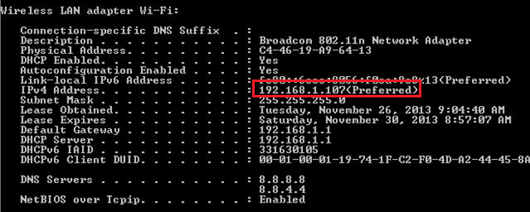

Figure : Use ipconfig to see local IP (IPv4 Address)

* Go to “**Network and Sharing center**”, choose **Wi-Fi Properties**, uncheck **IPv6** and double click **IPv4** and set as below:

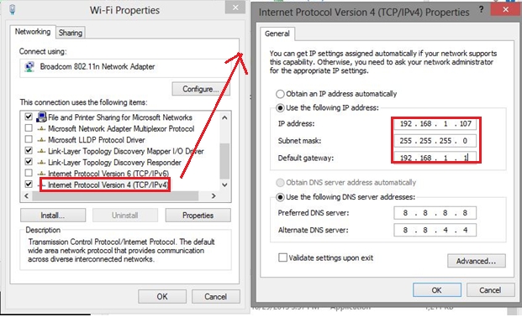

Figure : Set static IP

#### Activate necessary services

* Go to **Run**, type “**services.msc**”

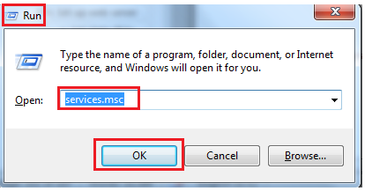Figure : Run services.msc

* At “**Remote Desktop Configuration**”, change Startup type to “**Automatic**” -> OK

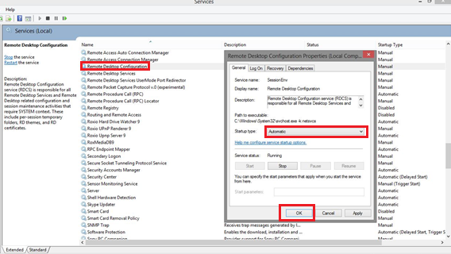

Figure : Active Services (services.msc)

* Repeat this step with “**Remote Desktop Services**”.

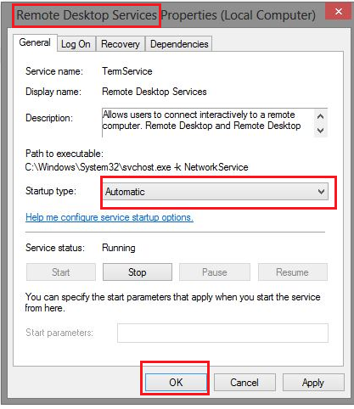

Figure : Remote Desktop Services Properties

#### Add remote desktop user

* In “**Device Manager**”, choose “Remote” tab. Stick “**Allow Remote Assistance connections to this computer**” and “**Allow remote connections to this computer**”.
* “**Select Users**”, then add which user will use for Remote Desktop.

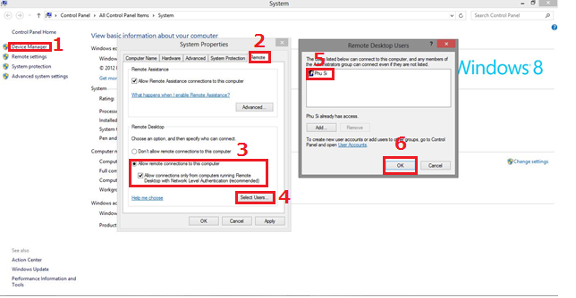

Figure : Add Remote Desktop Users

#### Install addition features

* Open **Programs and Features** -> **Turn Windows features on or off**-> Check **Telnet Client** and **Telnet Server**

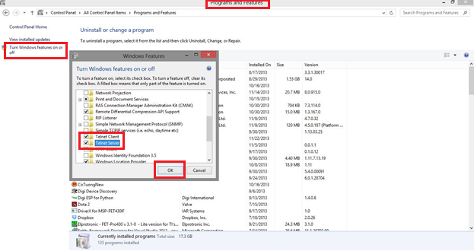

Figure : Install Telnet Client and Telnet Server

* Go to **Run**, type “**services.msc**”



Figure : Run services.msc again

* Choose “**Telnet**” service, change Startup type to “Automatic”, click Start and OK to finish.

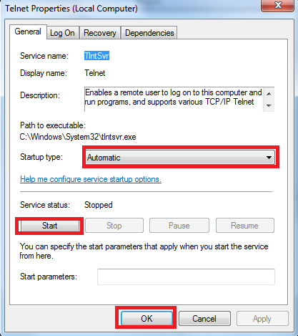

Figure : Start Telnet service

### Install Web Server ( Wamp Server)

#### Install Wamp

* Install wamp server and fill your configuration information

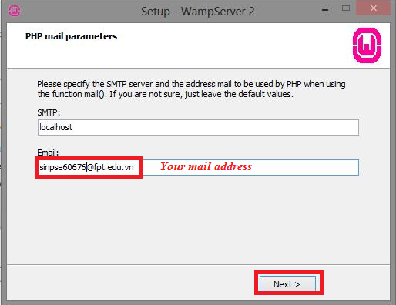

Figure : Install WampServer

* + After installing, there is [WAMP SERVER] icon at taskbar. Click on this icon and choose **Start All Services**

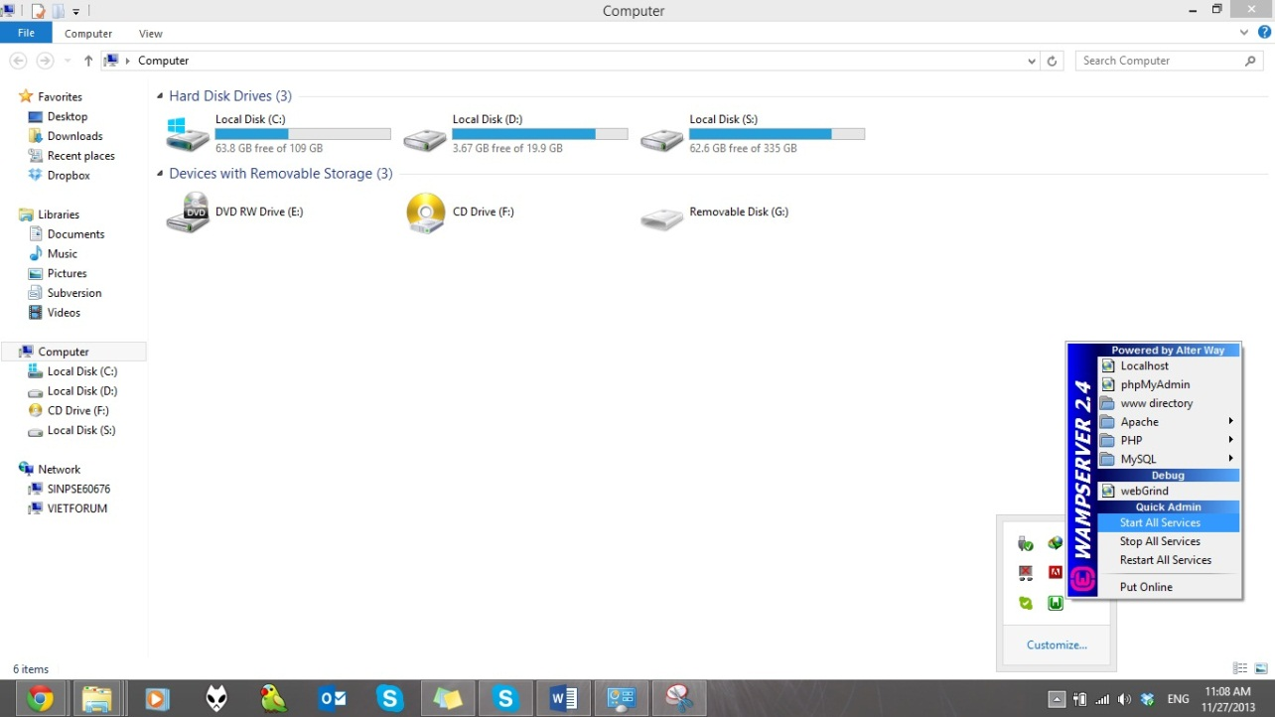

Figure : Start All Services

* + Open browser and type **localhost:81** (81 is port). When browser is displayed as below, you installed successfully

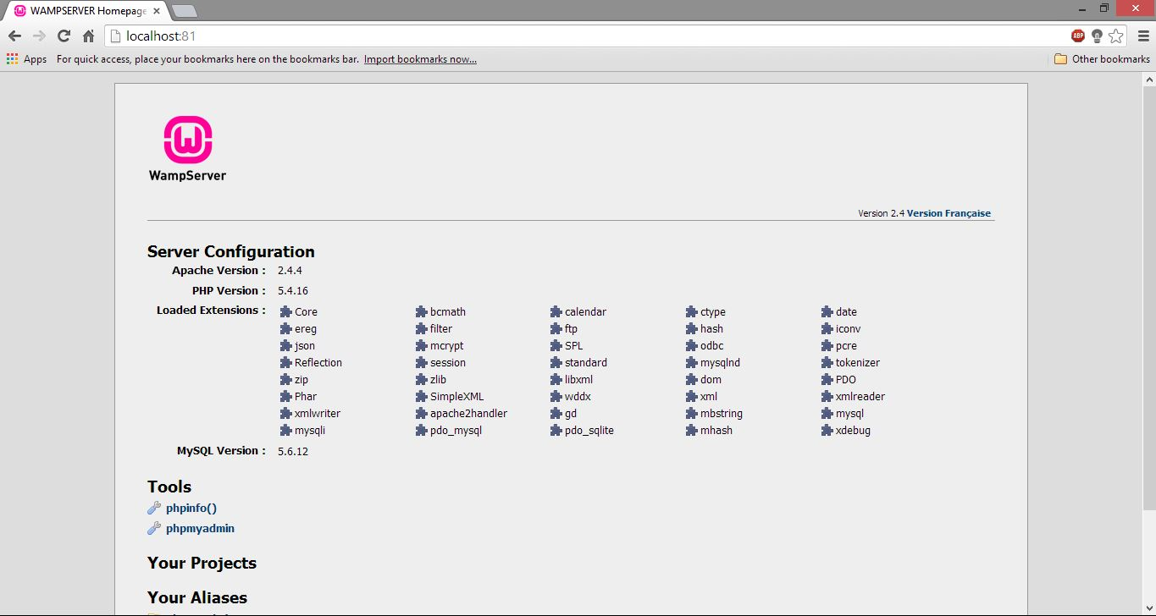

Figure : Main Screen of WampServer

#### Set up website

* + Copy website’s source code to \wamp\www\ folder.
* Go to **phpAdminPage** (<http://localhost/phpmyadmin/>) to import Database and create a new user for this database.

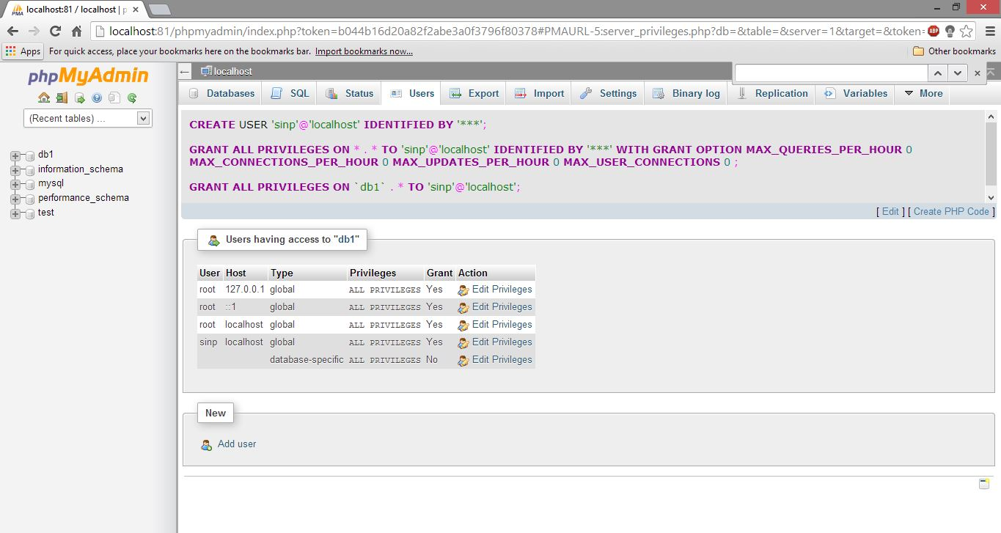

Figure : Import Database

* Edit **config.php** file to link website to Database.

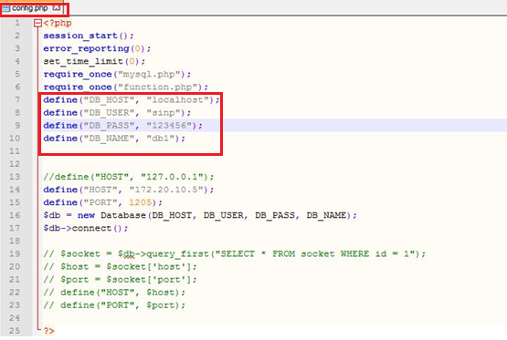

Figure : Define host and Database information

* Depend on Web server, you must open some extensions to use Socket (use for TCP protocol). With WampServer, you can open file httpd.conf (click Wamp icon, in tray bar, Apache/httpd.conf). Find “php_sockets.dll”, delete semicolon in the top of the line to enable php socket.

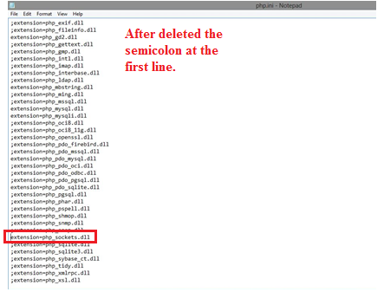

Figure : Enable PHP Socket

**Now, you can run the website on localhost!**

* *If you want to access the website in both WAN and LAN, you have to open some port of you modem. There are two ports which must be opened*
  + - 21~100 (include FTP, HTTP, SMTP …. Protocol).
    - 1205: Port to listen socket via TCP Protocol.

**Congratulations, you can start using the system!**

## User’s Guide

### Log-in

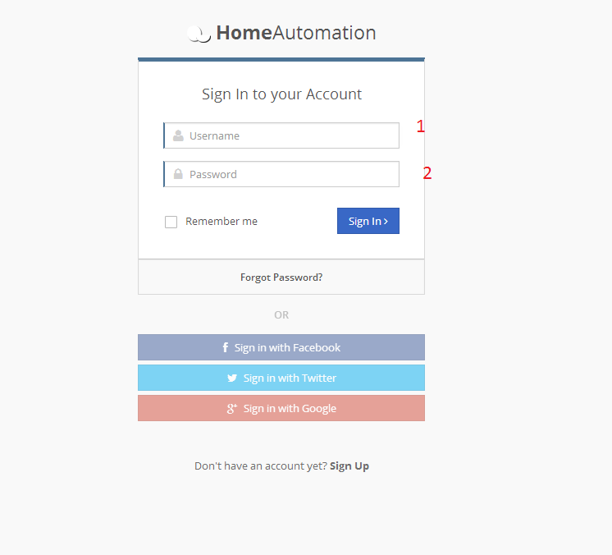

Figure : Login page

|  |  |  |
| --- | --- | --- |
| No. | Item | Description |
| 1 | Username | Fill out username which is registered |
| 2 | Password | Fill out password |

Table : Description of login page

You can log-in by your Facebook, Twitter or Google account. After log-in successfully, you will be navigated to [Dashboard] page as below:

### Using dashboard page

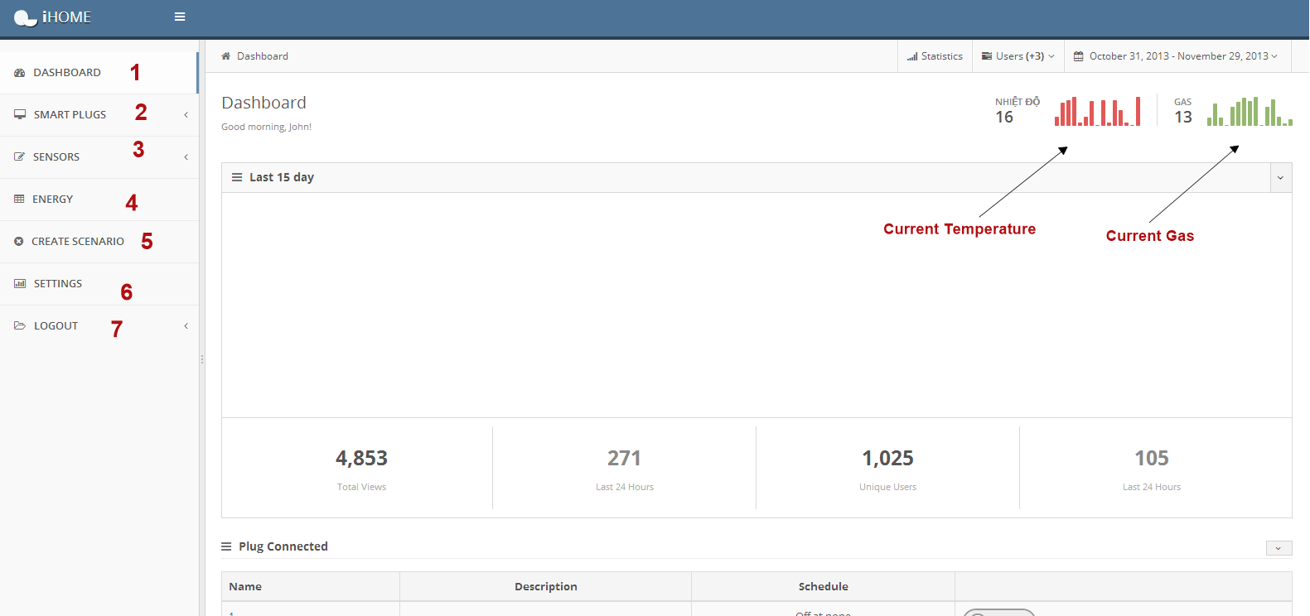

Figure : Dashboard page

|  |  |  |
| --- | --- | --- |
| No. | Item | Description |
| 1 | Menu: Dashboard | Link to dashboard page, to see overview iHome system |
| 2 | Menu: Smart Plugs | Include 2 sub-menus (Add Plug, Manage Plugs) |
| 3 | Menu: Sensors | Include 2 sub-menus (Add Sensor, Manage Sensors) |
| 4 | Menu: Energy | View the energy is used in iHome |
| 5 | Menu: Create Scenario | Create scenarios for unusual circumstances. |
| 6 | Menu: Setting | Set email, phone |
| 7 | Menu: Logout | Logout |

Table : Description of dashboard page

### Add plug manually

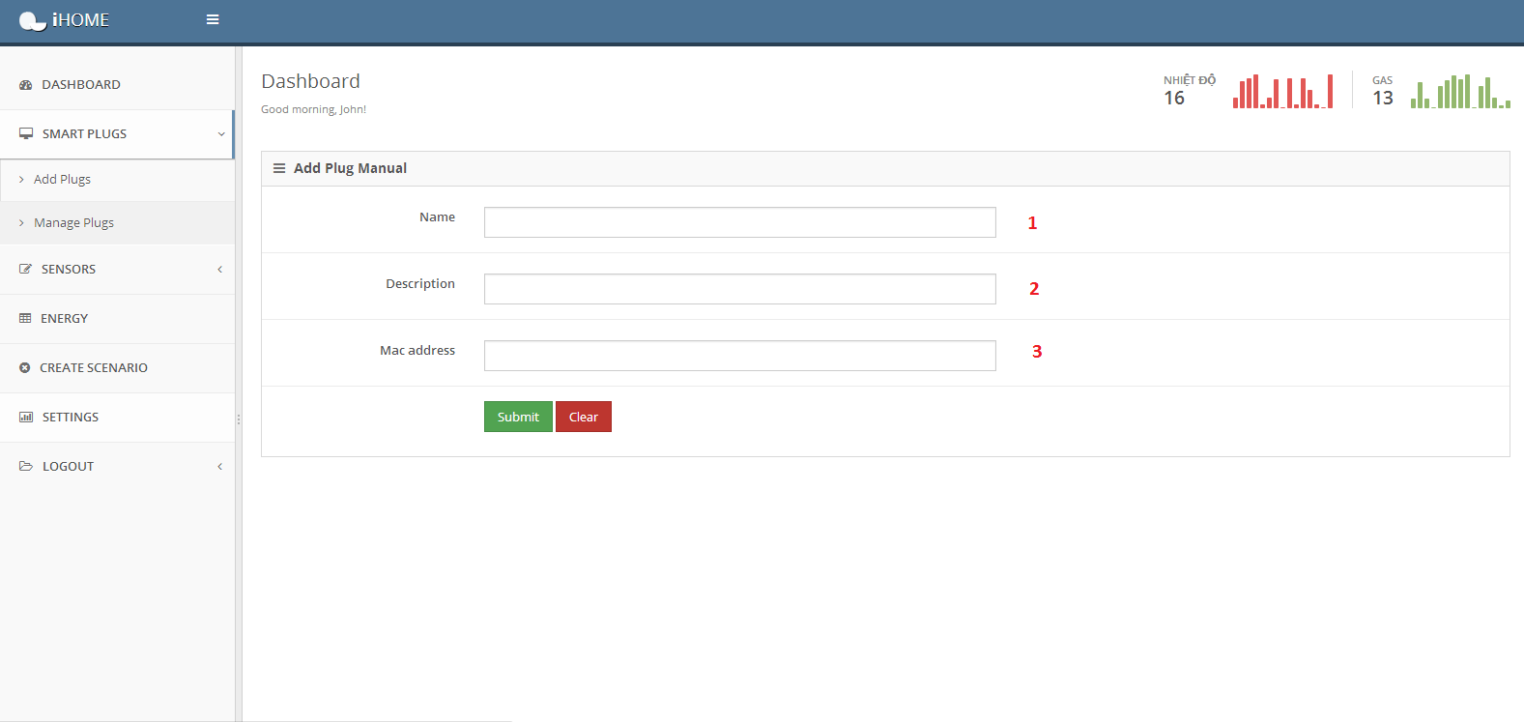

Figure : Add plug manual page

|  |  |  |
| --- | --- | --- |
| No. | Item | Description |
| 1 | Name of Plug | Fill out the name which plug you want to add. |
| 2 | Description for this Plug | Fill out description to define the plug. |
| 3 | Mac Address of Plug | Fill out exactly the MAC Address of plug |

Table : Description of add plug page

### Manage plug

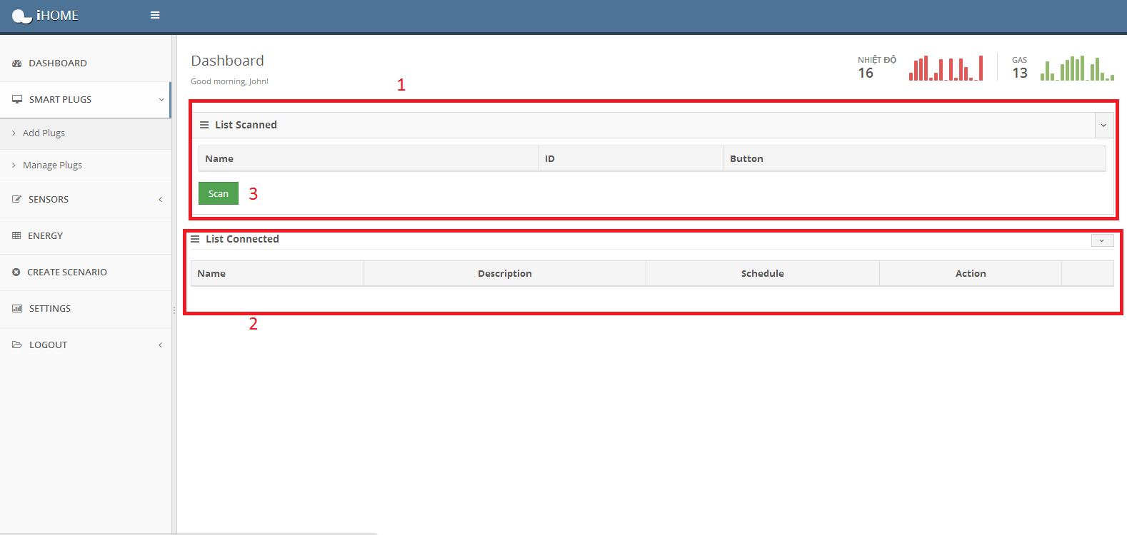

Figure : Manage plug page

|  |  |  |
| --- | --- | --- |
| No. | Item | Description |
| 1 | List Scanned | Show List scanned after click button “Scan” |
| 2 | List Connected | Show List connected after click button “Connect” |
| 3 | Scan Button | Scan all plugs in i-Home system. |

Table : Description of manage plug page

* Scan plug

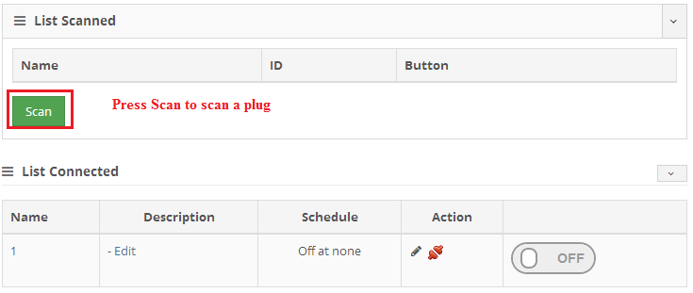

Figure : Scan plug function

This is the scan result

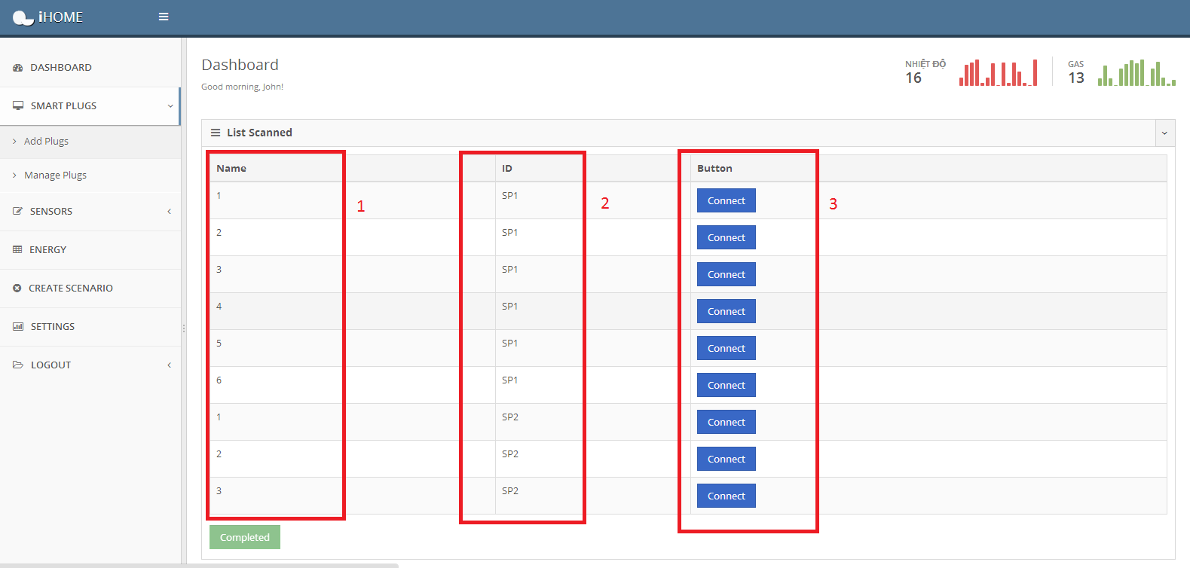

Figure : List plugs is scanned

|  |  |  |
| --- | --- | --- |
| No. | Item | Description |
| 1 | Name Column | Name of Plug |
| 2 | ID Column | Node Identifier (alternative to MAC Address) |
| 3 | Button Column | Click Connect to connect this plug to link Hardware and Web. (ex: Figure 5) |

Table : Description of list scanned plug

* Connect a plug

Press [Connect] button of the scanned plug

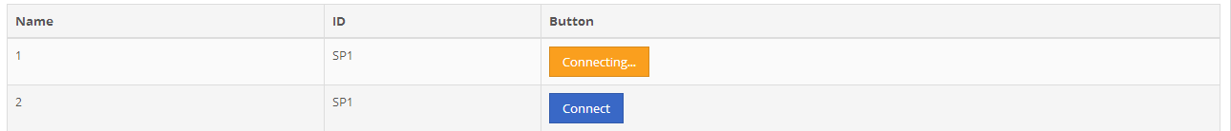

Figure : Press Connect button to connect plug

Result is the same at [List connected table]

* List connected table (Display all connected plug)

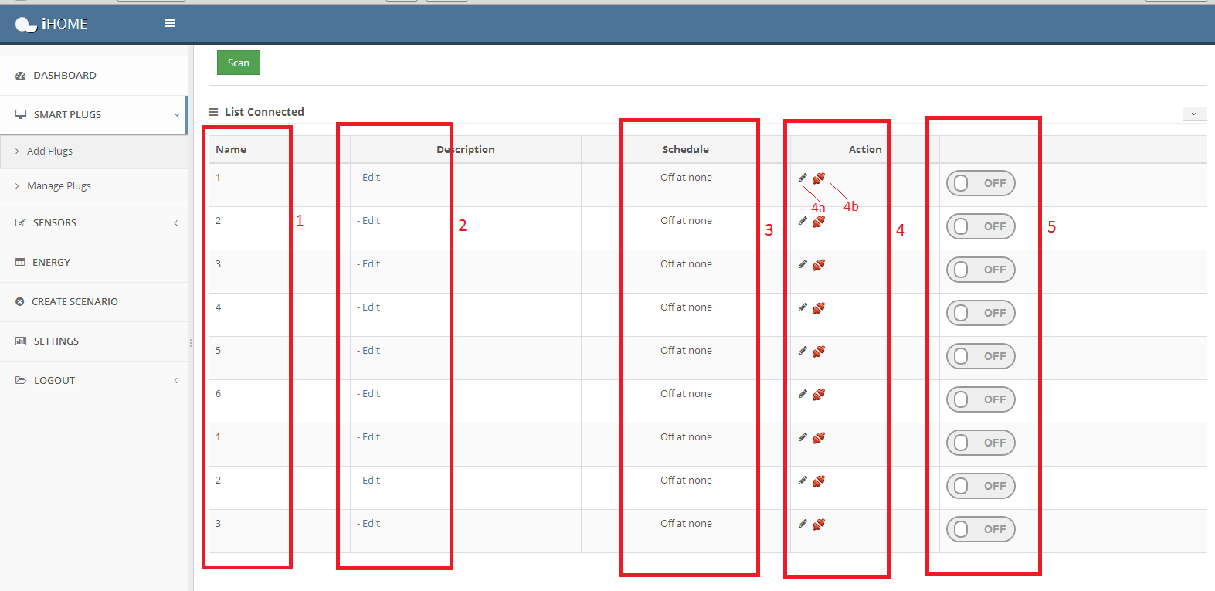

Figure : List plug connected

|  |  |  |
| --- | --- | --- |
| No. | Item | Description |
| 1 | Name Column | Name of plugs |
| 2 | Description Column | Can set description manual by click on Edit Button (Ex: Figure 7) |
| 3 | Schedule Column | Schedule of plugs |
| 4 | Action Column | Include 2 actions: Set Schedule and Disconnect |
| * 4a | Set schedule Button | Set Schedule to ON/OFF the plug |
| * 4b | Disconnect Button | Disconnect to remove the plug from system. |
| 5 | Switcher Button | Do ON/OFF the plug |

Table : Description of list connected

* Edit plug description

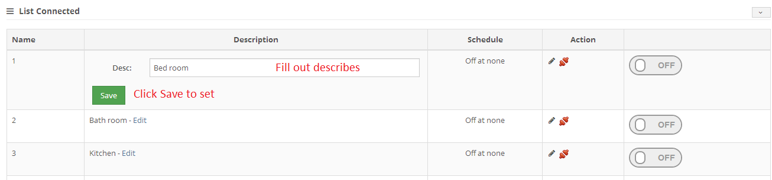

Figure : Edit plug function

* Set schedule for a plug

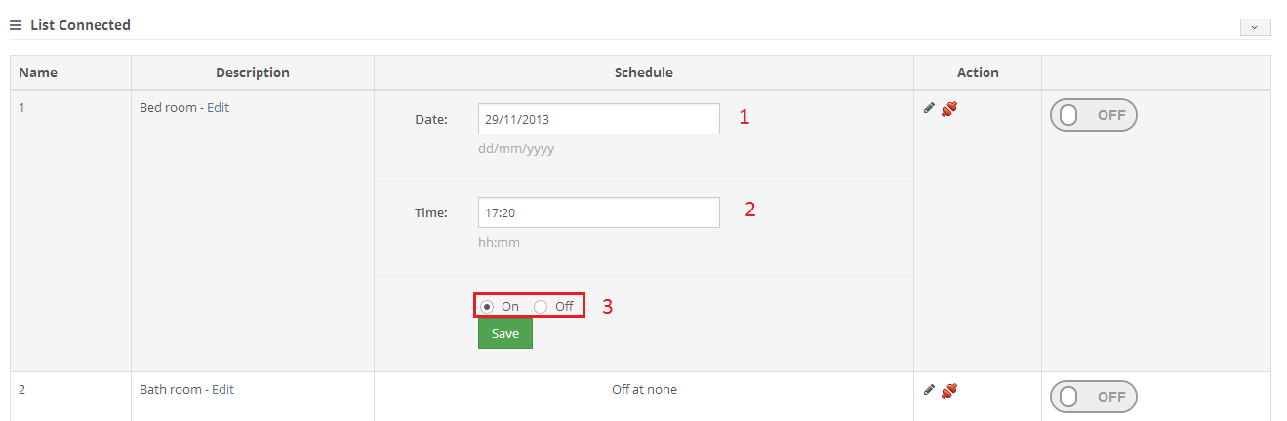

Figure : Set schedule function

|  |  |  |
| --- | --- | --- |
| No. | Item | Description |
| 1 | Textbox Date | Fill out the day when auto turn the plug |
| 2 | Textbox Time | Fill out the time when auto turn the plug |
| 3 | Radio Button On and Off | Turn On or Off when reached the schedule |

Table : Description of set schedule page

* Control plug

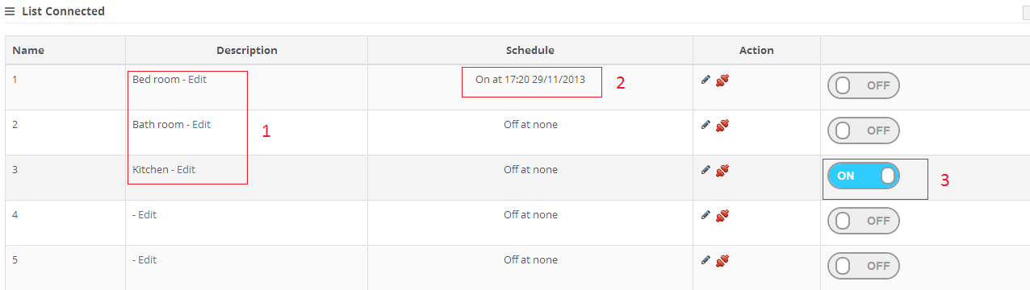

Figure : Manage plug board overview

|  |  |  |
| --- | --- | --- |
| No. | Item | Description |
| 1 | Edit Description | Example for edit description |
| 2 | Set schedule | Set up schedule for a plug |
| 3 | Switcher | Turn ON or OFF a Plug |

Table : Description of manage plug page

* Disconnect a plug

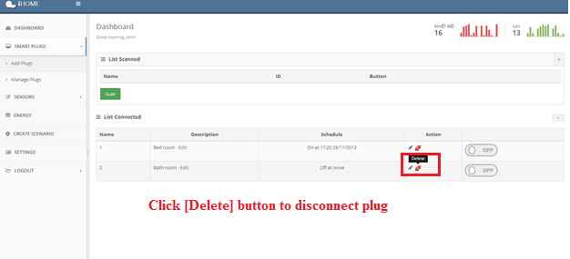

Figure : Delete plug function

### Add sensor manually

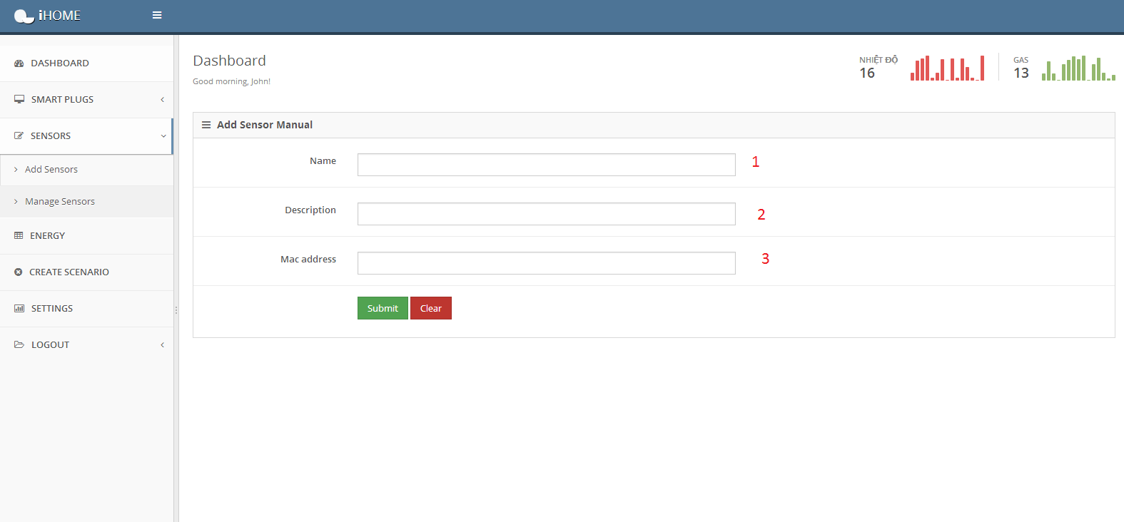

Figure : Add sensor page

|  |  |  |
| --- | --- | --- |
| No. | Item | Description |
| 1 | Name of Sensor | Fill out the name which Sensor you want to add. |
| 2 | Description for this Sensor | Fill out description to define the Sensor. |
| 3 | Mac Address of Sensor | Fill out exactly the MAC Address of Sensor |

Table : Description of add sensor page

### Manage sensor page

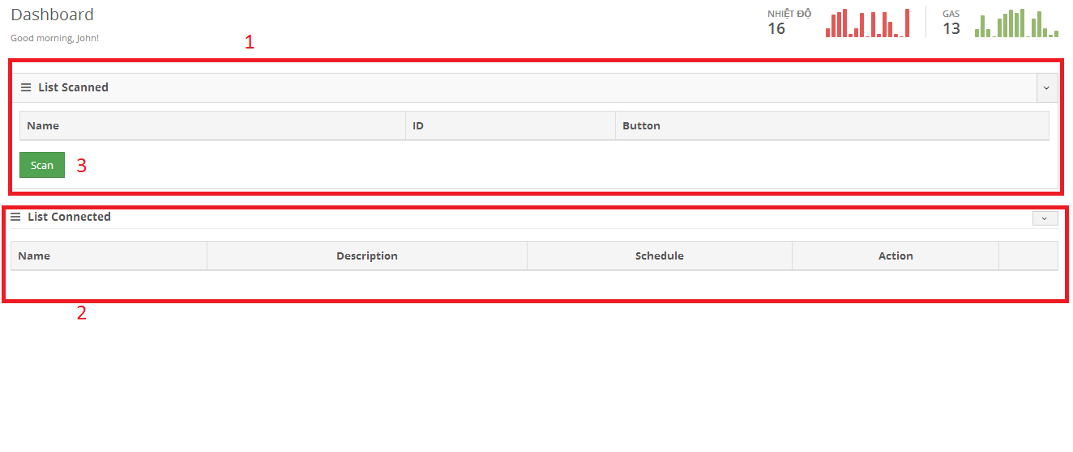

Figure : Manage sensor page

|  |  |  |
| --- | --- | --- |
| No. | Item | Description |
| 1 | List Scanned | Show List scanned after click button “Scan” |
| 2 | List Connected | Show List connected after click button “Connect” |
| 3 | Scan Button | Scan all sensors in i-Home system. |

Table : Description of manage sensor page

* Scan a sensor

Press [Scan] button to scan a sensor. Result is displayed as below

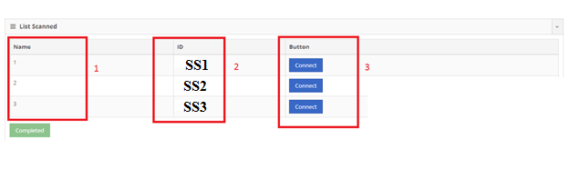

Figure : List sensors is scanned

|  |  |  |
| --- | --- | --- |
| No. | Item | Description |
| 1 | Name Column | Name of sensor |
| 2 | ID Column | Node Identifier (alternative to MAC Address) |
| 3 | Button Column | Click Connect to connect this sensor to link Hardware and Web. (ex: Figure 14) |

Table : Description of list scanned sensor

* Connect a sensor

Press [Connect] button of the scanned sensors

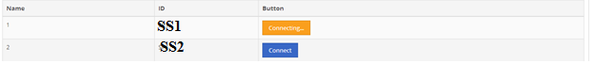

Figure : Press Connect button to connect the sensor

### Create scenario

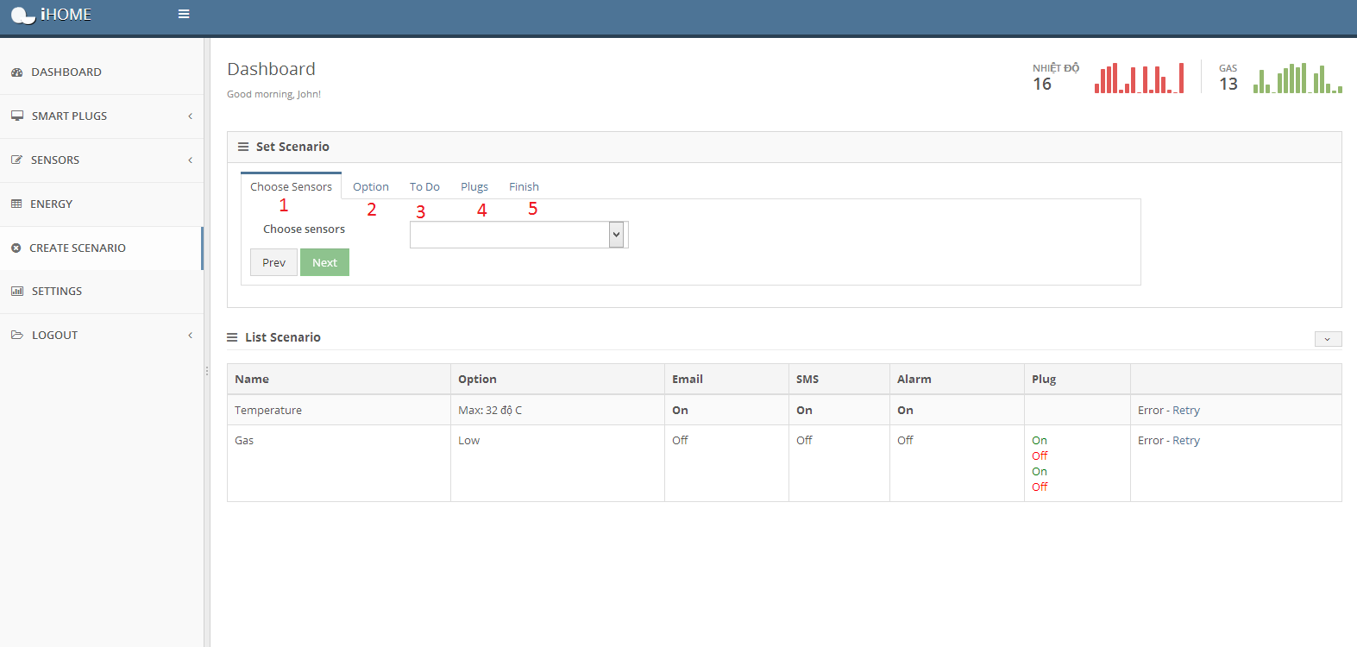

Figure : Create scenario page

|  |  |  |
| --- | --- | --- |
| No. | Item | Description |
| 1 | Choose Sensors | Choose on of sensors which is connected to system |
| 2 | Option | Set limit level for scenario |
| 3 | To Do | Do some actions (Send SMS, email, trig alarm, manage plugs) |
| 4 | Plugs | Turn On/Off when scenario occur |
| 5 | Finish | Finish the create scenario process |

Table : Description of create scenario page

* Create scenario process
* Choose sensor

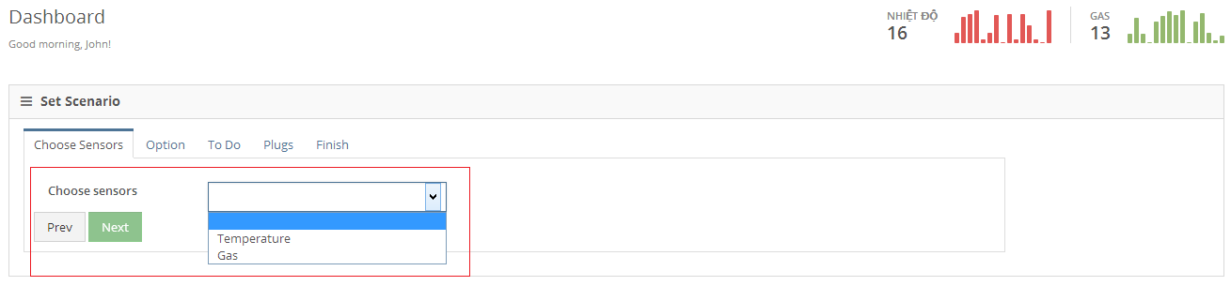

Figure : Choose sensor

Select the sensor to determine the status in i-Home system.

* Set option

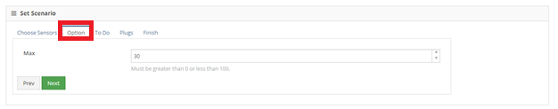

Figure : Set temperature option

* Set the maximum temperature (for temperature sensor only).
  + - If choose Gas sensor

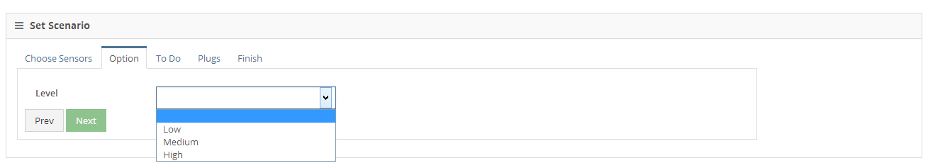

Figure : Set gas level option

Set the level of Gas option. We provide 3 levels of warning condition:

* Low: current gas concentration is low.
* Medium: current gas concentration is medium.
* High: current gas concentration is high.
* Set [To Do] tab

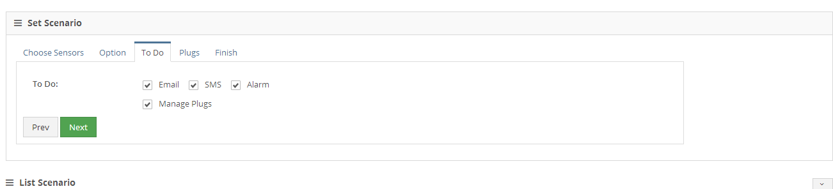

Figure : Choose actions

* Email: When scenario occurred, web server will send an email to email-address is set in Setting Page.
* SMS: When scenario occurred, web server will send a SMS to Phone Number is set in Setting Page.
* Alarm: When scenario occurred, alarm will be activated.
* Manage Plus: When scenario occurred, system will auto turn ON/OFF some plugs is designated.
  + If you chose [Manage Plugs] option

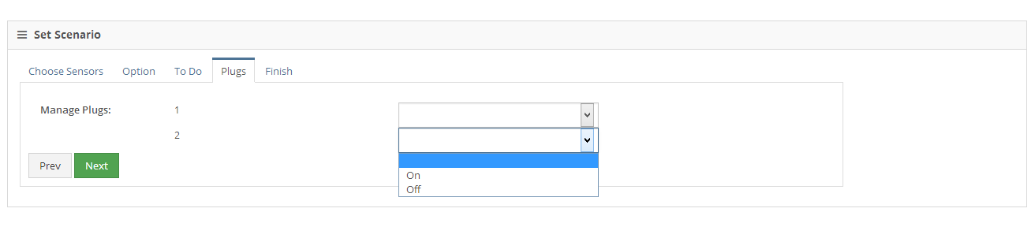

Figure : Set plugs

* + If you don’t choose [Manage Plugs] option

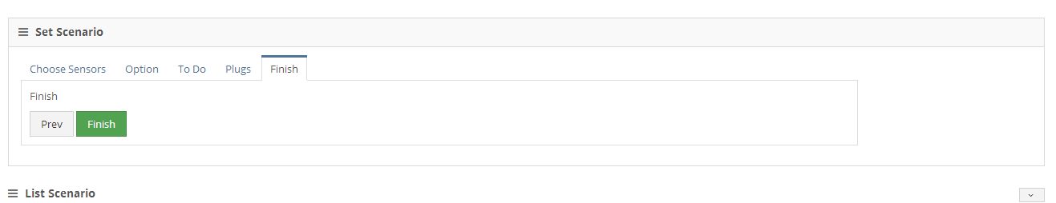

Figure : Finish process

If your scenario is OK then click [Finish] button to create it. If you want to edit something, press [Prev] button.

This screen will be displayed after finishing

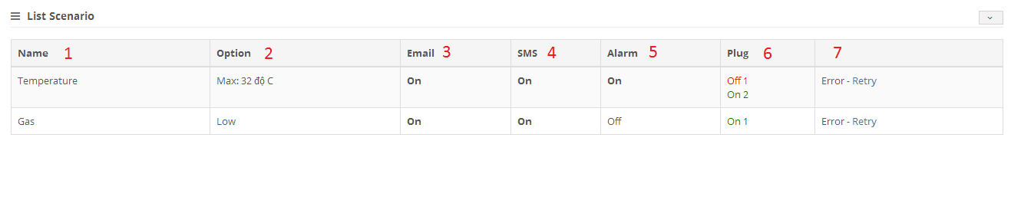

Figure : Scenario board

|  |  |  |
| --- | --- | --- |
| No. | Item | Description |
| 1 | Name | Name of sensors is set scenario |
| 2 | Options | Options of sensors |
| 3 | Email | Will send email or not, when scenario occur |
| 4 | SMS | Will send SMS or not, when scenario occur |
| 5 | Alarm | Will trig Alarm or not, when scenario occur |
| 6 | Plug | Will turn on/off plugs, when scenario occur |
| 7 | Status of Scenario | Hardware system are linked with Webserver or not (Ex: if working Figure 21) |

Table : Description of scenario page

### Setting page

This page allows users to set their email, phone number … to receive notification message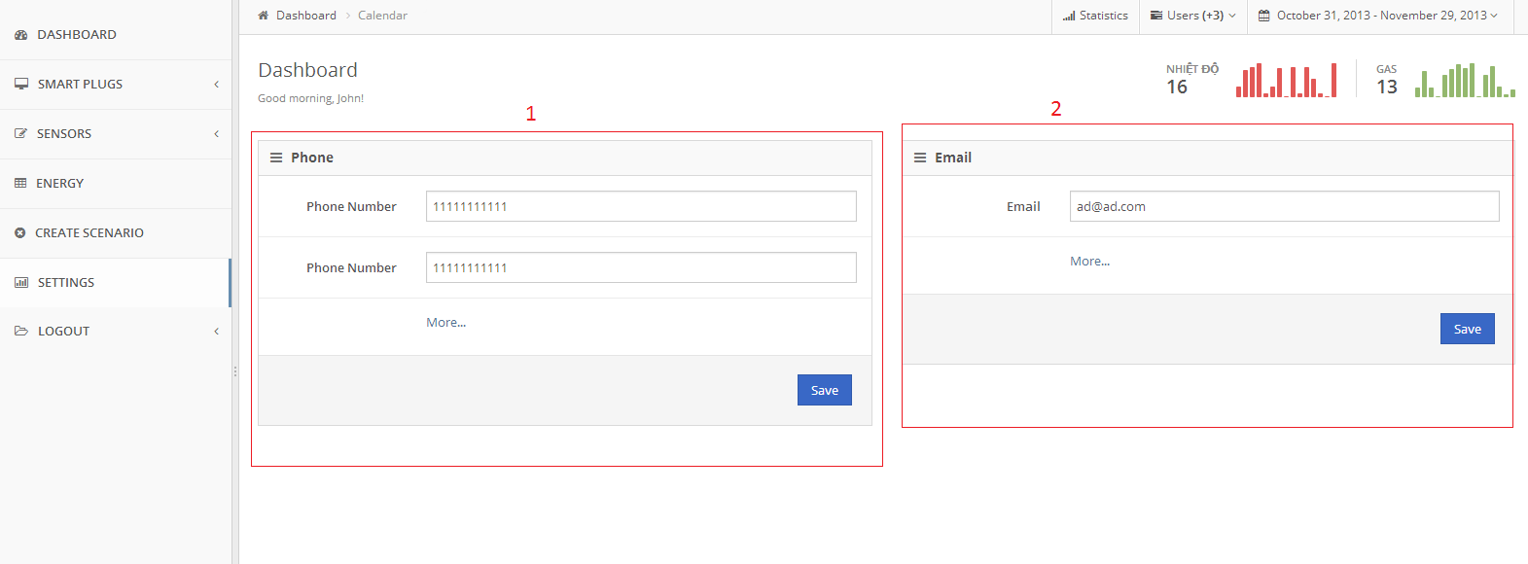

Figure : Setting Page

|  |  |  |
| --- | --- | --- |
| No. | Item | Description |
| 1 | Phone | Phone numbers will be received email when scenario occur |
| 2 | Email | Email addresses will be received email when scenario occur |

Table : Description of setting page

If you want to add more number or email, press [More…] to add.

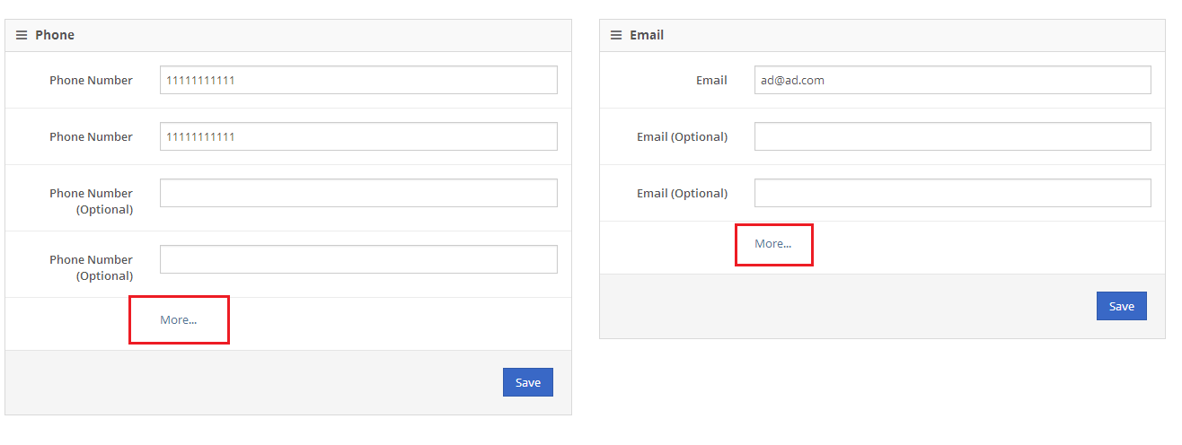

Figure : Add more email and phone number

# Works Cited

* All information about X-Bee module available at Digi web site:

<http://www.digi.com/>

* ZigBee Alliance web site : [http://www.zigbee.org](http://www.zigbee.org/)
* All information about ZigBee:
  + ZigBee Wireless Networking, Drew Gislason
  + XBee®/XBee-PRO® ZB RF Modules by Digi International
  + ZigBee Wireless Networks and Transceivers - Shahin Farahani
  + Building Wireless Sensore Networks - Robert Faludi
* MSP430FR57xx Family User's Guide - Texas Instruments
* http://processors.wiki.ti.com/index.php/CC3000